Photographs of the Existing Stopbanks on the Northside of the Waiho River – Franz Josef

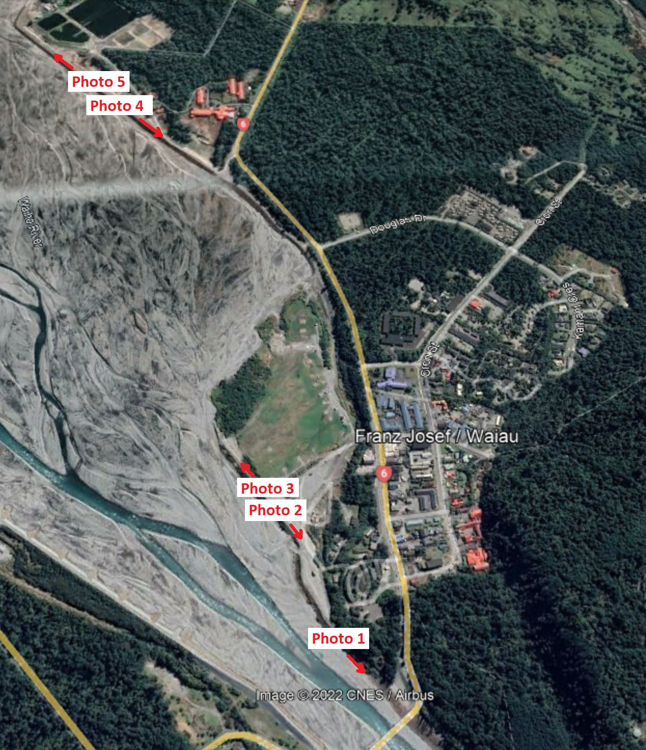
Locations of photos
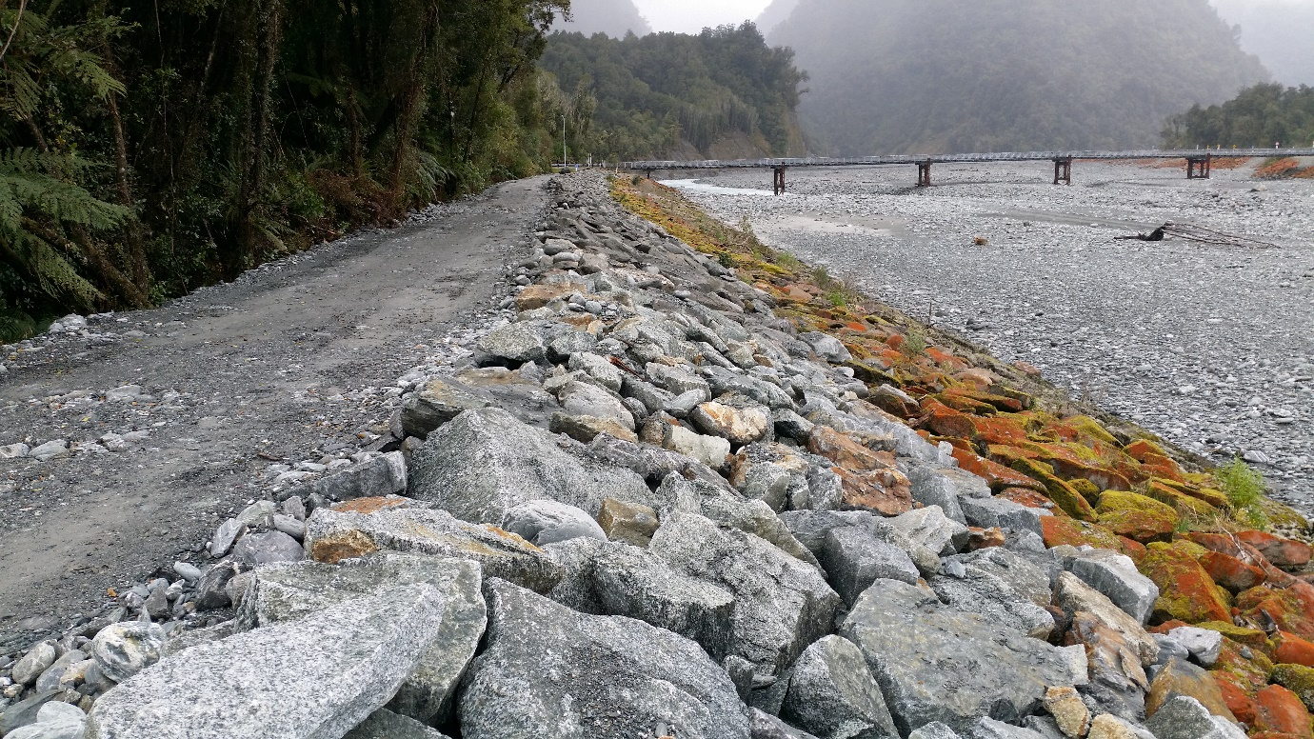
Photo 1 – Church Stopbank looking upstream towards the State Hiway 6 Bridge
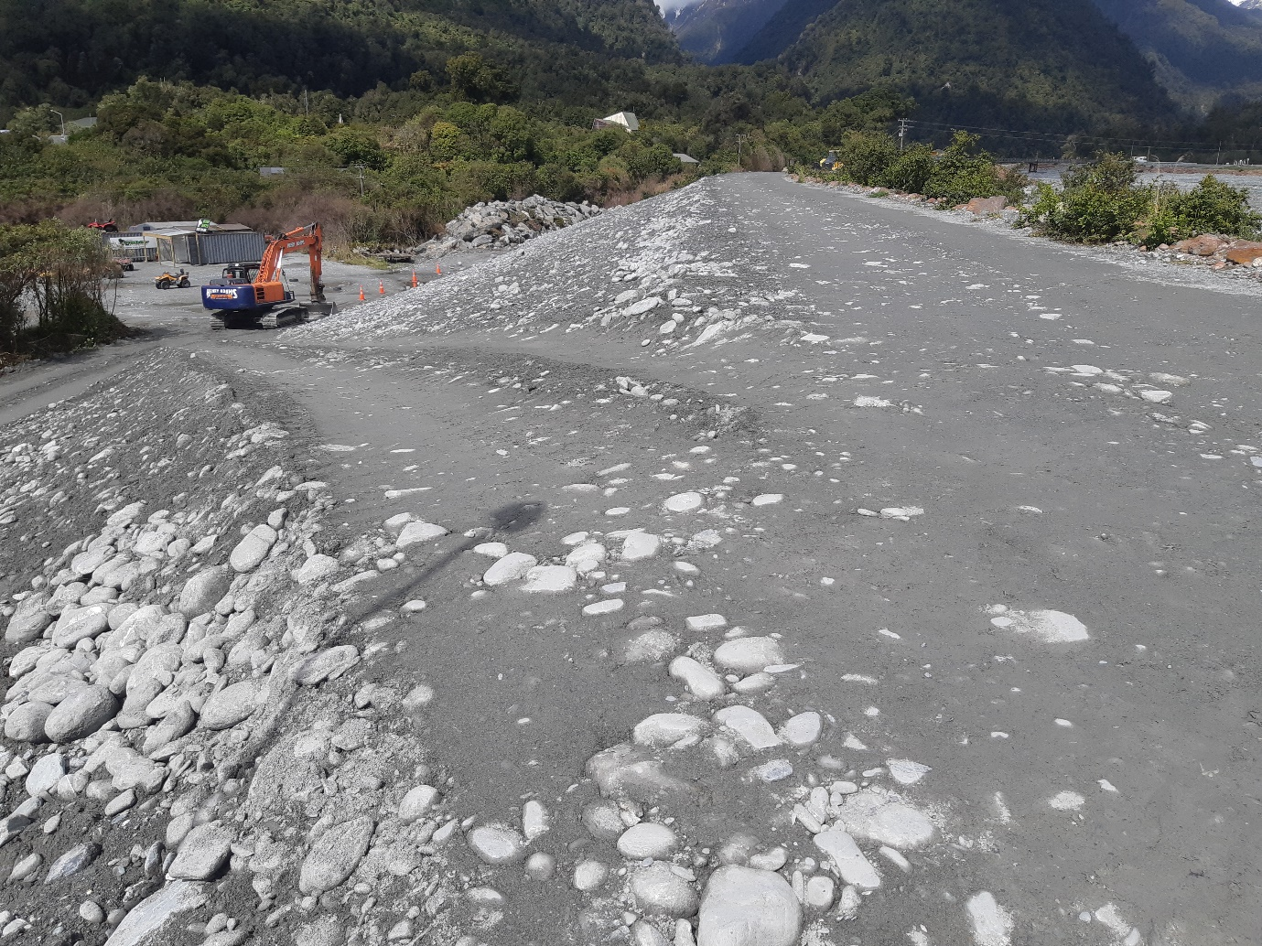
Photo 2 – Heliport Stopbank looking upstream
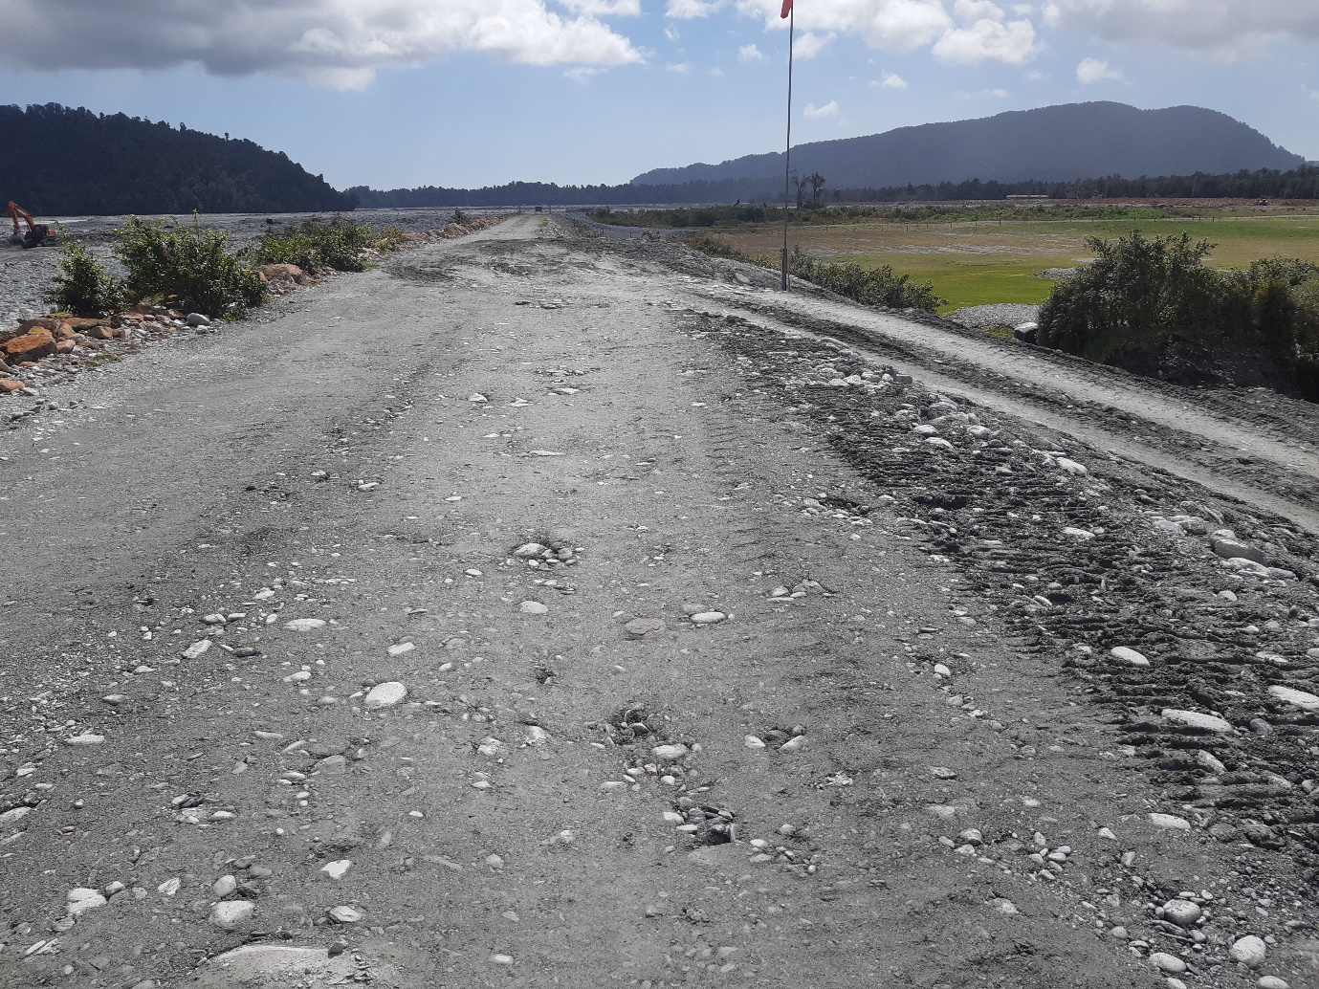
Photo 3 – Heliport Stopbank looking downstream
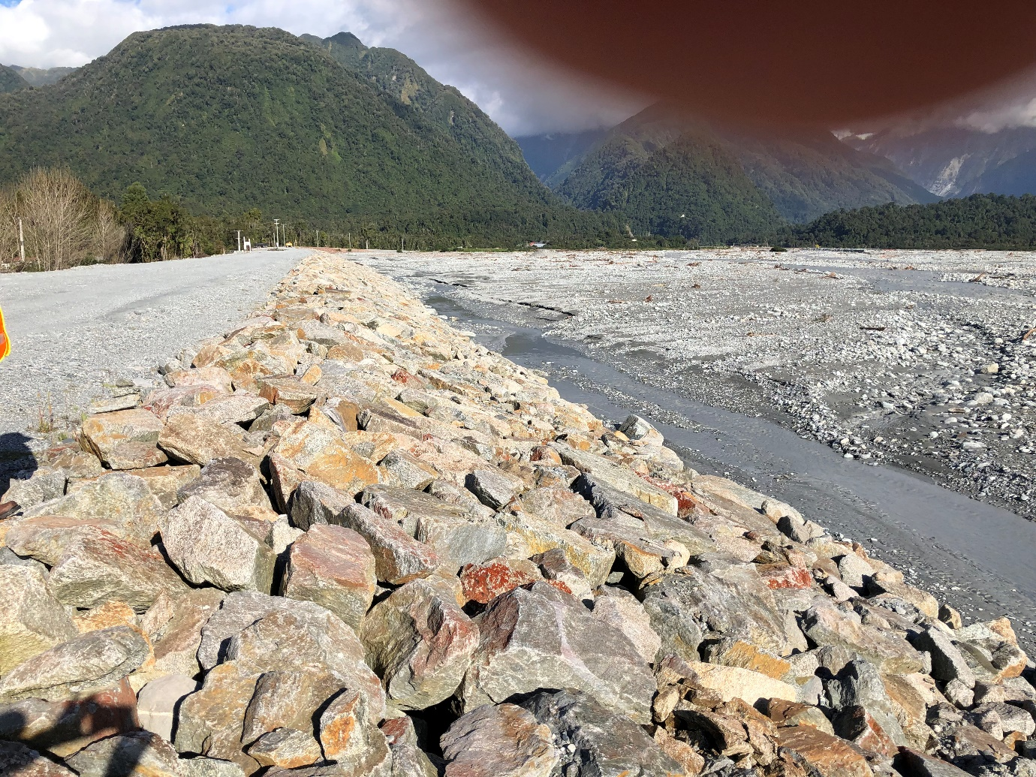
Photo 4 – Havill Wall looking upstream
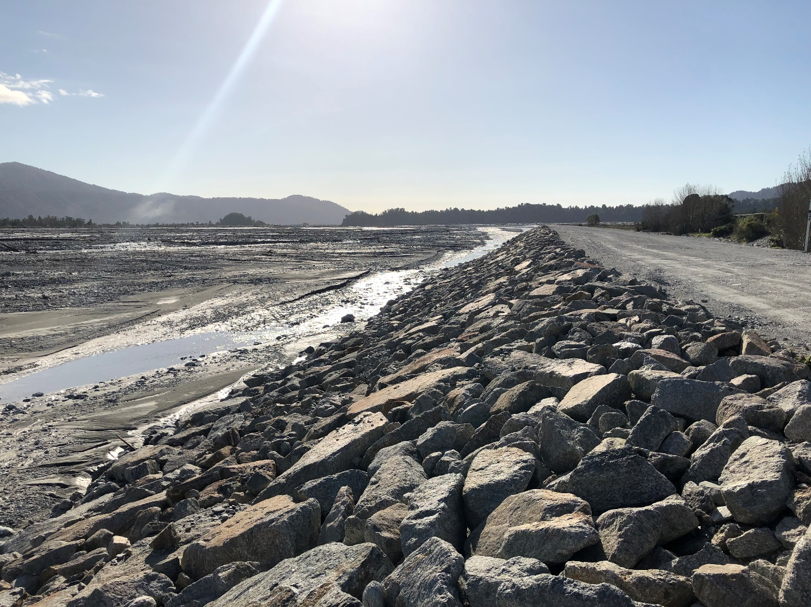
Photo 5 – Havill Wall looking Downstream

