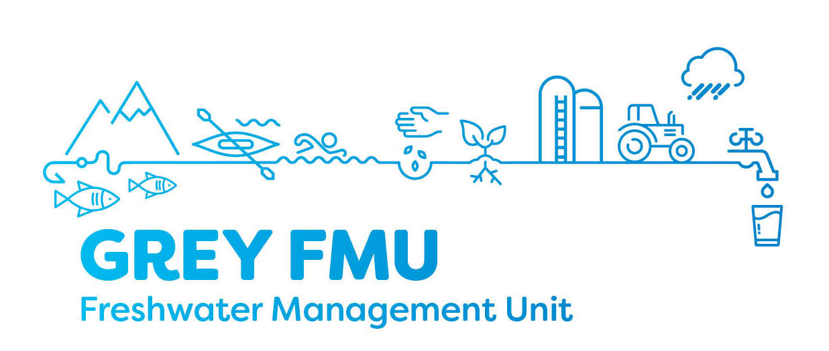
Meeting Notes
Grey River Freshwater Management Unit Meeting – Meeting 16
Date: 28/01/20
Location: West Coast Regional Council Chambers

Present at Meeting:
Sonya Perkin (Chair), Karen Grant, Baylee Kersten, Trevor Johnstone, Dave Waghorn, Stu Bland, Jonny Horrox (WCRC), Lillie Sadler (WCRC), Philippa Lynch (Ngai Tahu).
Guests: Kurtis Perrin-Smith (GDC), Rob Dewhurst (GDC).
Apologies: Murray Hay (GDC), Scott Williams, Jim Galloway.
Absent: Brett Cummings (WCRC)

Grey District Council – Drinking Water
Kurtis and Rob presented on the threats to municipal drinking water supplies in the Grey FMU.
There are several private water supplies in the FMU. Those under GDC custodianship are Greymouth, Runanga, & Blackball. A number of risks have been identified.
Low risk scenarios include: elevated nitrate, flood inundation, earthworks disrupting aquifer, dry weather changing water chemistry, surface microbial contamination permeating surface layers, silt blockage associated with earthquakes.
Moderate risk scenarios include: a road accident that discharges highly toxic substances upstream or up gradient of a take, toxins associated with cyanobacterial bloom, contaminants entering private bores that are up gradient from municipal takes.

Actions that would improve drinking water security:
- Contingency plans for managing spills that pose a catastrophic risk to drinking water supplies. Managing the spill so that it does not contaminate a water supply would be under the RC’s jurisdiction.
- Managing major land development where it could affect a water supply, particularly a groundwater take. There are examples where major humping and hollowing has led to buried organic material contaminating water supplies e.g. Atarau/Moonlight
- Firmer management of structures that provide a direct pathway to the aquifer i.e. bypass dry and vadose layers above the groundwater level. Particular examples are private bores that are up gradient of a municipal take, where these bores have inadequate wellhead protection.

Further work on Water Quality recommendations
Group worked through main attributes, national bottom lines and ways to achieve them.
E.coli
Microbial health of waterways are of high importance to the community. Some concern around human faecal sources. Municipal sewerage discharges are well managed by GDC, and there are consents to cover these activities. GDC are constantly improving as funding allows, including pressure on the Greymouth properties yet to connect to available separated networks.
- Getting urban properties connected to separated sewerage is a high priority – maybe a loan scheme is required to help facilitate faster uptake and connection.
- Bores should be required to comply with a minimum practical standard of wellhead protection. We don’t want another Hastings.
- Fencing: Conditions around this could be modified according to stocking rate. For example, areas with low stocking rates are likely to have more waterways per stocking unit, making the cost of fencing disproportionately high relative to potential impacts.
- Stock exclusion is good, but it needs to be applied in a way that considers the cost and logistic implications, like flood risk.
Turbidity
- Encourage best practice for sediment management, for different types of use: mining, farming, forestry sediment, urban development. Recommendations for good practice measures to be tailored for specific activities.
Concern around the role of forestry with sedimentation in streams. Group informed about the National Environmental Standard for Plantation Forestry, significantly amended in 2018, which will improve the regulation of sediment discharges from forestry operations.
https://www.mpi.govt.nz/growing-and-harvesting/forestry/national-environmental-standards-for-plantation-forestry/

Fauna
- Set above national bottom line, 80-100 MCI
- Provide education and extension for people on how to provide quality habitat, aquatic weed recognition, fencing waterways.

Action: Next meeting come back with good practice details. Sonya will provide for Farming.

Next meeting – continue working through recommendations.

Meeting Closed

