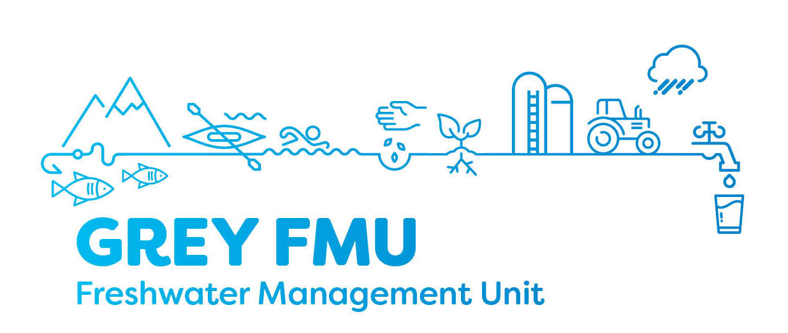
Grey River Freshwater Management Unit Meeting – Meeting 6
Meeting Date: 04/04/19 – originally scheduled 26/03/19
Location: West Coast Regional Council Chambers

Attendee’s:

Scott Williams, Stu Bland, Karen Grant, Jim Galloway, Baylee Kersten, Dave Waghorn, Trevor Johnston, Andrew Robb (WCRC), Murray Hay (Grey DC),
Apologises / Absent:
Greg Hart (Buller DC), Francois Tumahai (Ngati Waewae), Sonya Perkin (Chair), Philippa Lynch (Ngai Tahu)

Supporting staff:
Edith Bretherton (WCRC), Hadley Mills (WCRC), Jonny Horrox (WCRC)

Key topics covered
- Recap on previous meetings
- Stakeholders presentation at FMU
- Envirolink – what it is and how it can be of use to this group
- Water Quantity continued – planning framework and options, groundwater and surface water interactions
- Lake Brunner project

Meeting outcomes and action required
- Dean Kelly, Fish and Game to be invited to April meeting
- Invite other key stakeholders to future meetings
- Details of Lake Brunner / Moana field trip to be finalised, including offer to visit Baylee Kerstens family home.
- Sonya Perkin to share with the group some of the issues farmers experienced through the Lake Brunner project and how they were resolved.

Next meeting date: 30 April 2019 6 – 8pm

