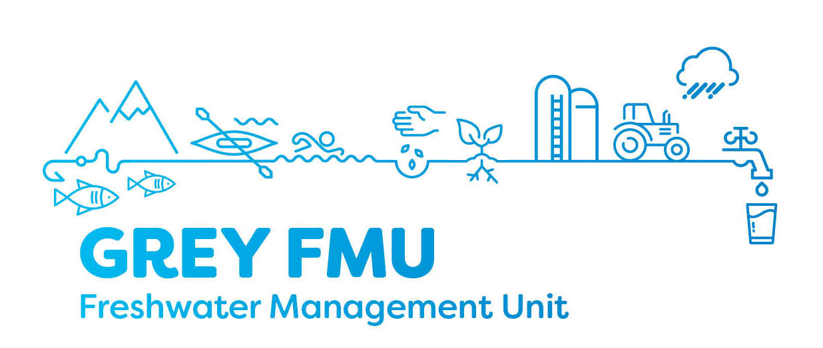
Grey River Freshwater Management Unit Meeting – Meeting 4
Meeting Date: 22 January 2019 6-8pm
Location: West Coast Regional Council Chambers

Attendee’s:

Sonya Perkin (Chair), Scott Williams, Trevor Johnston, Stu Bland, Dave Waghorn, Karen Grant, Baylee Kersten, Andrew Robb (WCRC), Murray Hay (Grey DC), Philippa Lynch (Ngai Tahu), Matthew Ross (Ngai Tahu) – guest.
Apologises / Absent:
Greg Hart (Buller DC), Jim Galloway,

Supporting staff:
Jonny Horrox (WCRC), Hadley Mills (WCRC), Edith Bretherton (WCRC).

Key topics covered
- Recap of the process so far
- SOE report
- The creation of a possible facebook page for the Grey FMU.
- NPSFM compulsory values
- Grey FMU values and attributes tables
- Other Councils regional plans
- Attributes and how they work
- Possible Planning Outcomes Templates

Meeting outcomes and action required
- Share previous presentation that includes the map showing water quality testing sites and trends within the Grey FMU with the group.
- State of the Environment Report to be shared with the group once completed.
- Discuss with Mfe and confirm back to group what the term ‘’limits’’ means in the NPSFM context
- Members to discuss the content of the facebook page and if the group will manage it themselves.
- WCRC to provide contact recreation visitor numbers data
- Organise Lake Brunner site visit for mid-year
- Circulate the Lake Brunner annual report to the group.
- Draft Planning Outcomes Template

Next meeting date: 26 February 2019 6 – 8pm

