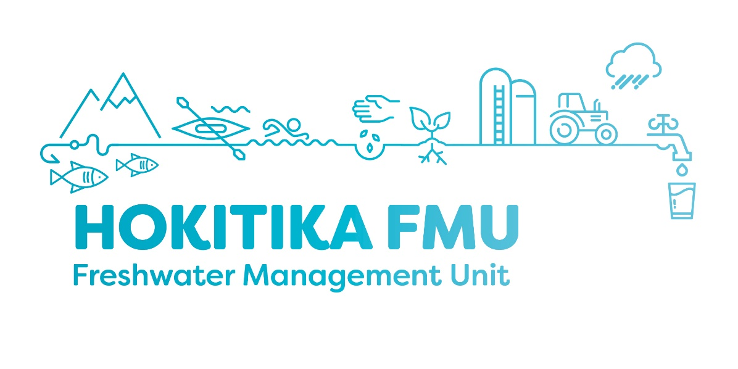
Agenda: Community Information Sessions for Hokitika Freshwater Management Unit (FMU)

Date: 21st January 2020
Time: 5.30pm
Venue: Westland District Council – Council Chambers
Attendees: Open to the public

Date: 23rd January 2020
Time: 5.30pm
Venue: Harihari Community Hall
Attendees: Open to the public

Agenda:

Time | Item
5.30pm | Housekeeping.  Purpose of this session.
5.40pm | Introduction to the National Policy Statement for Freshwater Management (NPSFM) implementation team.
5.45pm | Introduce and discuss NPSFM
6.10pm | Latest Freshwater Monitoring Results.
6.45pm | Purpose, structure and details of the Hokitika FMU group and how you can get involved.
7.00pm | Questions and Answers (NPSFM Team).
7.15pm | Meeting ends.  Nibbles/coffee/tea.

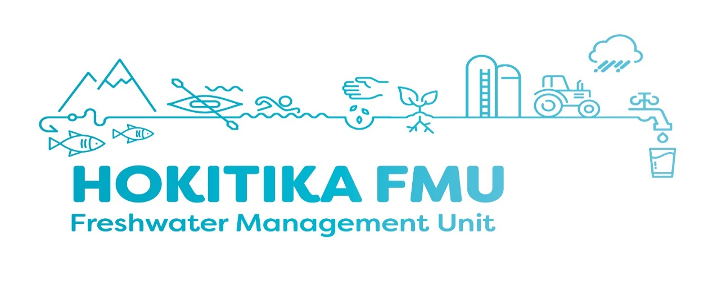
Purpose of the Hokitika FMU group
The purpose of the Group is to engage with the community to identify their values for, and understand the issues with, freshwater quality and quantity in the Hokitika Freshwater Management Unit (FMU). The Group will then make recommendations to the Council Resource Management Committee (RMC) for future plan provisions and work programmes to manage the land and water resources within the FMU.

Who should apply?
- People who have an interest in freshwater issues within the Hokitika FMU area,
- People who are able to commit to attending a 2 hour meeting once a month until September 2021,
- People who will work together with the group to achieve balanced and reasonable outcomes.

The Group will be made up of people with a range of backgrounds and interests relating to land and water, these interests may include:
- Agriculture  - Indigenous biodiversity/environment  - Recreation  - Mining  - Forestry  - Hydro  - Fishing  - Drinking water | - Conservation  - Sustainable development  - Tourism  - Economic development  - Urban development  - Public health  - General community  - Rural settlements
How to apply to become a member Hokitika FMU Group:
- Fill out an online form on the West Coast Regional Council Website here: https://www.wcrc.govt.nz/council/online-services/application-to-join-a-community-group/?ed-step=1.
- Call the West Coast Regional Council to request a paper form. Ph. 03 7680466,
- Application forms are also available at the Community Information Session

Key Dates
- 7 February: Applications close.
- 10 – 14 February: Interviews.
- 10 March: FMU Group members appointed.
- 24 March: First group meeting 5.30pm.

Meeting Locations:
Hokitika FMU Group meetings will be held in Hokitika, location TBC. Dial in options will be available.

