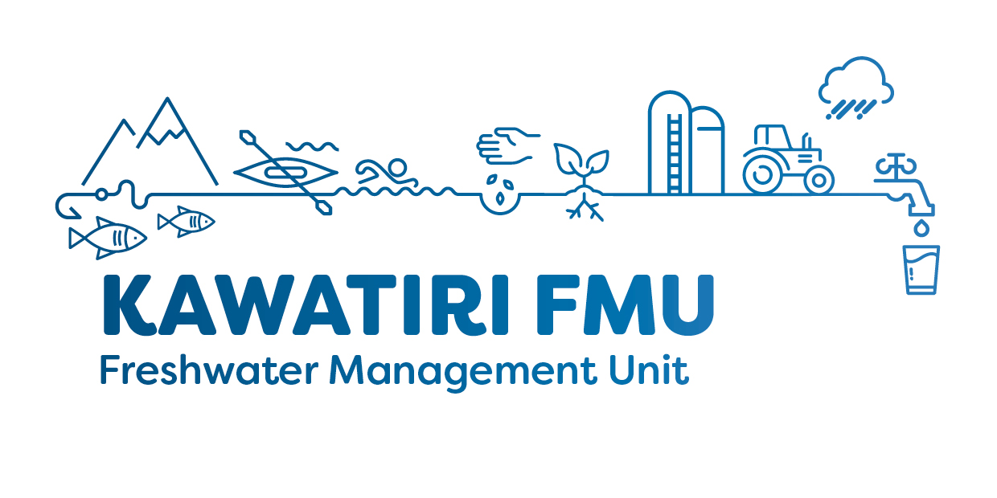
Kawatiri FMU Group Terms of Reference
Purpose and Function
The purpose of the Group is to engage with the community to identify their values for, and understand the issues with, freshwater quality and quantity in the Kawatiri Freshwater Management Unit (FMU). The Group will then make recommendations to the Council Resource Management Committee (RMC) for future plan provisions and work programmes to manage the land and water resources within the FMU. The recommendations may contain both regulatory (e.g. rules in plans) and non-regulatory (e.g. riparian planting) measures to maintain or improve freshwater quality and quantity outcomes in the FMU.
The Group will operate in partnership with Poutini Ngāi Tahu to recognise and respect the principles of the Treaty of Waitangi and develop recommendations which consider manawhenua cultural values including:
- Te Mana o te Wai and the taonga status of Waimāori
- Rangatiratanga and Kaitiakitanga
- Mahinga kai and other customary uses including pounamu
- Protection of the Mauri of waterbodies and restoration where degraded
- A Ki Uta Ki Tai - (mountains to sea) approach to integrated land and water management
- Mātauranga Māori
- Recognition and protection of wetlands, waipuna (springs), estuaries, hāpua and lagoons, of significance to Poutini Ngāi Tahu, as Wāhi taonga
Group Objectives
Work with the community to:
- Understand the issues affecting freshwater quality and quantity in the Kawatiri FMU
- Identify and prioritise values and uses for freshwater quality and quantity in the Kawatiri FMU
- Consider and recognise Te Mana o te Wai
- Develop objectives and limits for maintaining or improving freshwater quality and quantity, informed by how land and water are valued and used in the FMU
- Develop a range of regulatory and non-regulatory approaches for achieving those objectives and limits
- Provide Council with issues, values, objectives and limits and their recommended regulatory and non-regulatory approaches for achieving these by February 2021.
Establishment and Status
The Kawatiri FMU Group (the Group) is established under the Local Government Act 2002. It has the status of an Advisory Committee of the West Coast Regional Council (the Council) with no decision-making powers.
Council Consideration of Kawatiri FMU Group Recommendations
The RMC is responsible for the review and approval of the regulatory proposals recommended by the Group, including ensuring consistency with relevant statutory requirements. Non-regulatory proposals will be considered by the Council (RMC) in conjunction with relevant external organisations, including local and iwi authorities.
The Council (RMC) will consider the Group’s recommendations. If any recommendations are inconsistent with the Council’s views or statutory requirements, these elements will be referred back to the Group for further consideration.
Group Membership
The Kawatiri FMU Group will be appointed by the Council and will have the following membership:
- One member appointed by the Regional Council, who shall be an elected member,
- One member appointed by the Buller District Council who shall be an elected member,
- Two members appointed by the Papatipu Rūnanga whose takiwā falls entirely or partially within the Kawatiri FMU boundary,
- At least eight members from the community with a range of backgrounds and interests related to land and water management within the FMU. Selection will ensure a cross section of values, understanding and perspectives in the community. The Council may approve additional members if it determines their necessity to ensure appropriate balance.
In determining the composition of the Group’s community membership, consideration will be given to balancing land and water management values and interests, including, but not limited to:
- Agriculture
- Indigenous biodiversity/environment
- Recreation
- Mining
- Forestry
- Hydro
- Fishing
- Drinking water
- Conservation
- Sustainable development
- Tourism
- Economic development
- Urban
- Public health
- General community
- Rural settlements
To be eligible for consideration for appointment to the Kawatiri FMU Group, a community nominee must live in, or be able to demonstrate a close connection with, the FMU.
Each community member must also reflect the interests of a wider group within the community, and will be required to engage with their organisations and networks to share information and get feed-back on matters being considered by the Group.
West Coast Regional Council, Buller District Council and Poutini Ngāi Tahu will appoint their own representatives on the committee.
Chairperson
The Chairperson has additional responsibilities, including ensuring that the Group functions properly, there is full participation during meetings, all relevant matters are discussed and that effective decisions are made and carried out in a timely manner as per the Terms of Reference. WCRC staff with provide the chairperson and the group with administrative support including direction on planning policy and science. The Chairperson must provide leadership and ensure that the goals and objectives of the Group are met. The Chairperson may need to work between meetings to liaise with technical experts, and represent the Group at external meetings when required.
The Chairperson is to be determined by the Kawatiri FMU Group when all members have been appointed. The Group will be chaired by the member from the Regional Council in the interim.
Quorum
A quorum consists of:
- Half of the members if the number of members (including vacancies) is even; or
- A majority of members if the number of members (including vacancies) is odd.
Proxies or alternates are not permitted to vote or provide input into group deliberations on behalf of a group member or organisation. The Group will at all times operate in accordance with the requirements of the Standing Orders of Council, under the Local Government Act (2002), and the Local Government Official Information and Meetings Act.
Reporting
The group will provide updates to the Council’s Resource Management Committee, and the community via the WCRC website, at least quarterly.
Meetings and Workshops
The Group will meet monthly, with workshops and additional meetings as required.
Some meetings may be open to the public to attend as observers with an allocated time slot for public questions.
Zoom (online) meeting attendance is available to those unable to attend in person. A short summary of the meeting will be published on the WCRC website after each meeting.
Meeting Protocols
General meeting protocols have been agreed by the group and may be amended by group as and when required.
- Cellphones to be off or on silent
- Meetings to start and finish on time
- Allow people to finish speaking
- Allow everyone a change to contribute
- Be open and professional in discussions
- Media requests – if approached to bring to the group, a response and spokesperson will be formed from there
- Enquires – Nathans contact details, as Chair to be put on the WCRC website so any public enquires can come to him to share with the group as appropriate.
- Facebook content will be drafted by the Chair and circulated to the group with 48 response time. No response means no issue.

Duration of the Kawatiri FMU Group
The Kawatiri FMU Group shall exist for the duration of the development and delivery of Kawatiri FMU freshwater quality and quantity recommendations to Council, and shall cease to exist once Council has made decisions on the proposals recommended.
General Operating Principles
The Group is expected to:
- Work in a collaborative and co-operative manner using its best endeavours to reach solutions that take account of the interests of all sectors of the community
- Seek consensus in its decision-making where possible
- Seek assistance and exhaust all avenues to resolve matters where the Group encounters fundamental disagreements
- Report to the Council the matters where agreement has been achieved and also matters where disagreement has not been resolved, including whether there is a consensus or majority view on each matter.
Group Support
The Group will be supported by the West Coast Regional Council, with the primary contact being the Planning Team Leader, Lillie Sadler.
A minimum of two Council staff will attend each meeting and will provide administrative support, minute taking, technical advice and information. Any additional investigation or data collection requested by the Group will require Council approval. Staff from Buller District Council, Te Rūnanga o Ngāti Waewae, and Te Rūnanga o Ngāi Tahu will be invited to attend meetings, and provide technical advice and information where appropriate.

