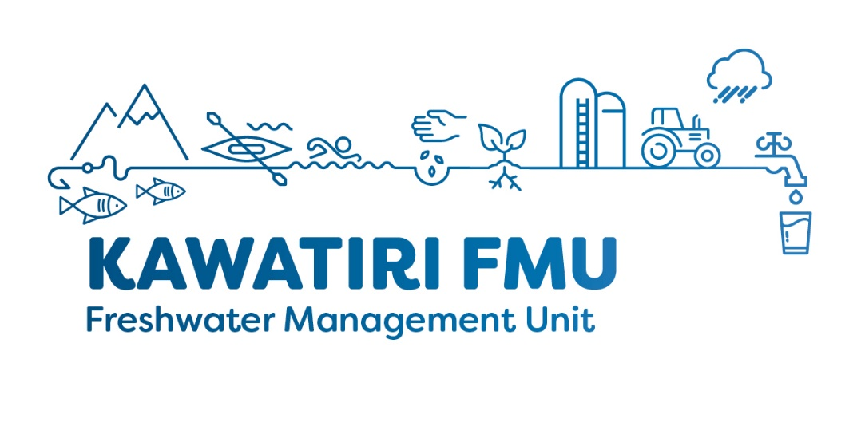
Kawatiri Freshwater Management Unit (FMU) Meeting – Meeting 1
Meeting Date: 6 August 2019 5.30-7.30pm
Location: Westport Library

Attendees:

Campbell Robertson (by phone), Caroline Jones, Colin Hope, Douglas Phillips, Lisa Steenhauer, Michael Kingsbury, Nathan Keogan, Neal Clementson (WCRC), Philippa Lynch (Ngai Tahu),

Apologises / Absent:

Francois Tumahai (Ngati Waewae), Di Rossiter

Supporting staff:
Jonny Horrox (WCRC), Hadley Mills (WCRC), Stefan Beaumont (WCRC)

Key topics covered:
- Group and staff introductions, session framework and house keeping
- Terms of Reference
- Current water quality and quantity state of environment within the Kawatiri FMU.

Meeting outcomes and action required:
- Neal Clementson to contact BDC to request a replacement representative.
- Election of chair deferred to meeting three
- Communication principles review and agreed.
- Meeting schedule reviewed, revision required, will be updated and brought to next meeting.
- Terms of reference reviewed and agreed by the group.

Next meeting date: 5.30-7.30pm 17 September 2018

