

File Note.
Date of visit: 5th December 2012
Wetland: HOKP119
Size of wetland on property: 24.9ha
Location: 1616 Old Christchurch Rd. Kawhaka
Owners: Kees & Anne Van Beek
Other properties & landowners of wetlands: Todd Stewart, Charles Barclay, David Beaton, Cornelis Schapp, Jan Frederick Billie, Peter Whittall, Caro Nonny, Andy Grigg
Type of land use: dry stock
Weather(rain past 72 hours): 108mm

Kees and Anne Van Beek are interested in developing this schedule 2 wetland area in the form of humping and hollowing for the purpose of grazing stock. There is a prominent swamp along the Western boundary. A creek flows from East to West feeding this swamp. Kees plans to leave these areas alone (and fence if necessary).

Kees applied for consent to develop this area in 2007. They were asked to seek permission from neighbours and concerned parties. The Department of Conservation and Ngati WaeWae approved. They are still to hear back from Cranley Farms, the Gilbertsons Family, Richard Stevens, Charlie Barclay, Fish and Game (WC region) and Todd Stewart.

On the day that I visited 108mm rain had fallen over the previous 72hours. So gumboots were essential! The wetland comprises largely of Tangle Ferns, rushes, sedges and Spagnum Moss. There were pockets of larger trees Manuka, Rimu, Kawhaka, Kahikatea, with a splattering of Gorse. Fern birds are present along with Weka, Pukeko and Mudfish.

Some stock occasionally find their way up there, so is seldom grazed. Kees and Anne would be prepared to sell to the Natures Heritage Fund if an ecologist was to classify it as a significant wetland.

6 December 2012
HF

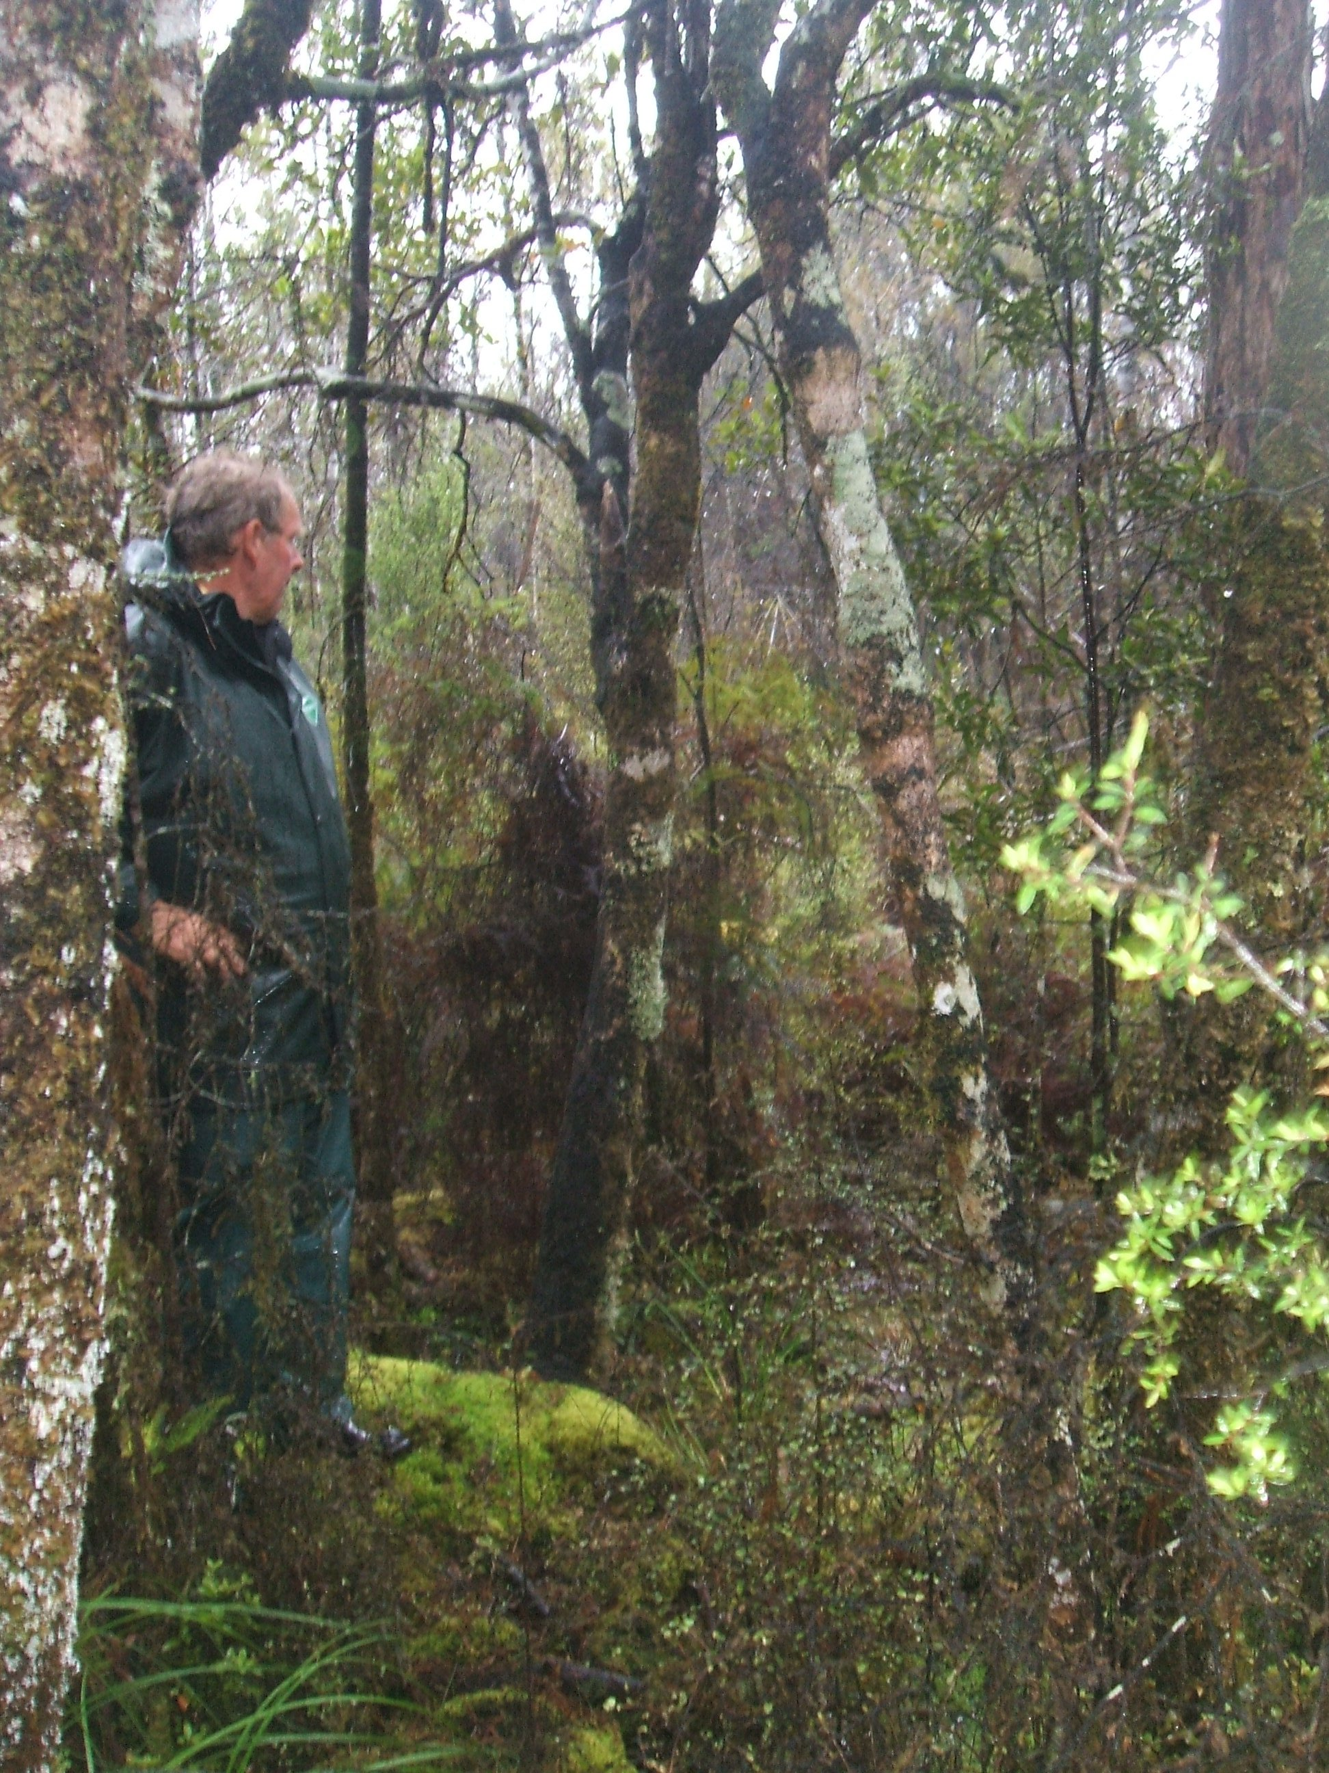

E1452001, N5267426 Location 1. Looking S.

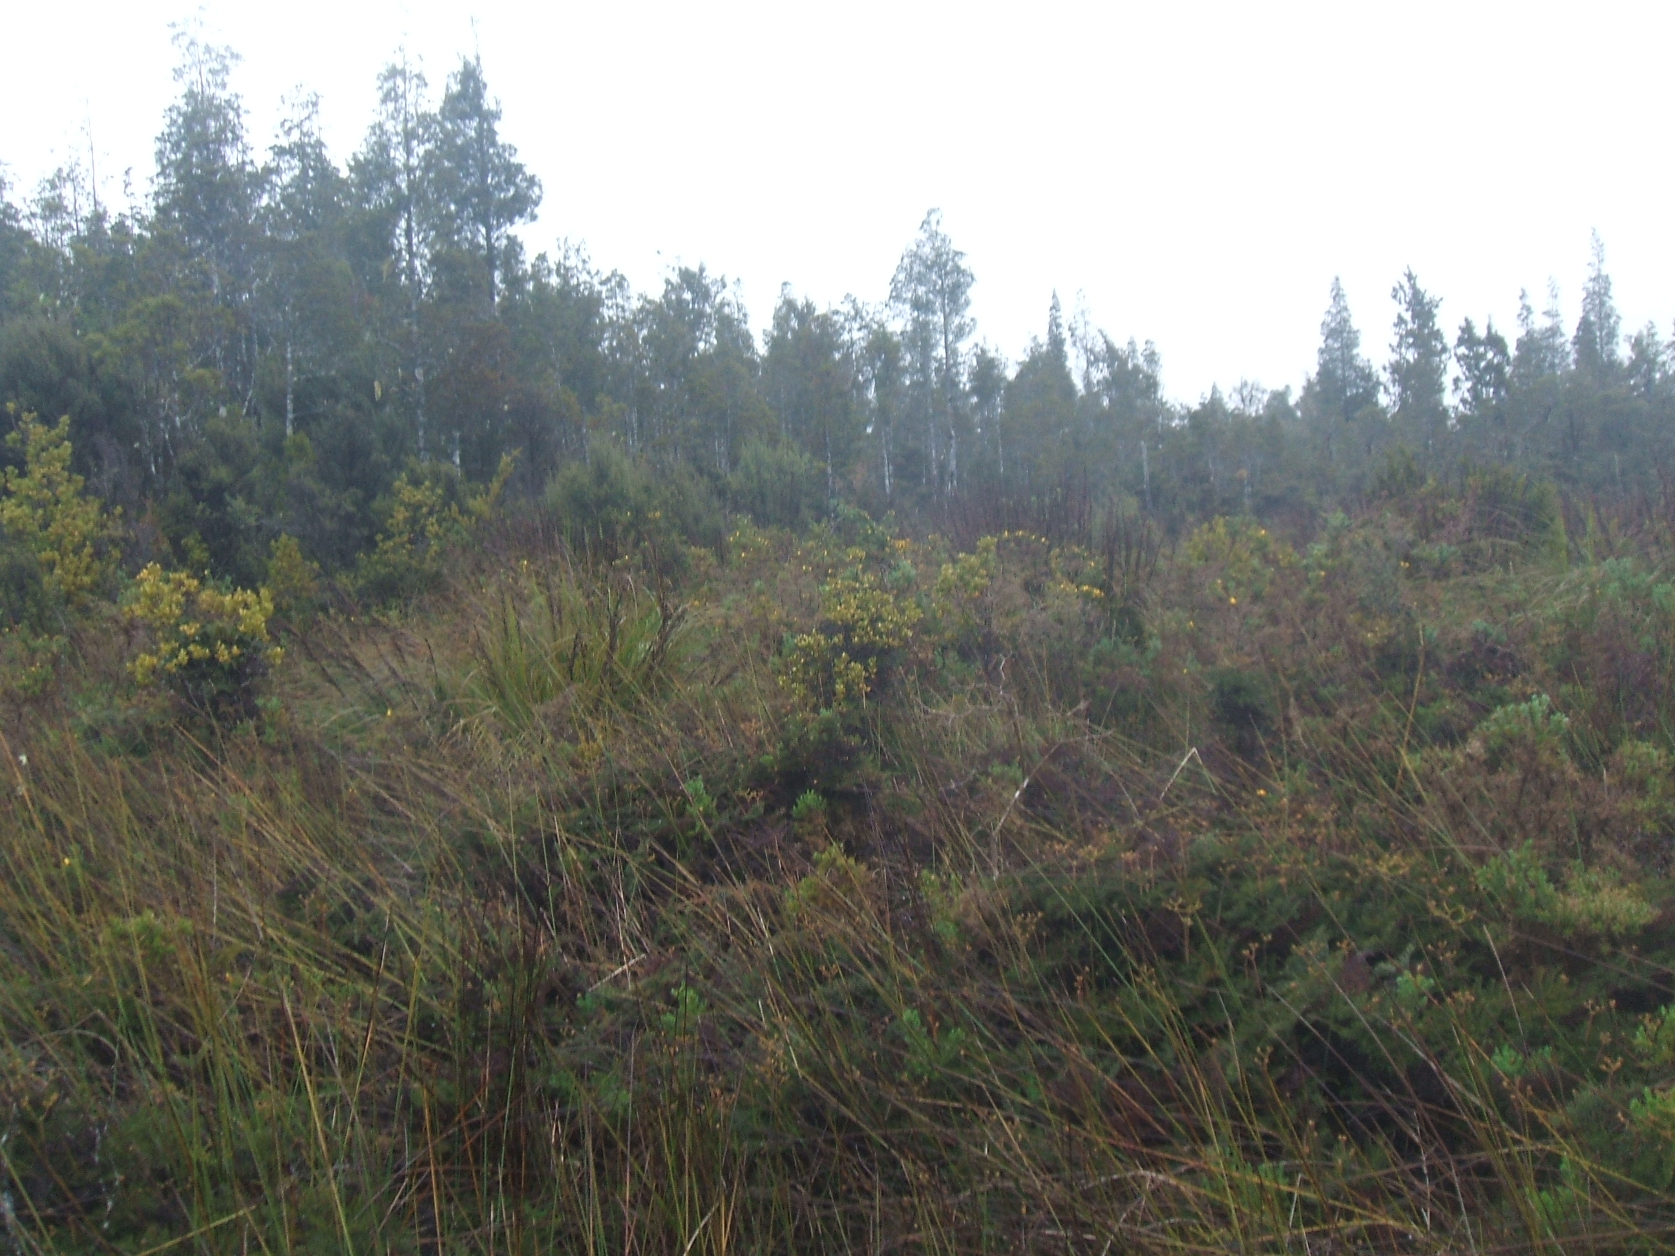

photo 1. E1452015, N5267472 Location 2. Looking SW.

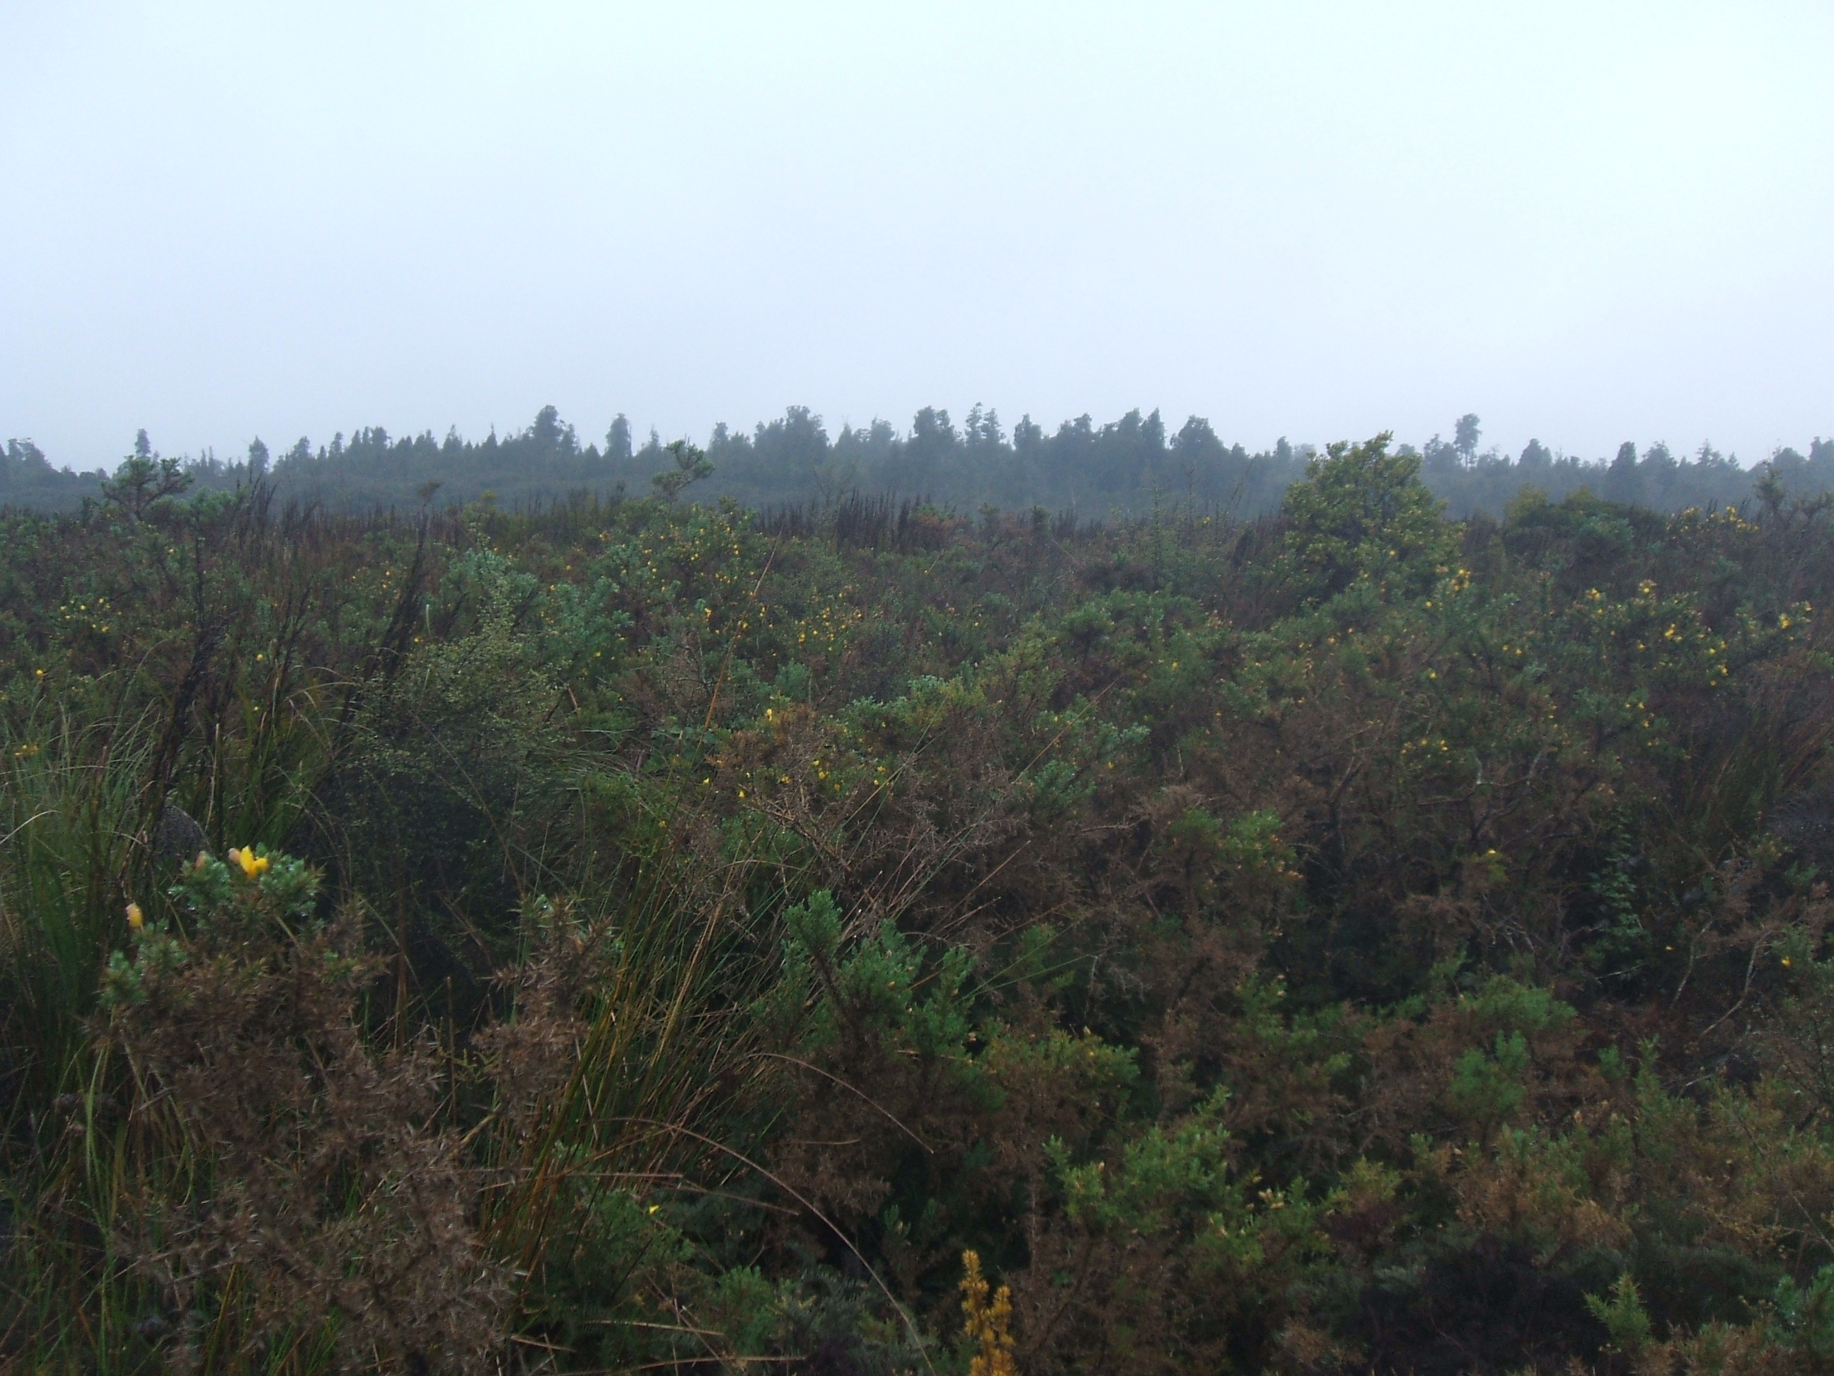

photo 2. E1452015, N5267472 Location 2. Looking N.

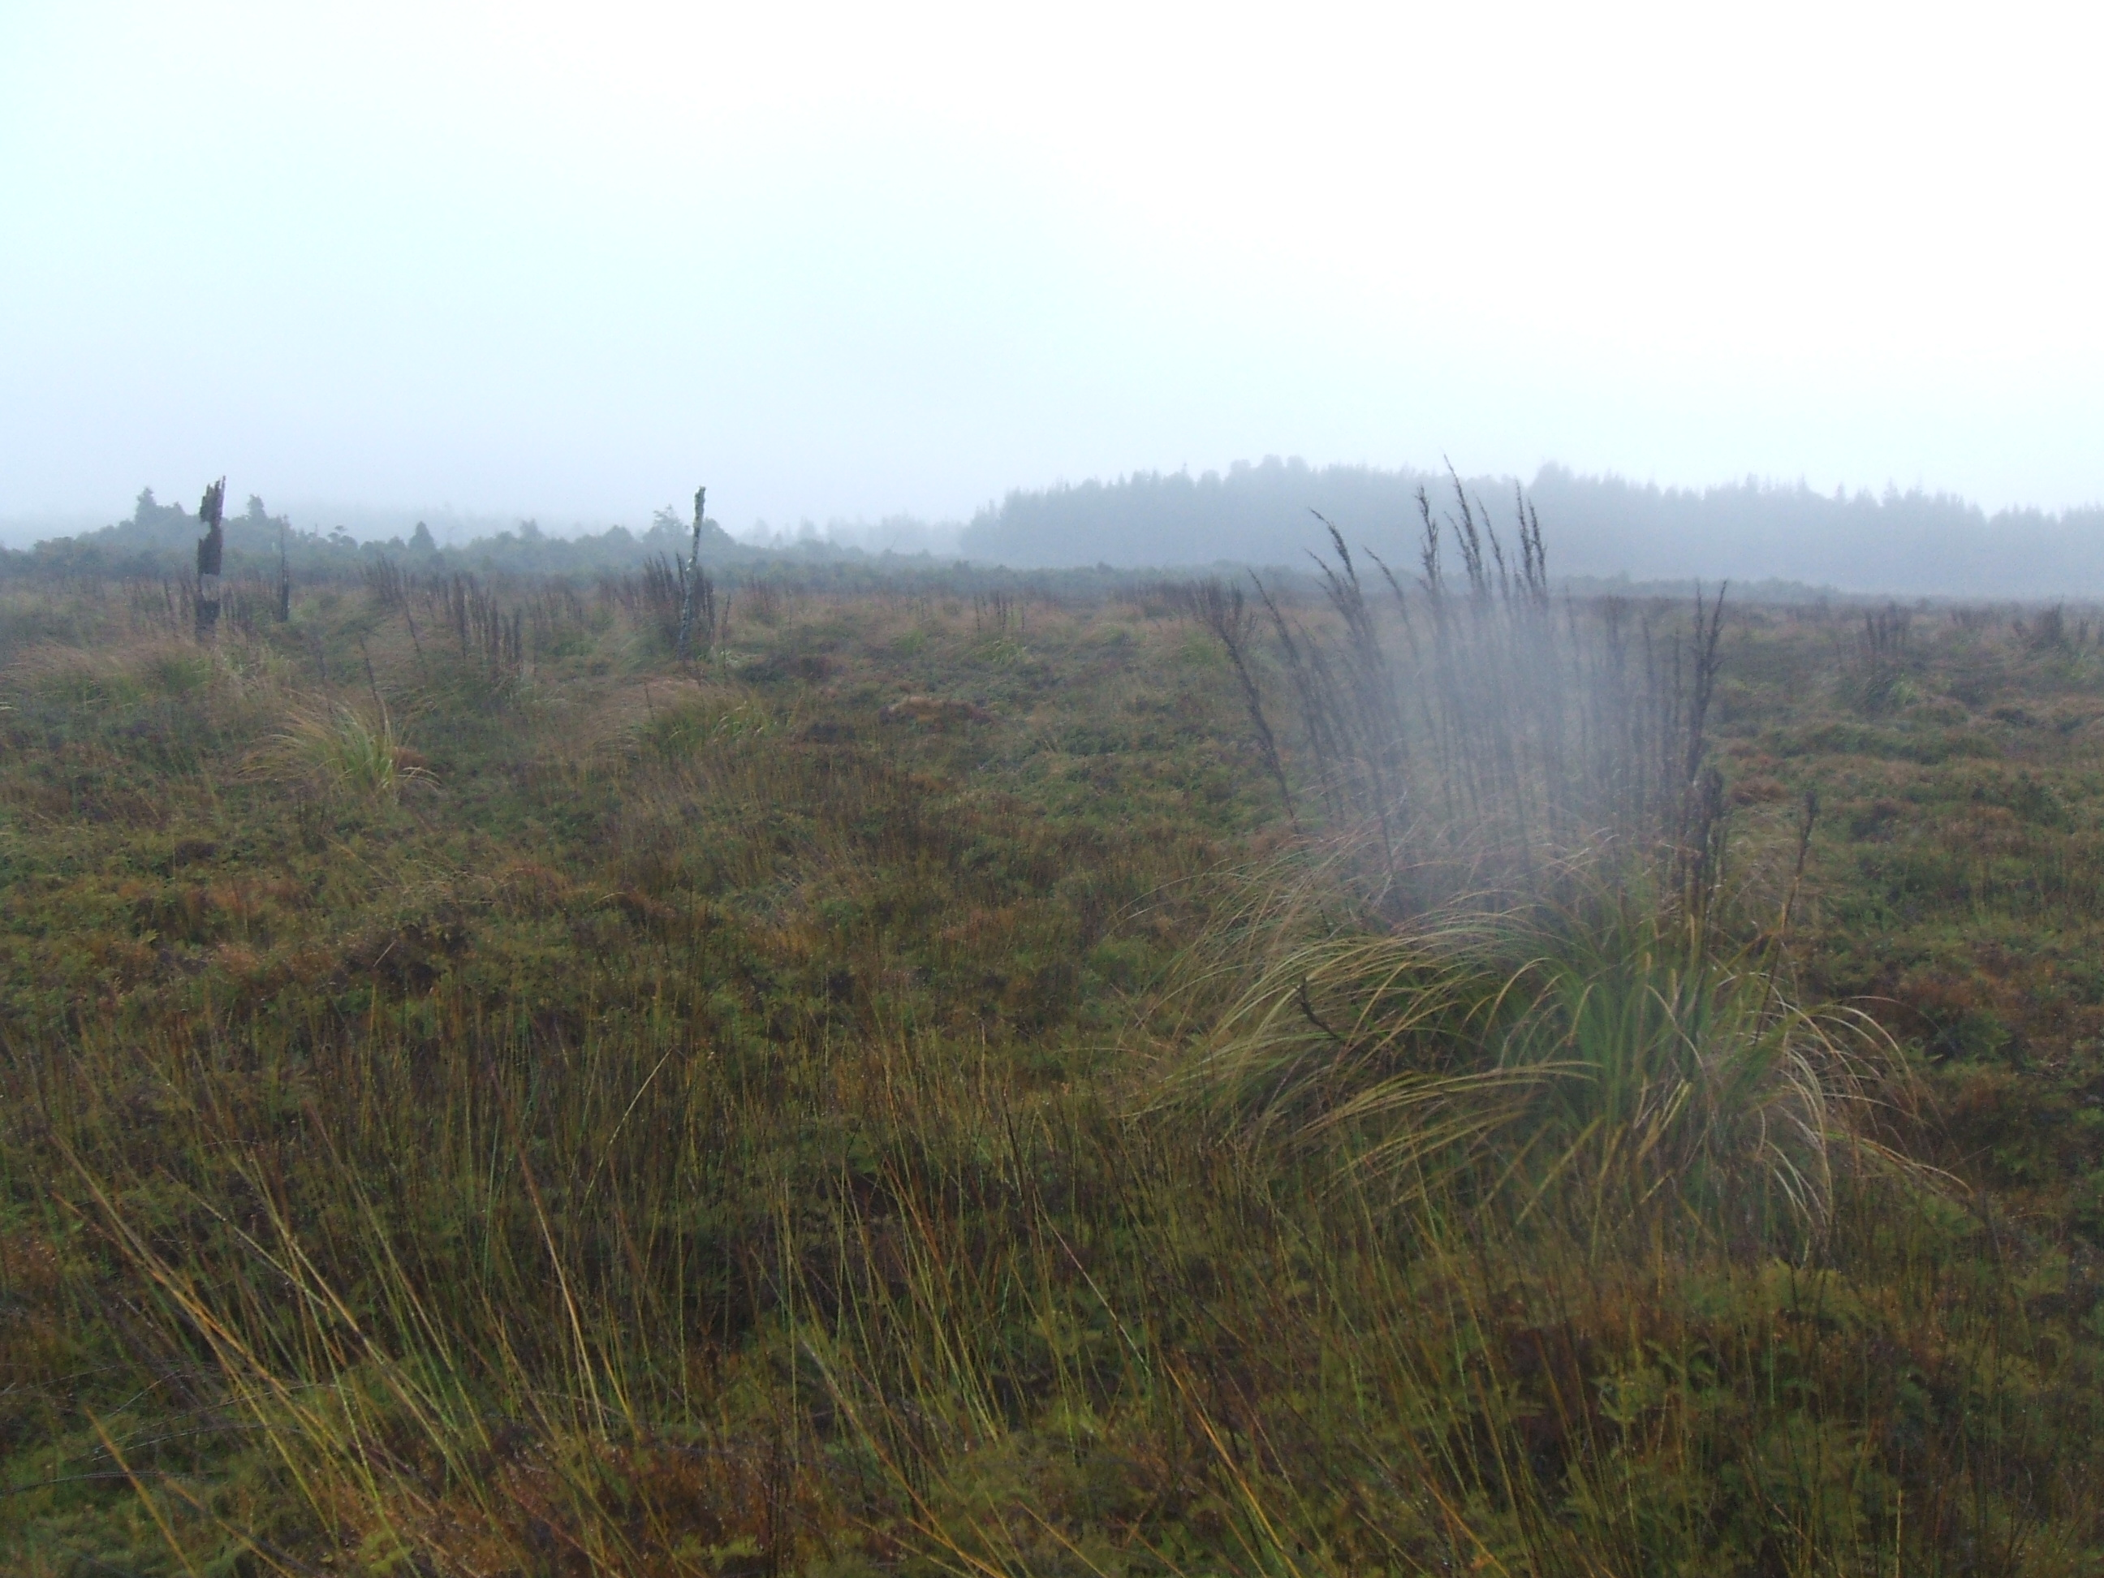

photo 1. E1452021, N5267495 Location 3. Looking W.

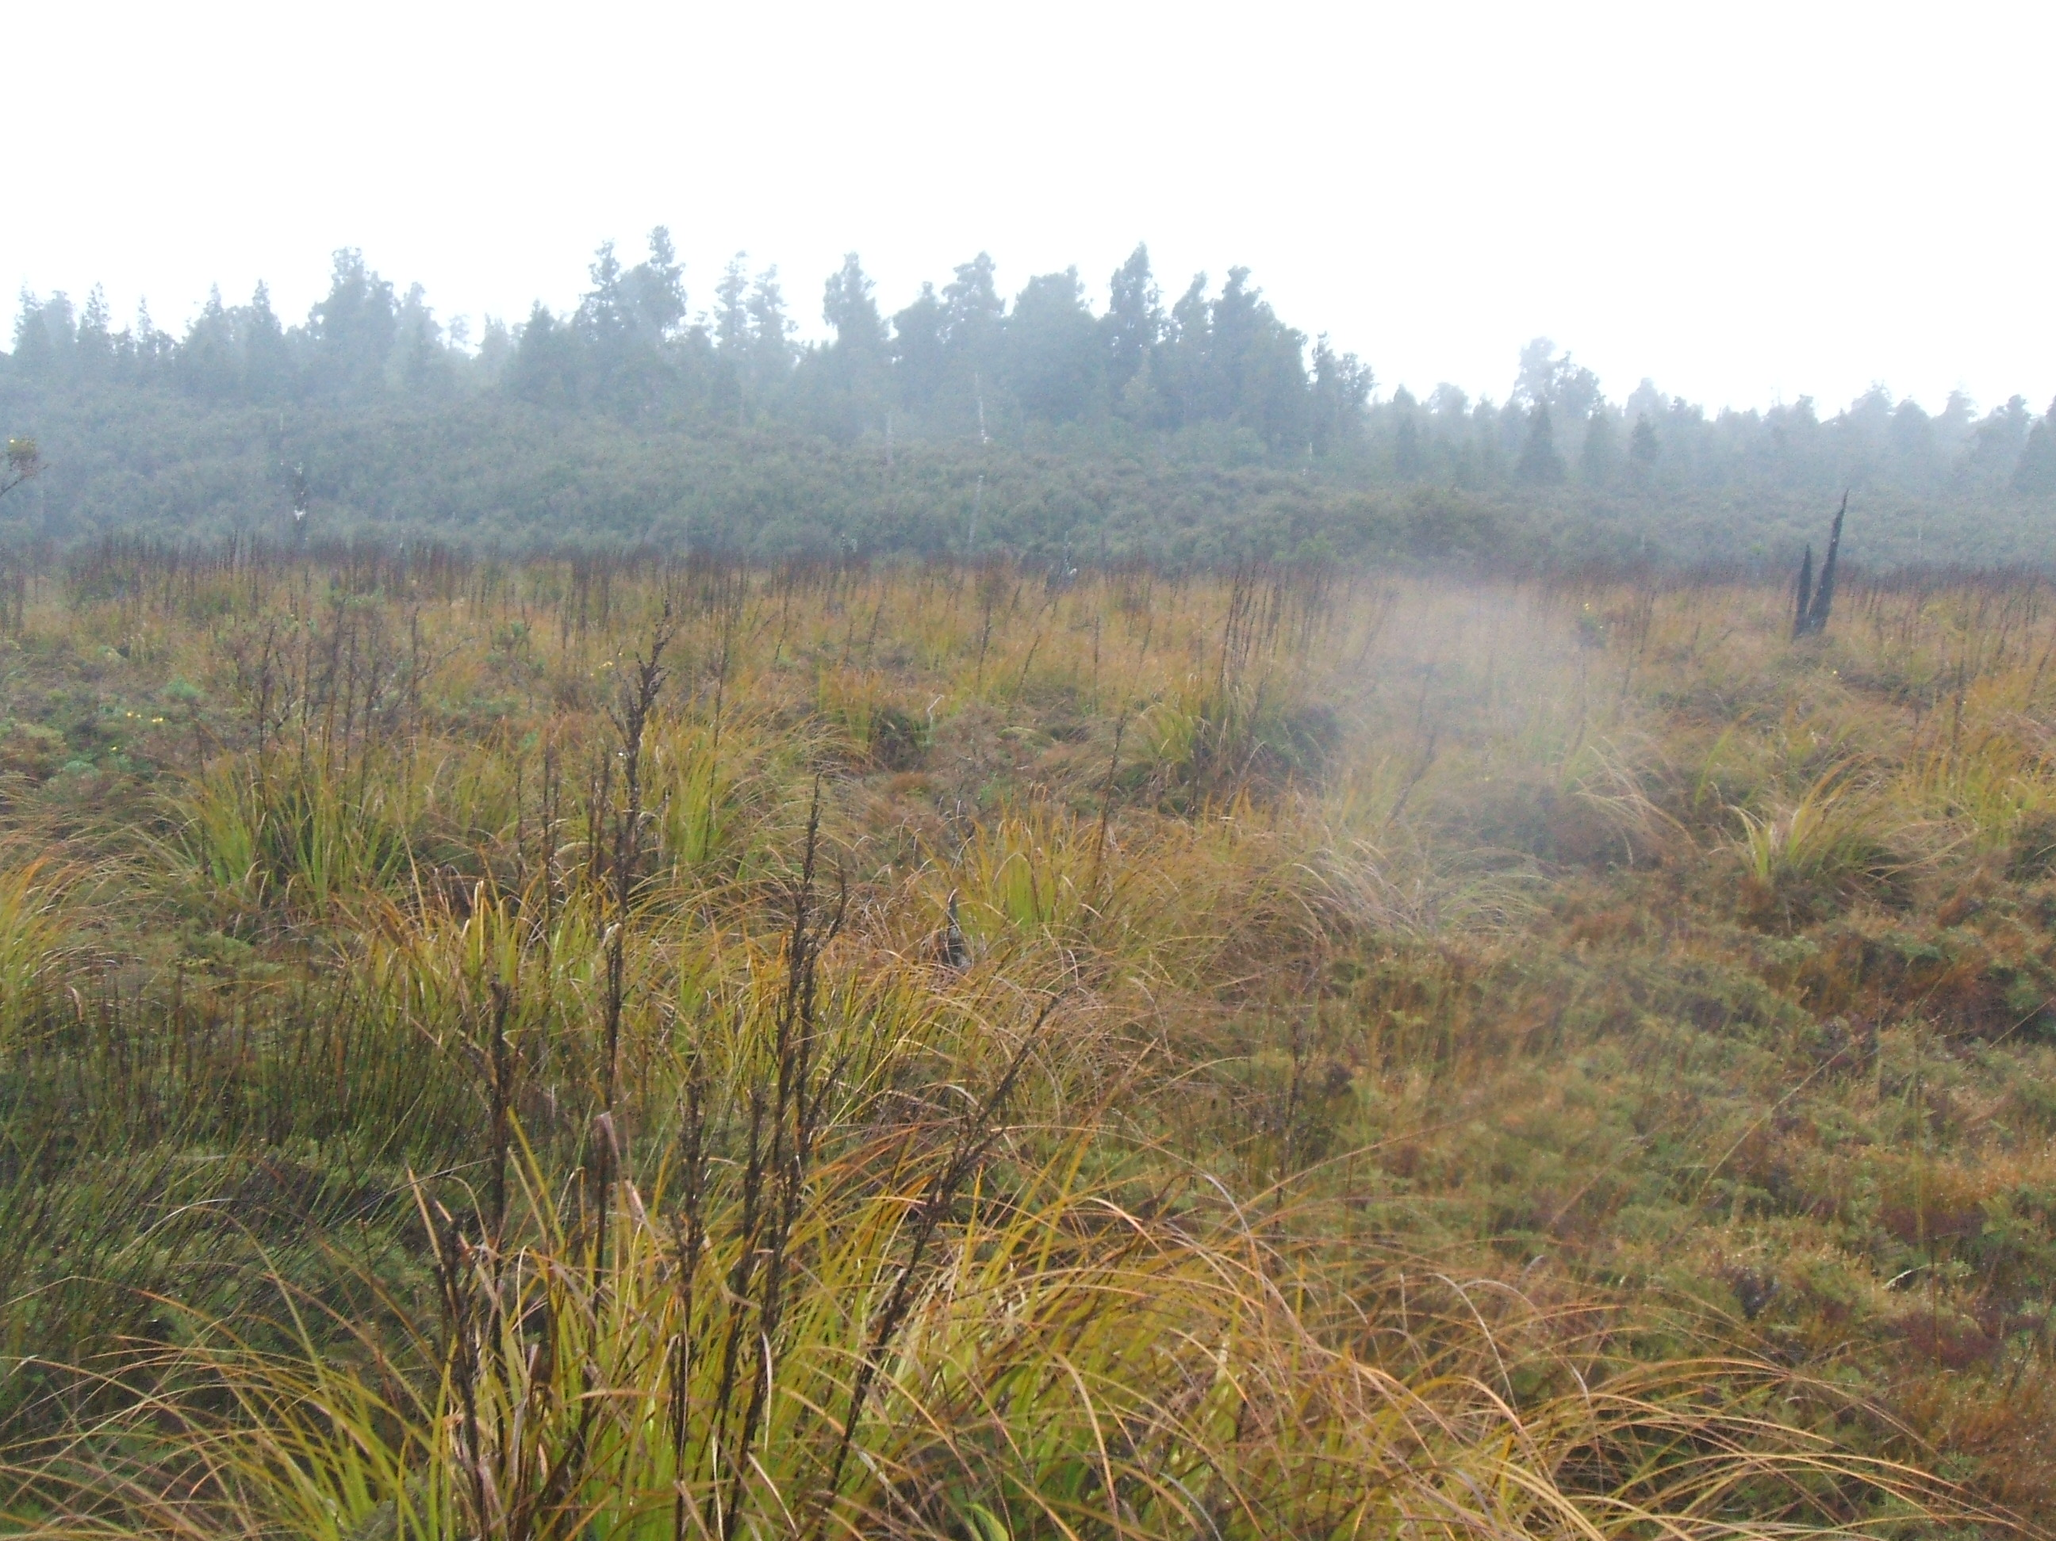

photo 3. E1452021, N5267495 Location 3. Looking N.

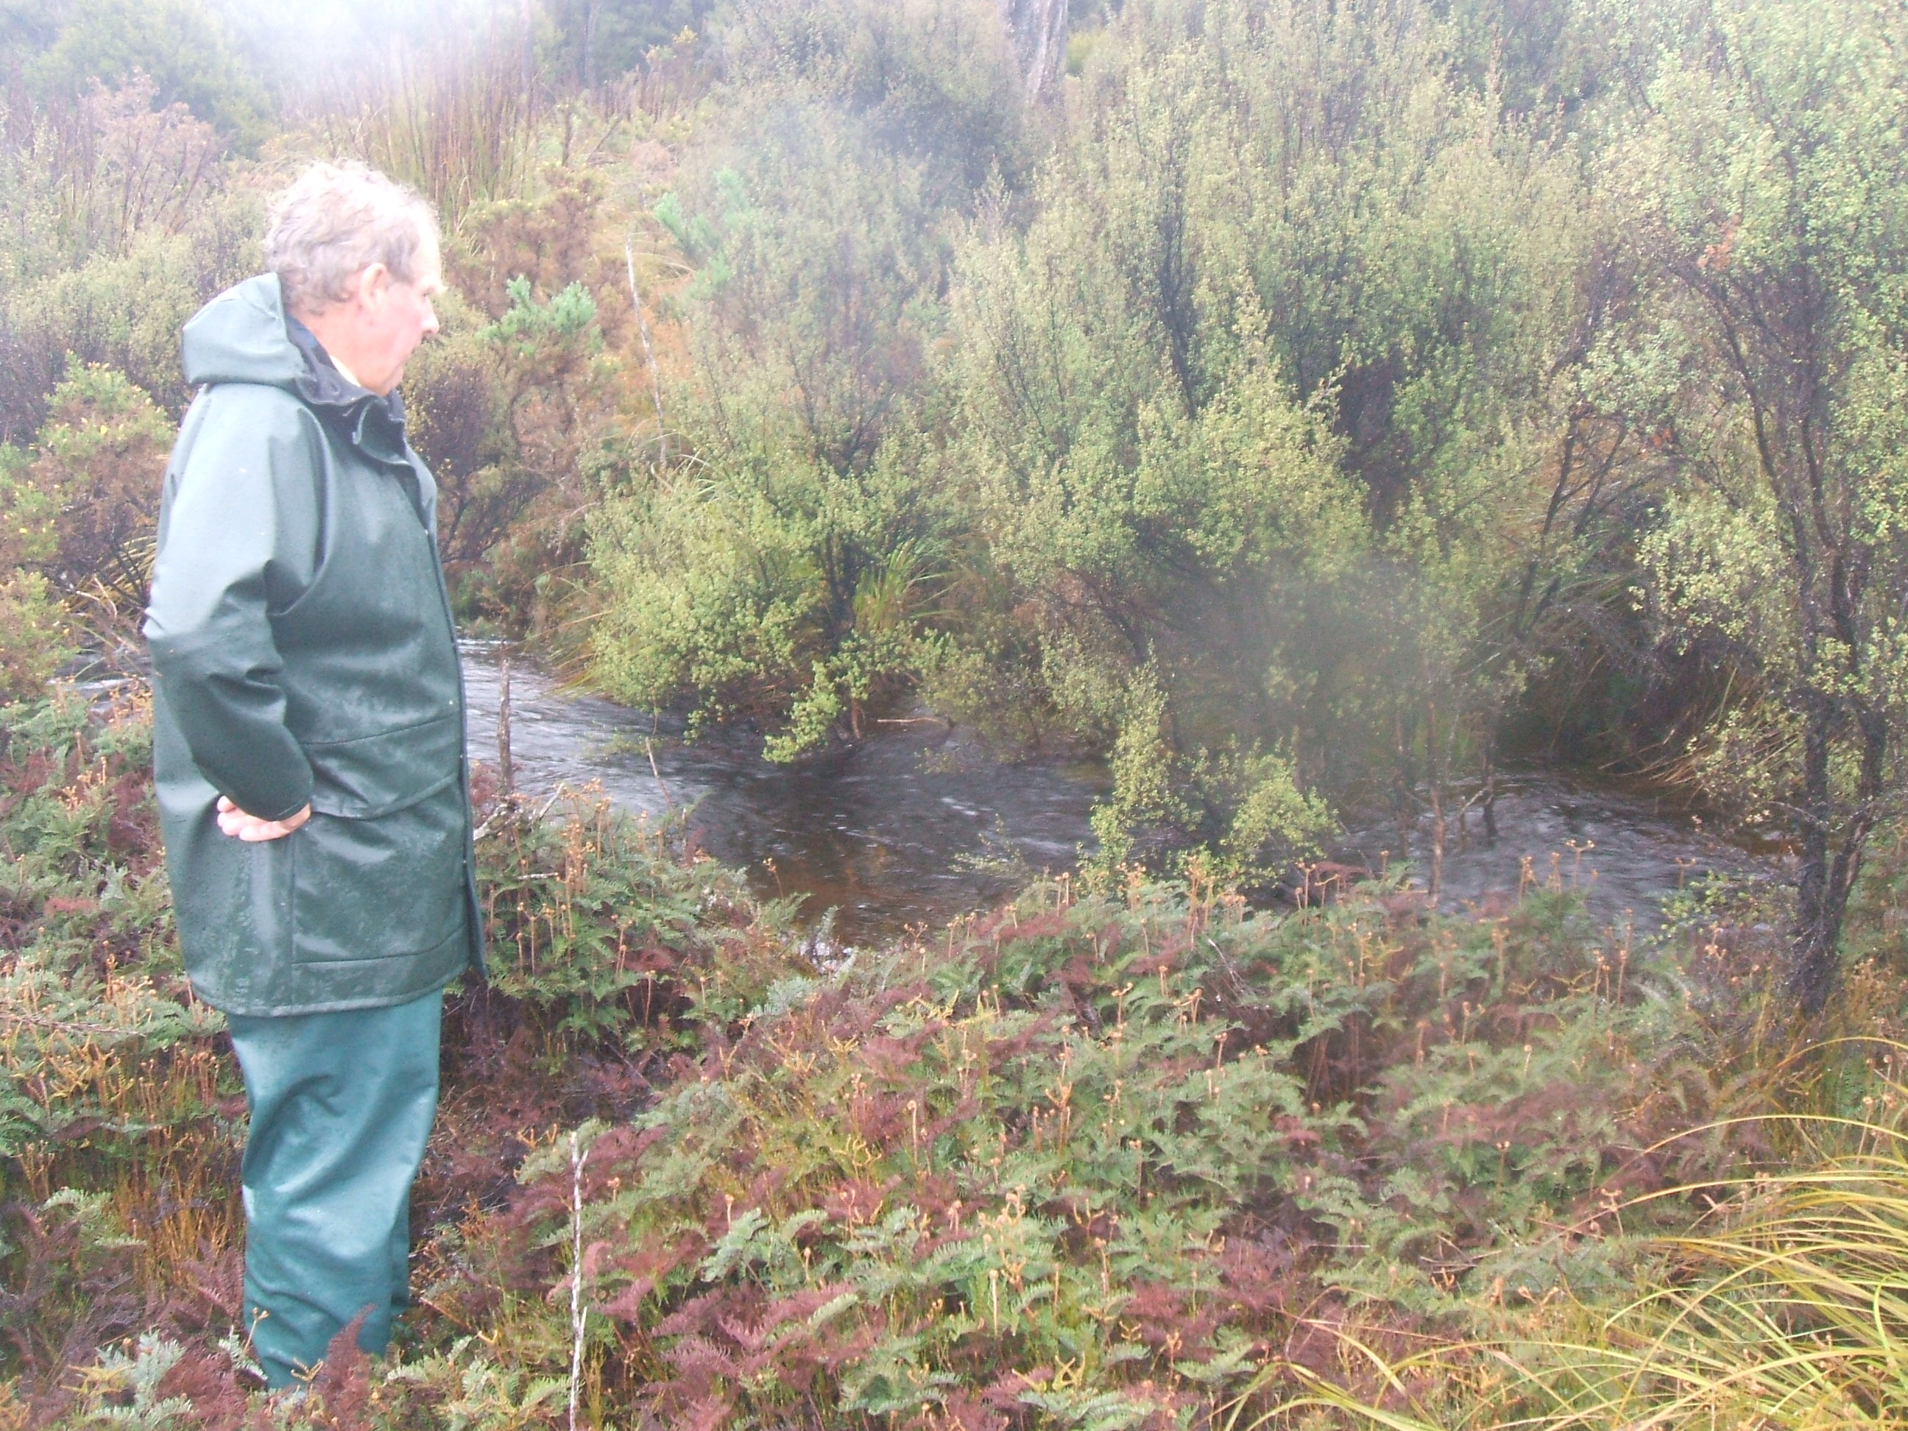

photo 1. E1451961, N5267768 Location 4. Kees, inspecting stream. Looking N.

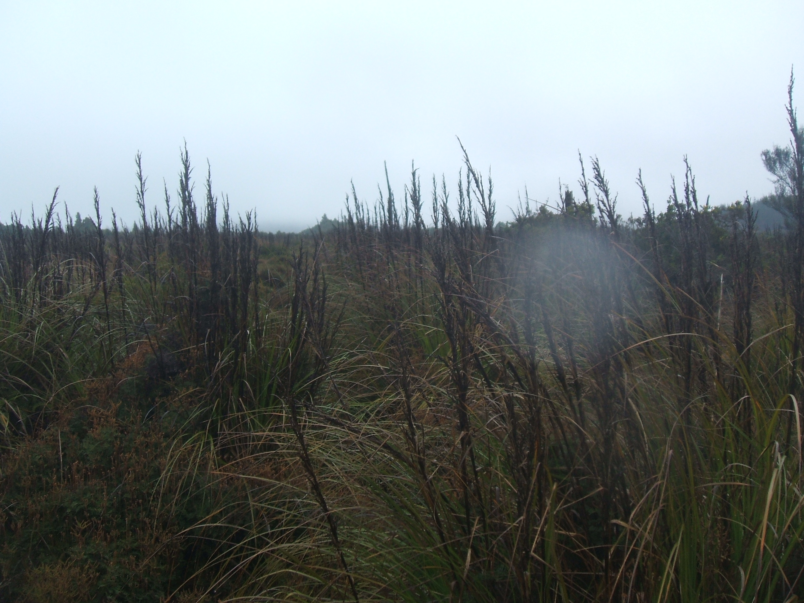

photo 2. E1451961, N5267768 Location 4. Looking N.

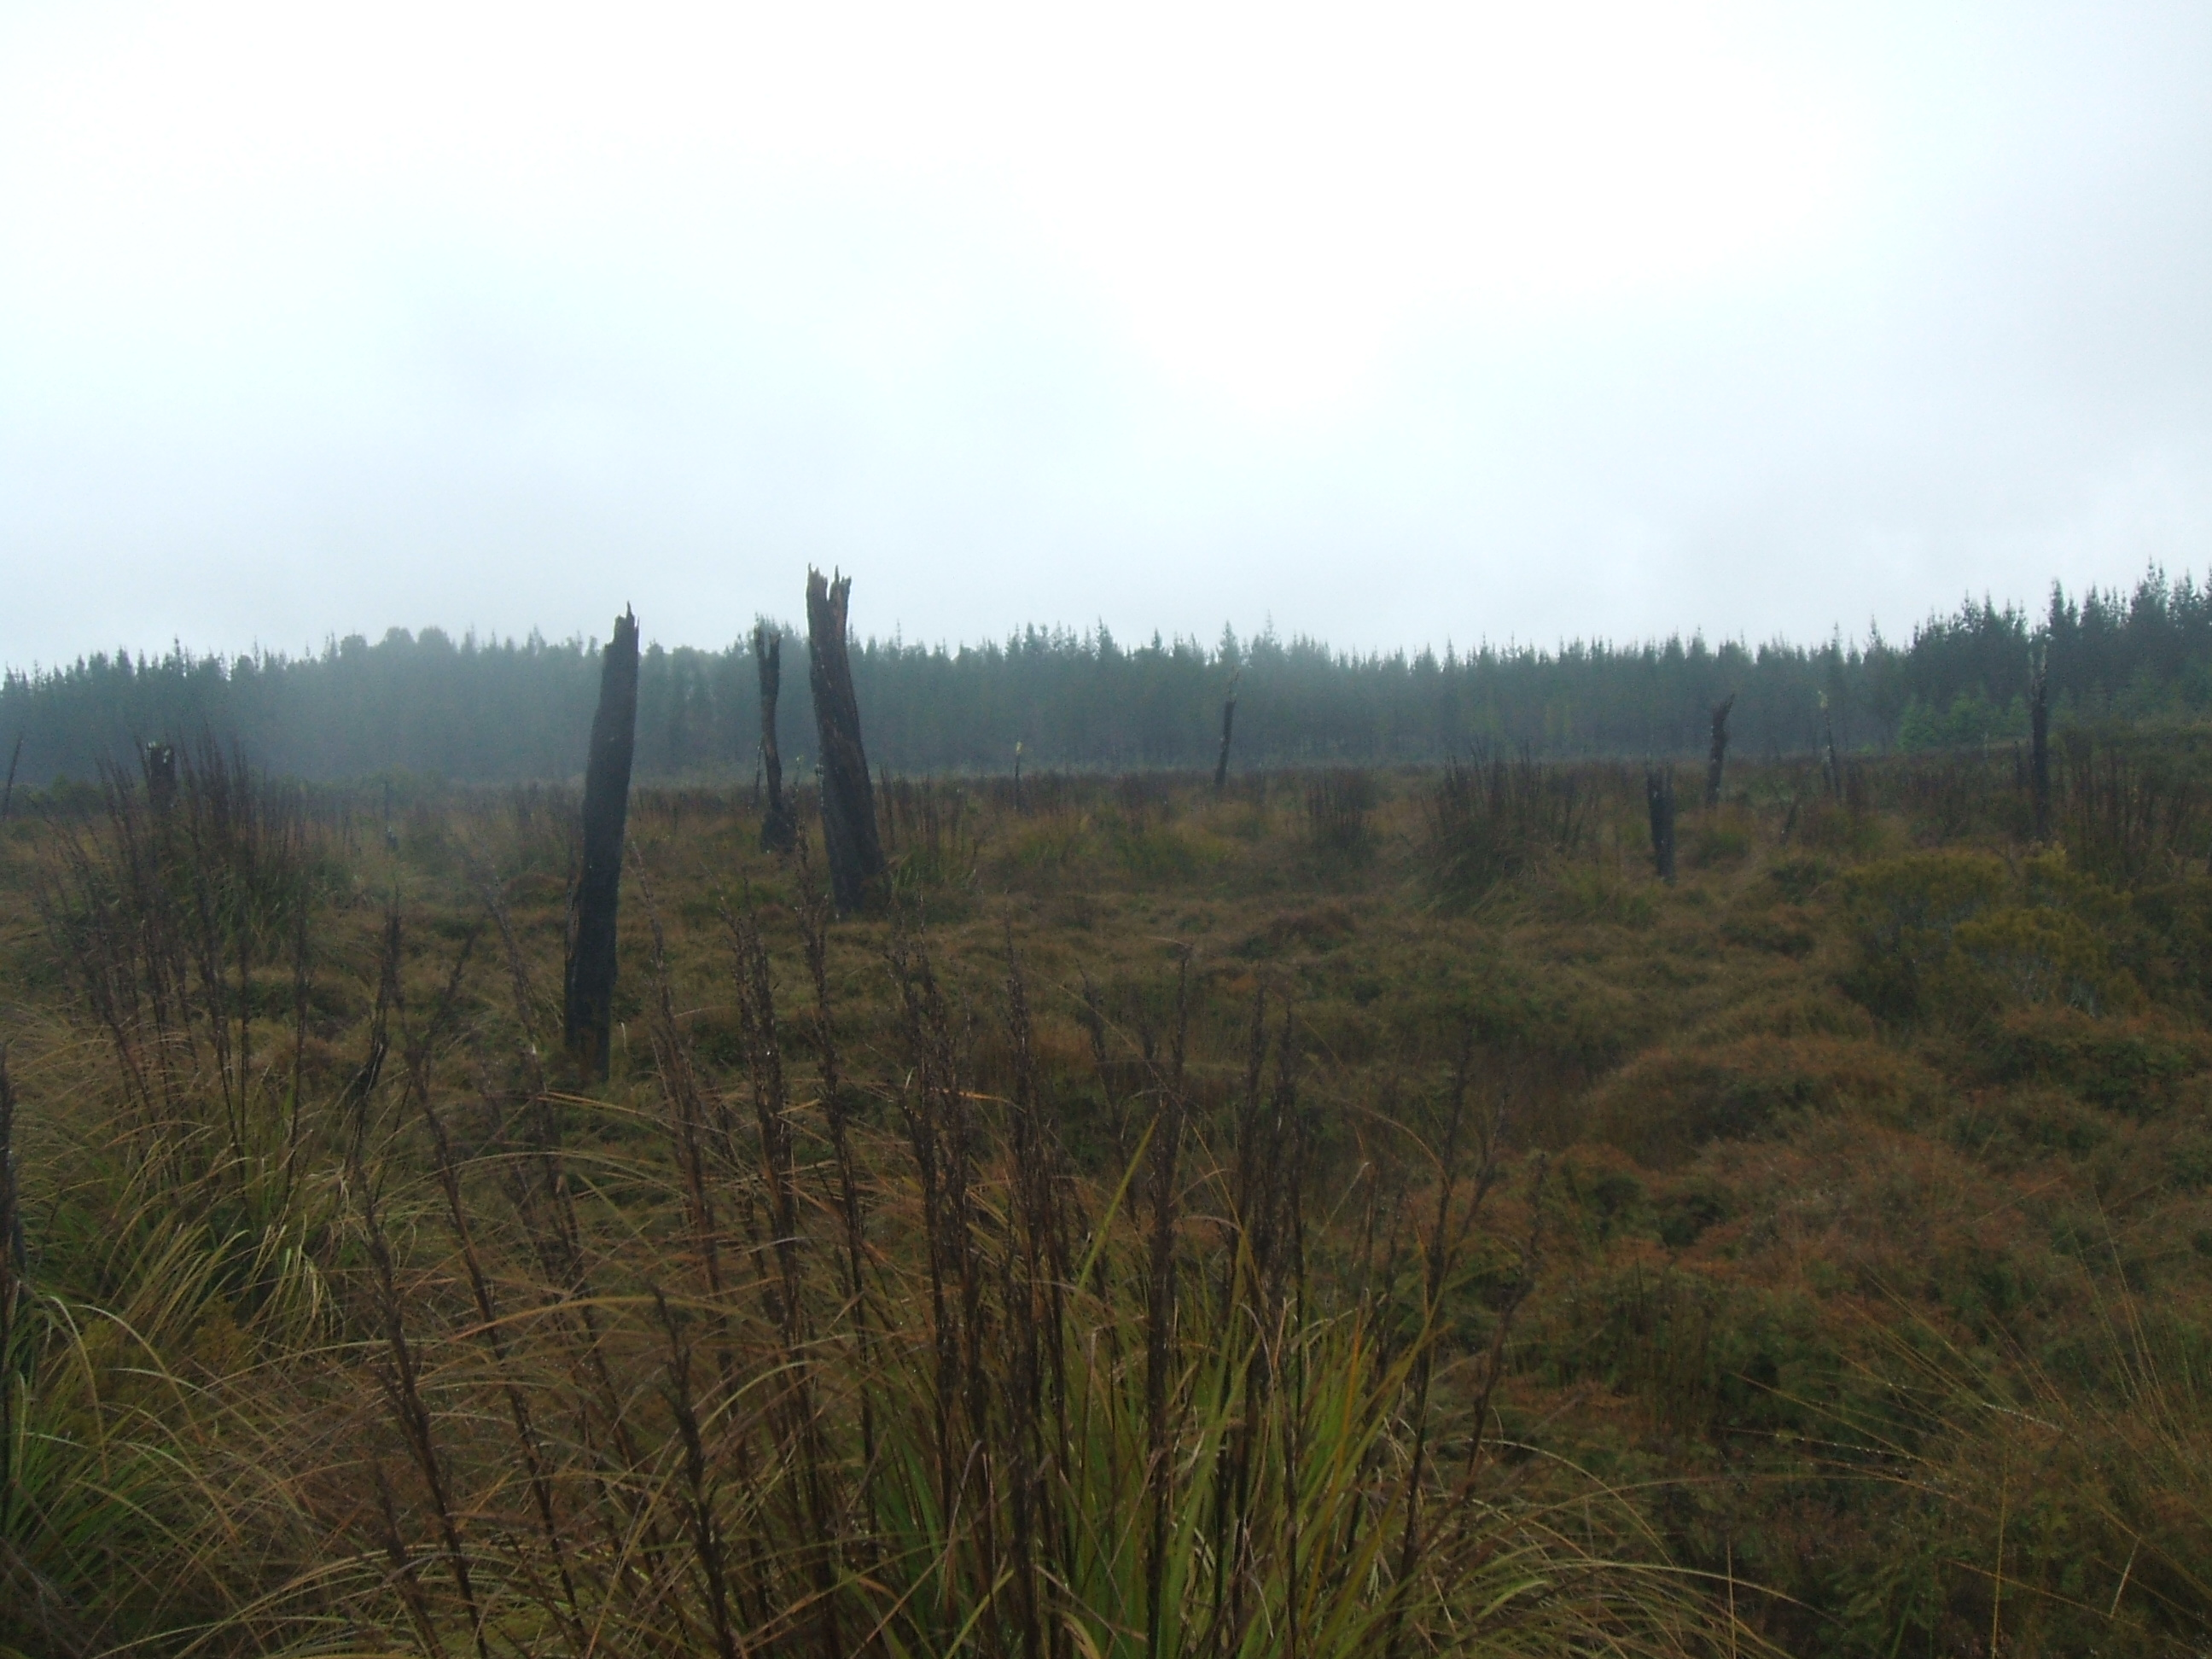

photo 1. E1451770, N527763 Location 5. Looking W.

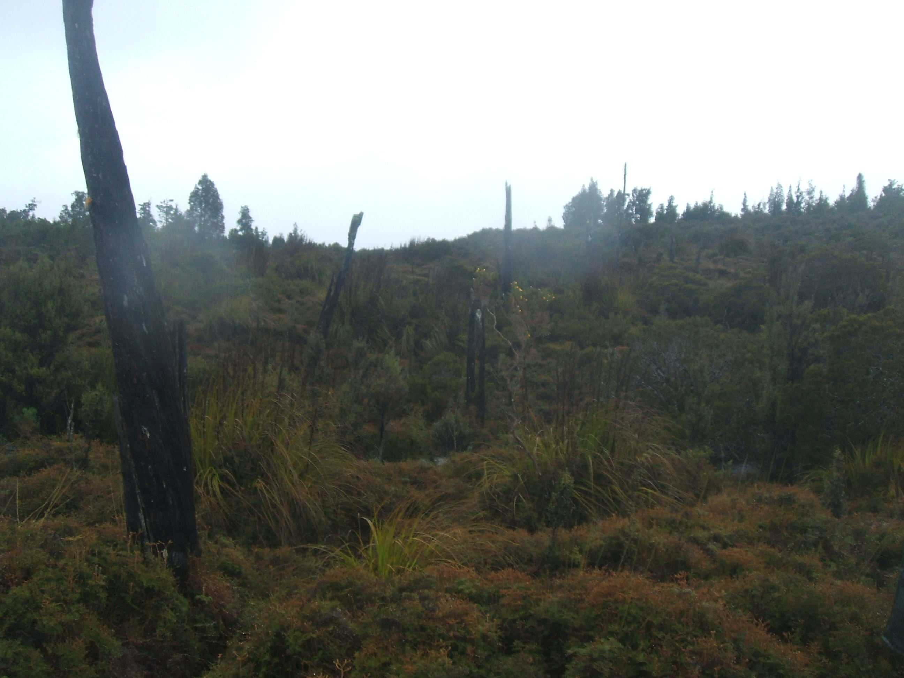

photo 2. E1451770, N527763 Location 5. Looking N.

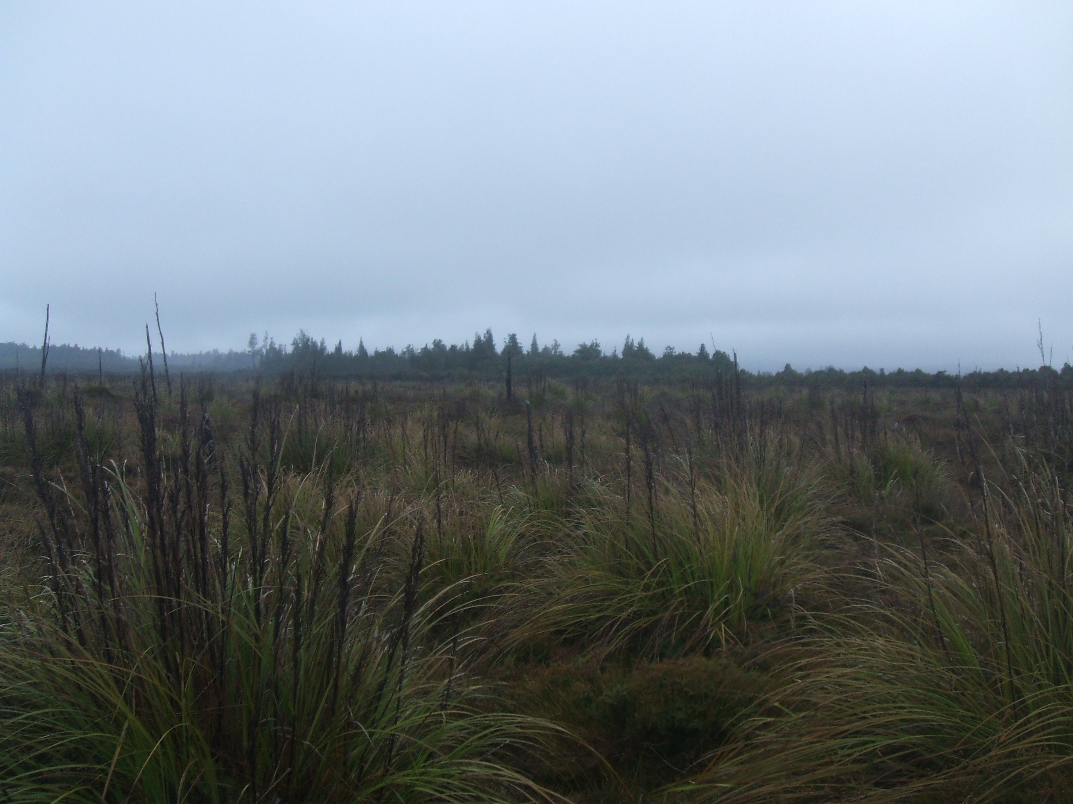

photo 1. E1451691, N5267756 Location 6. Looking E.

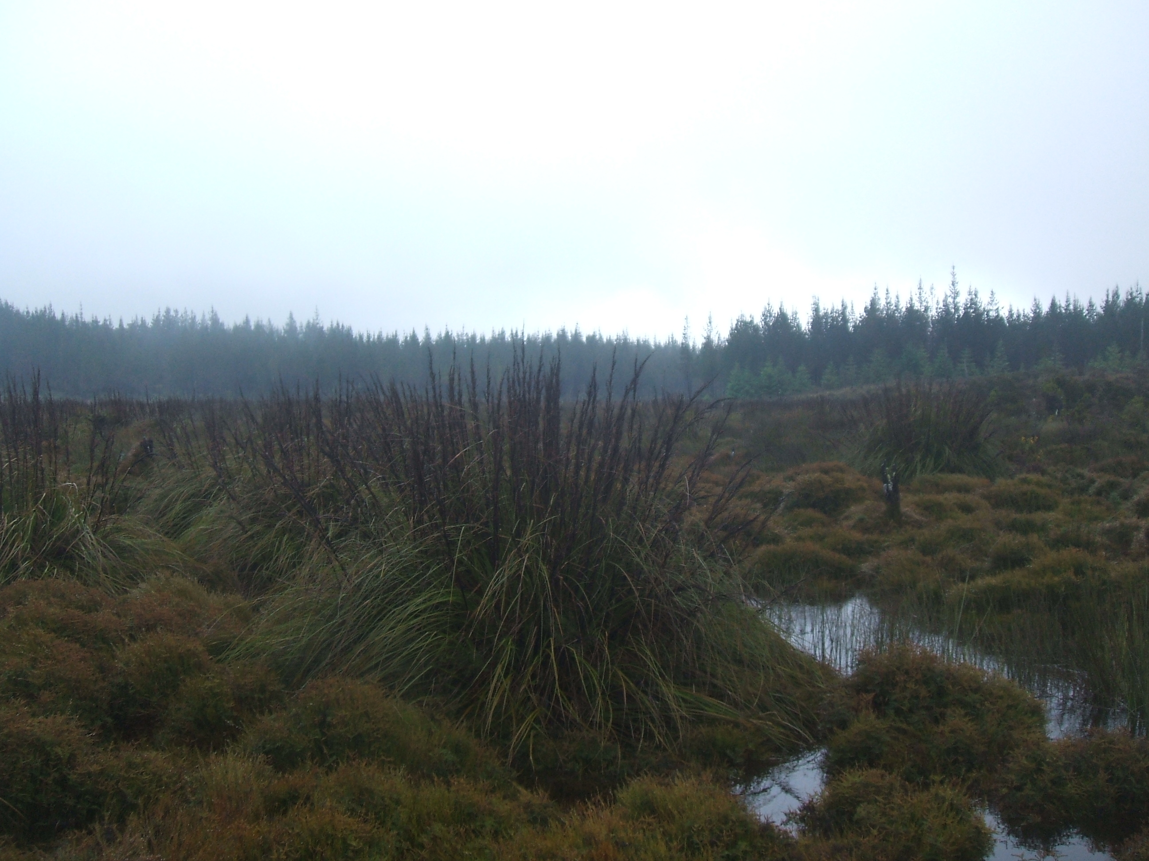

photo 2. E1451691, N5267756 Location 6. Looking W.

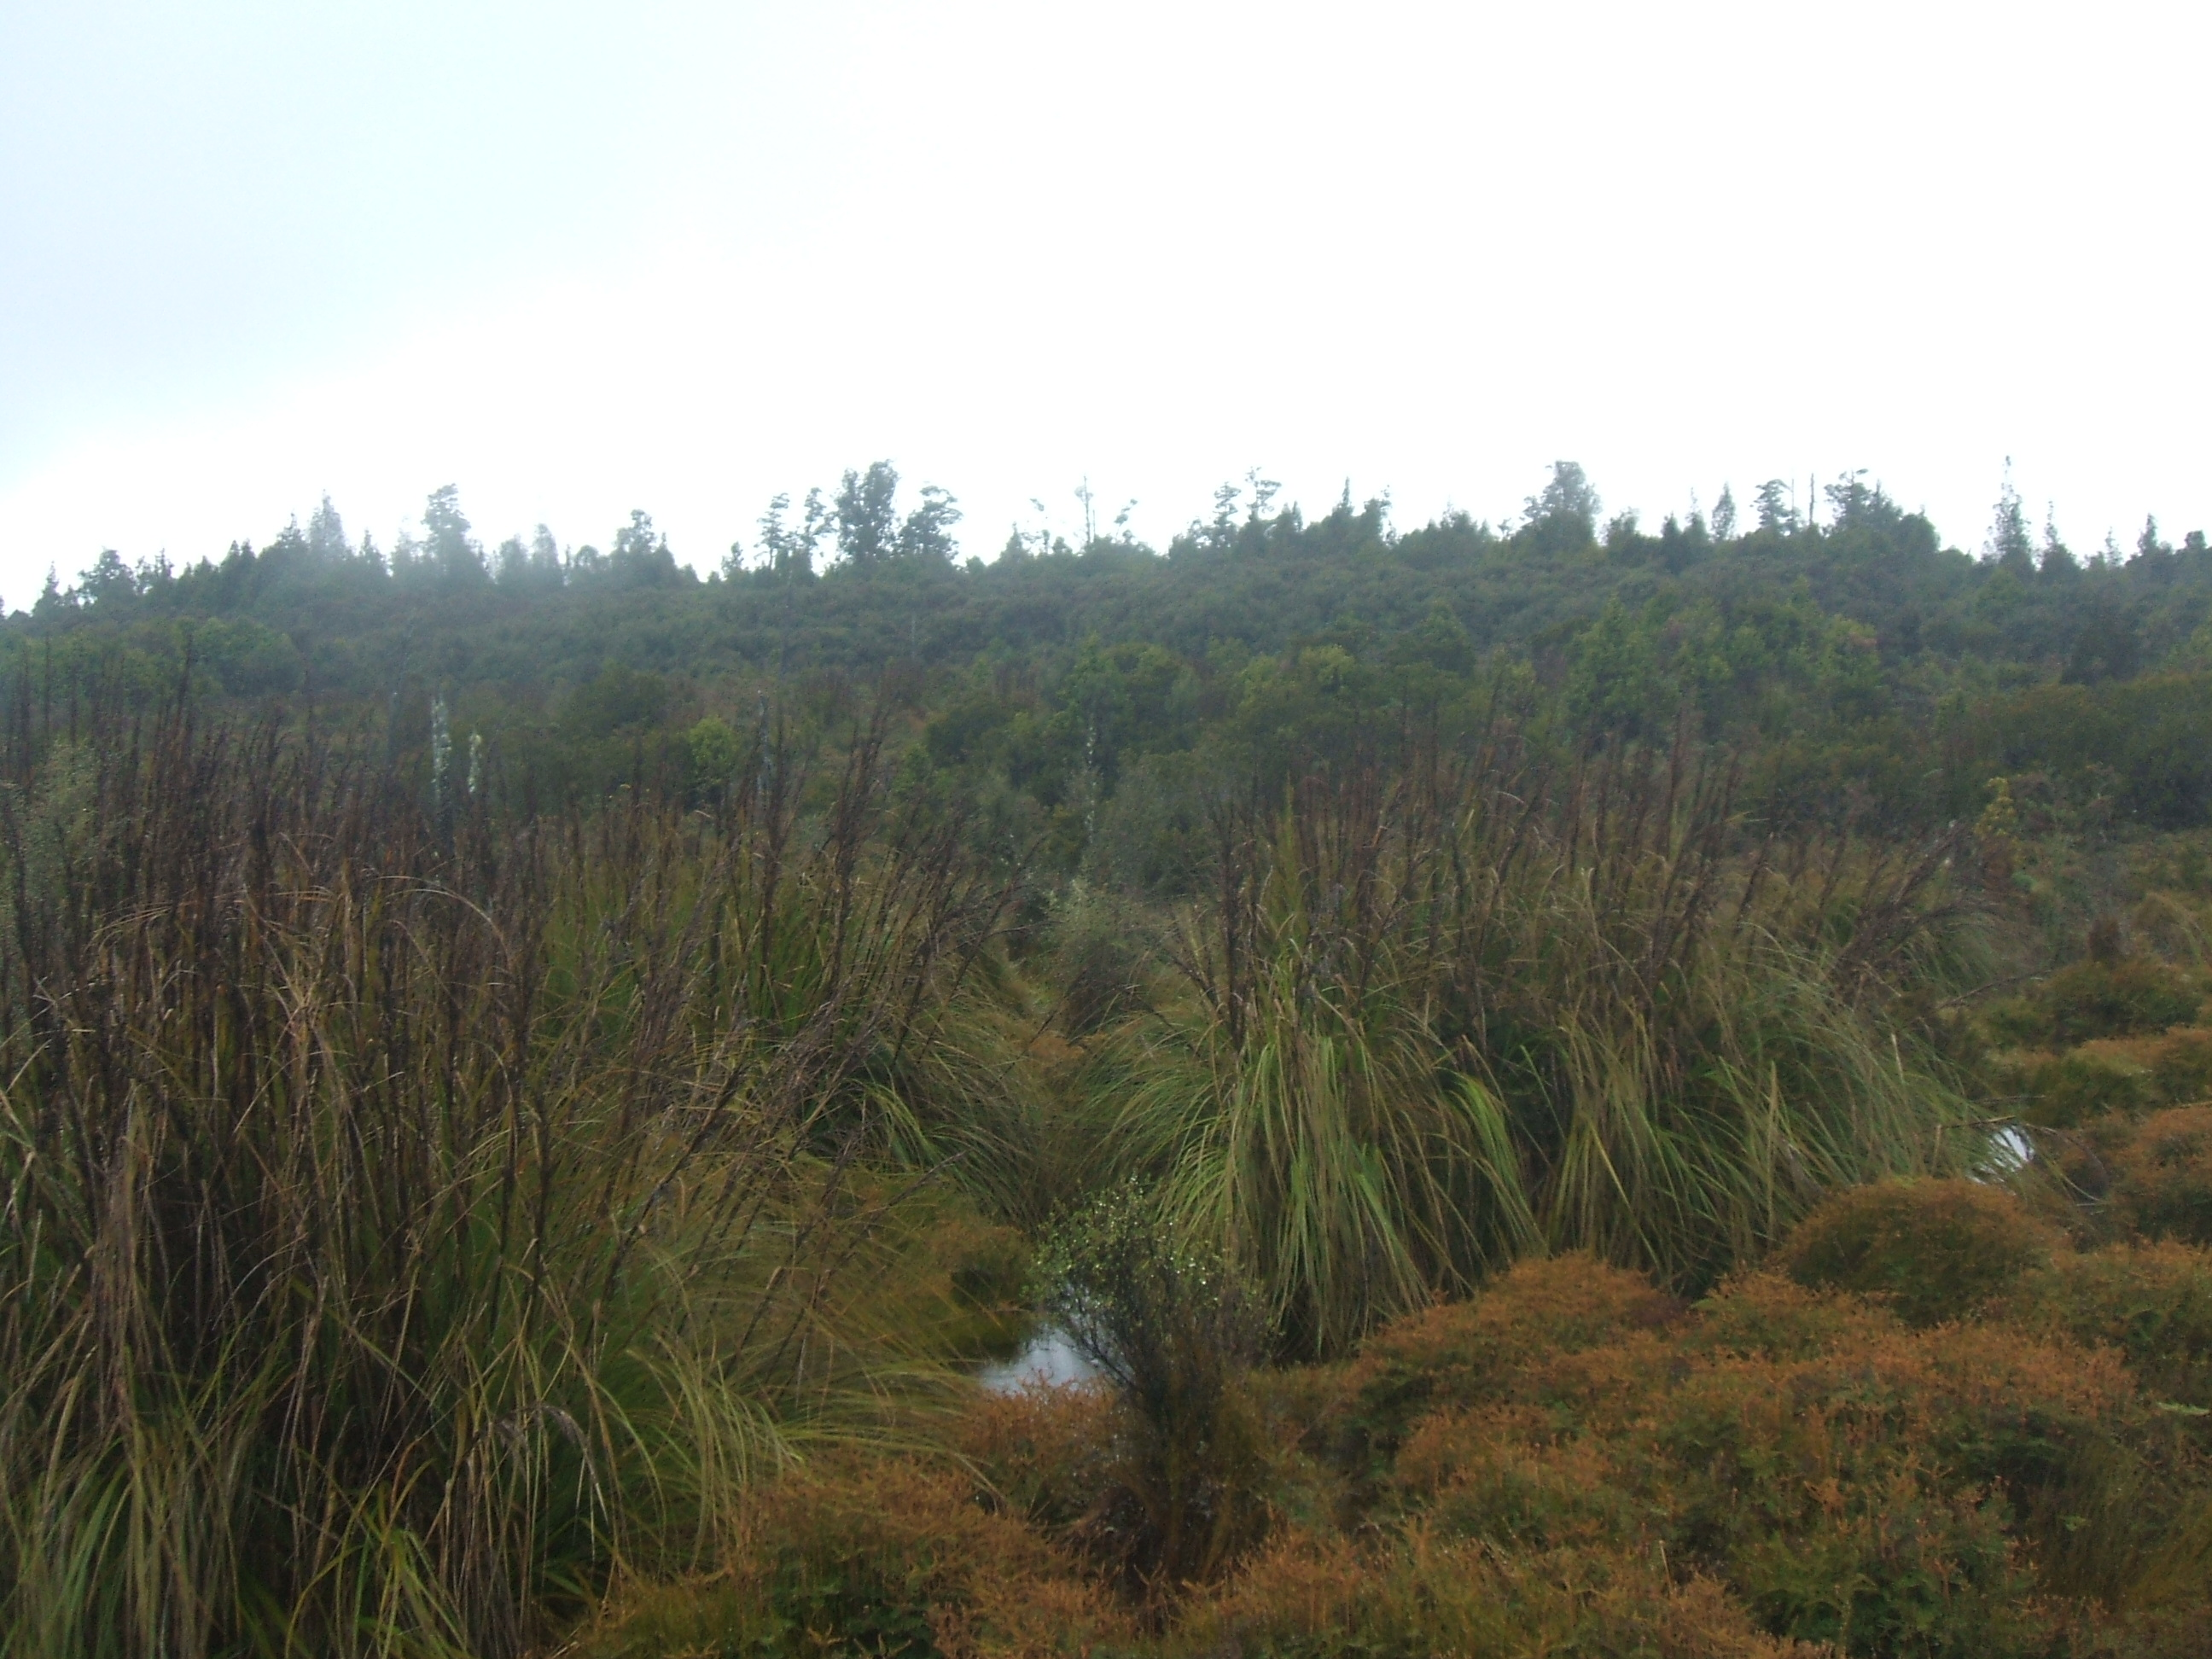

photo 3. E1451691, N5267756 Location 6. Looking N.

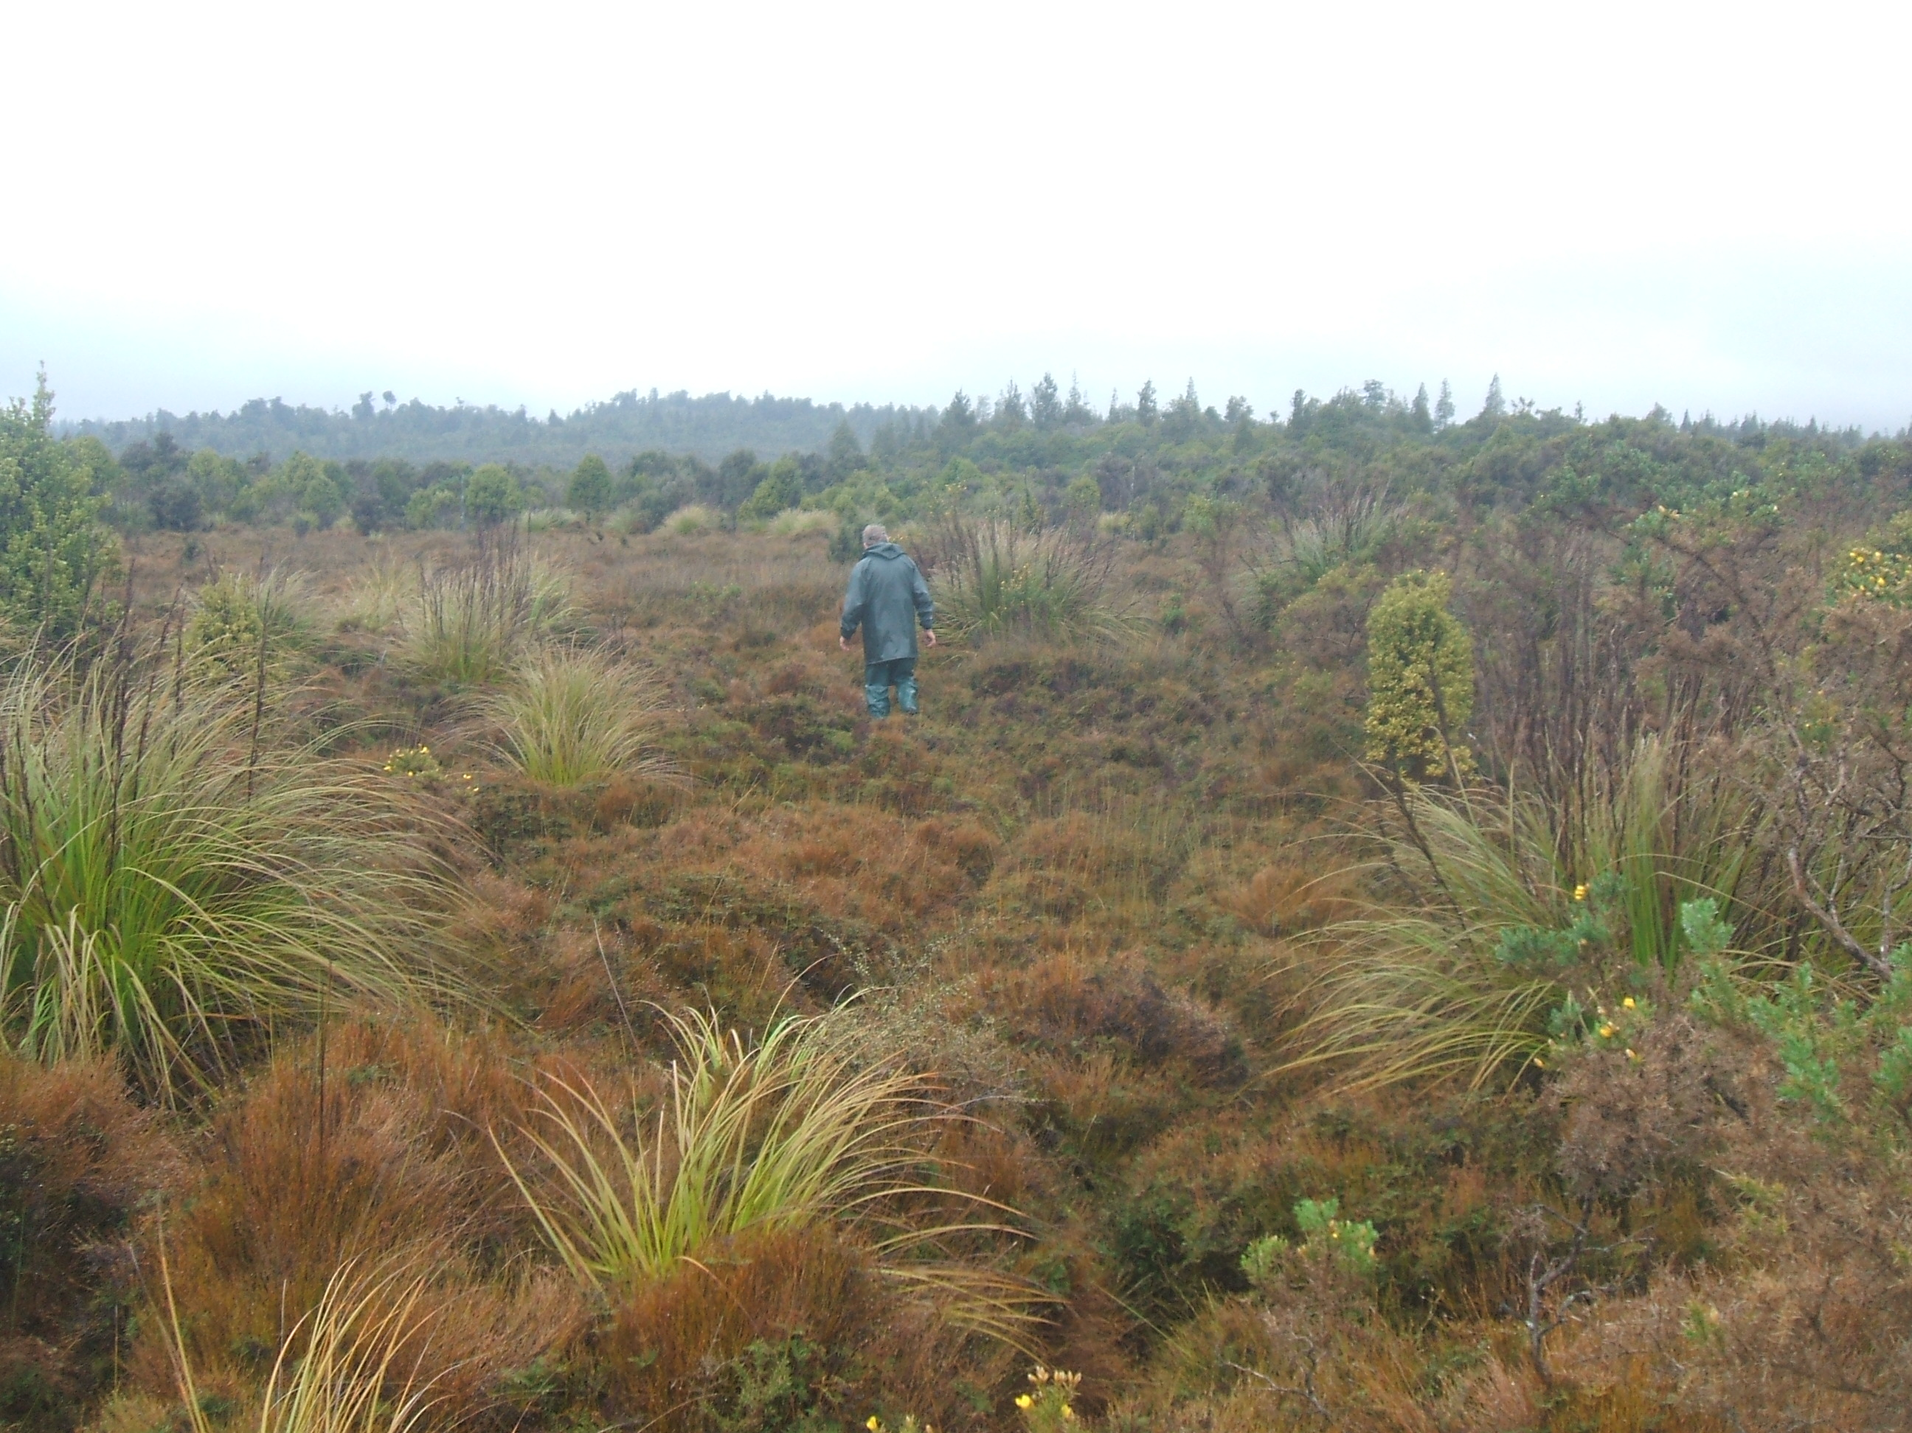

E1451624, N5267583 Location 7. Looking S.

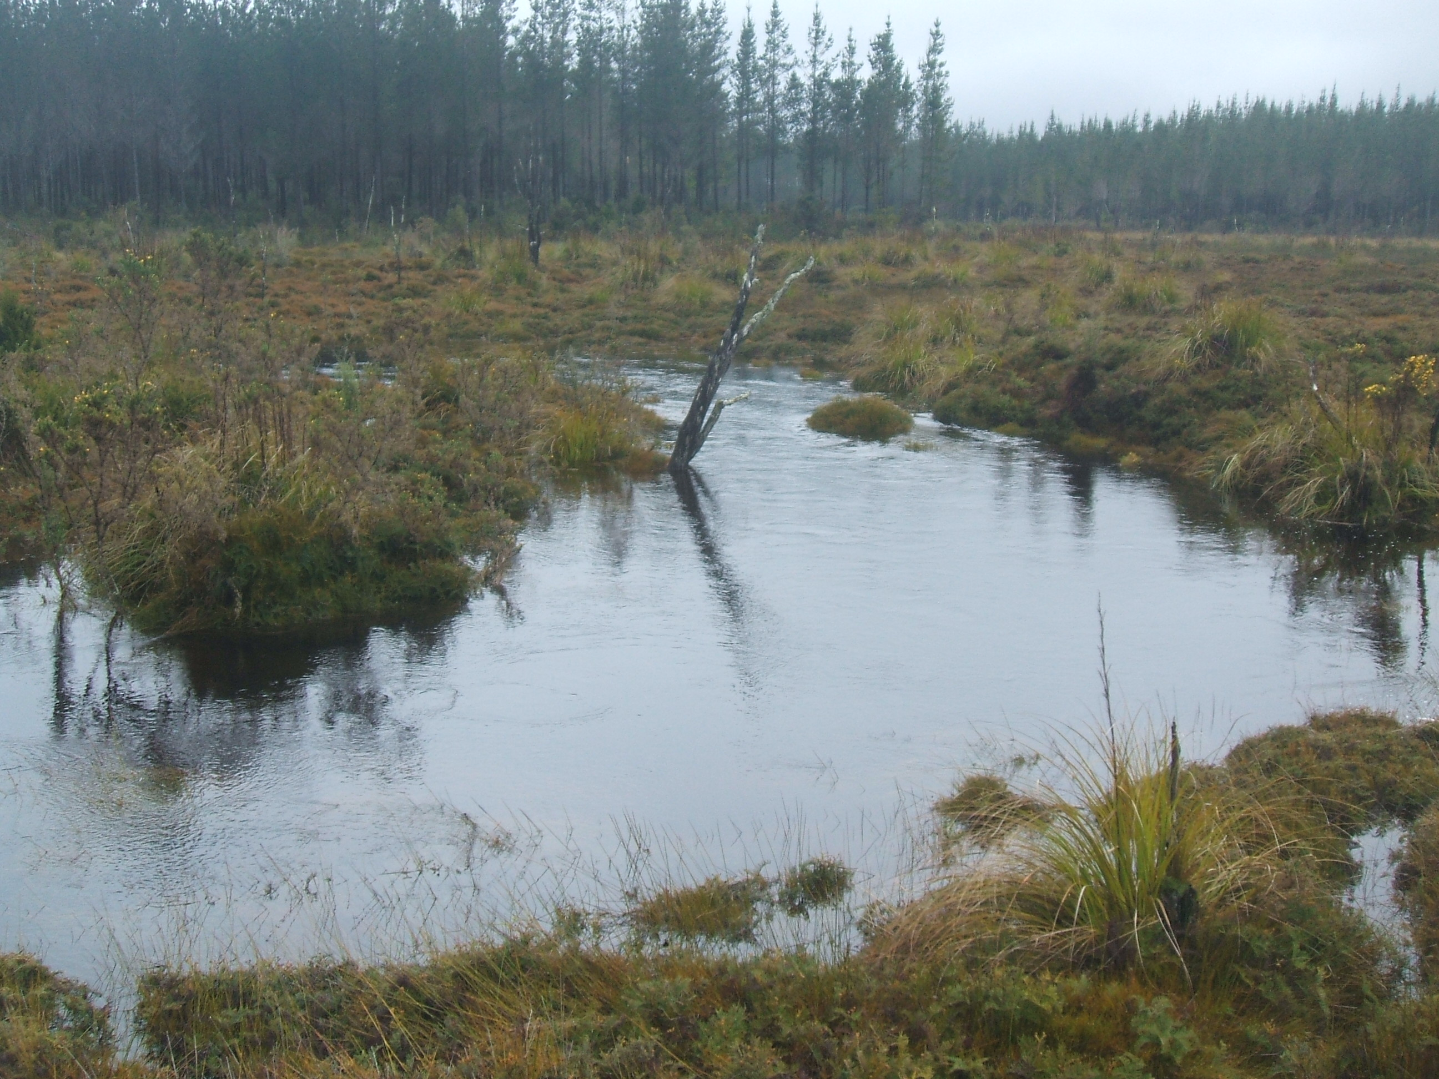

E1451375, N5267569 Location 8. Whiskey Creek. Looking N.

