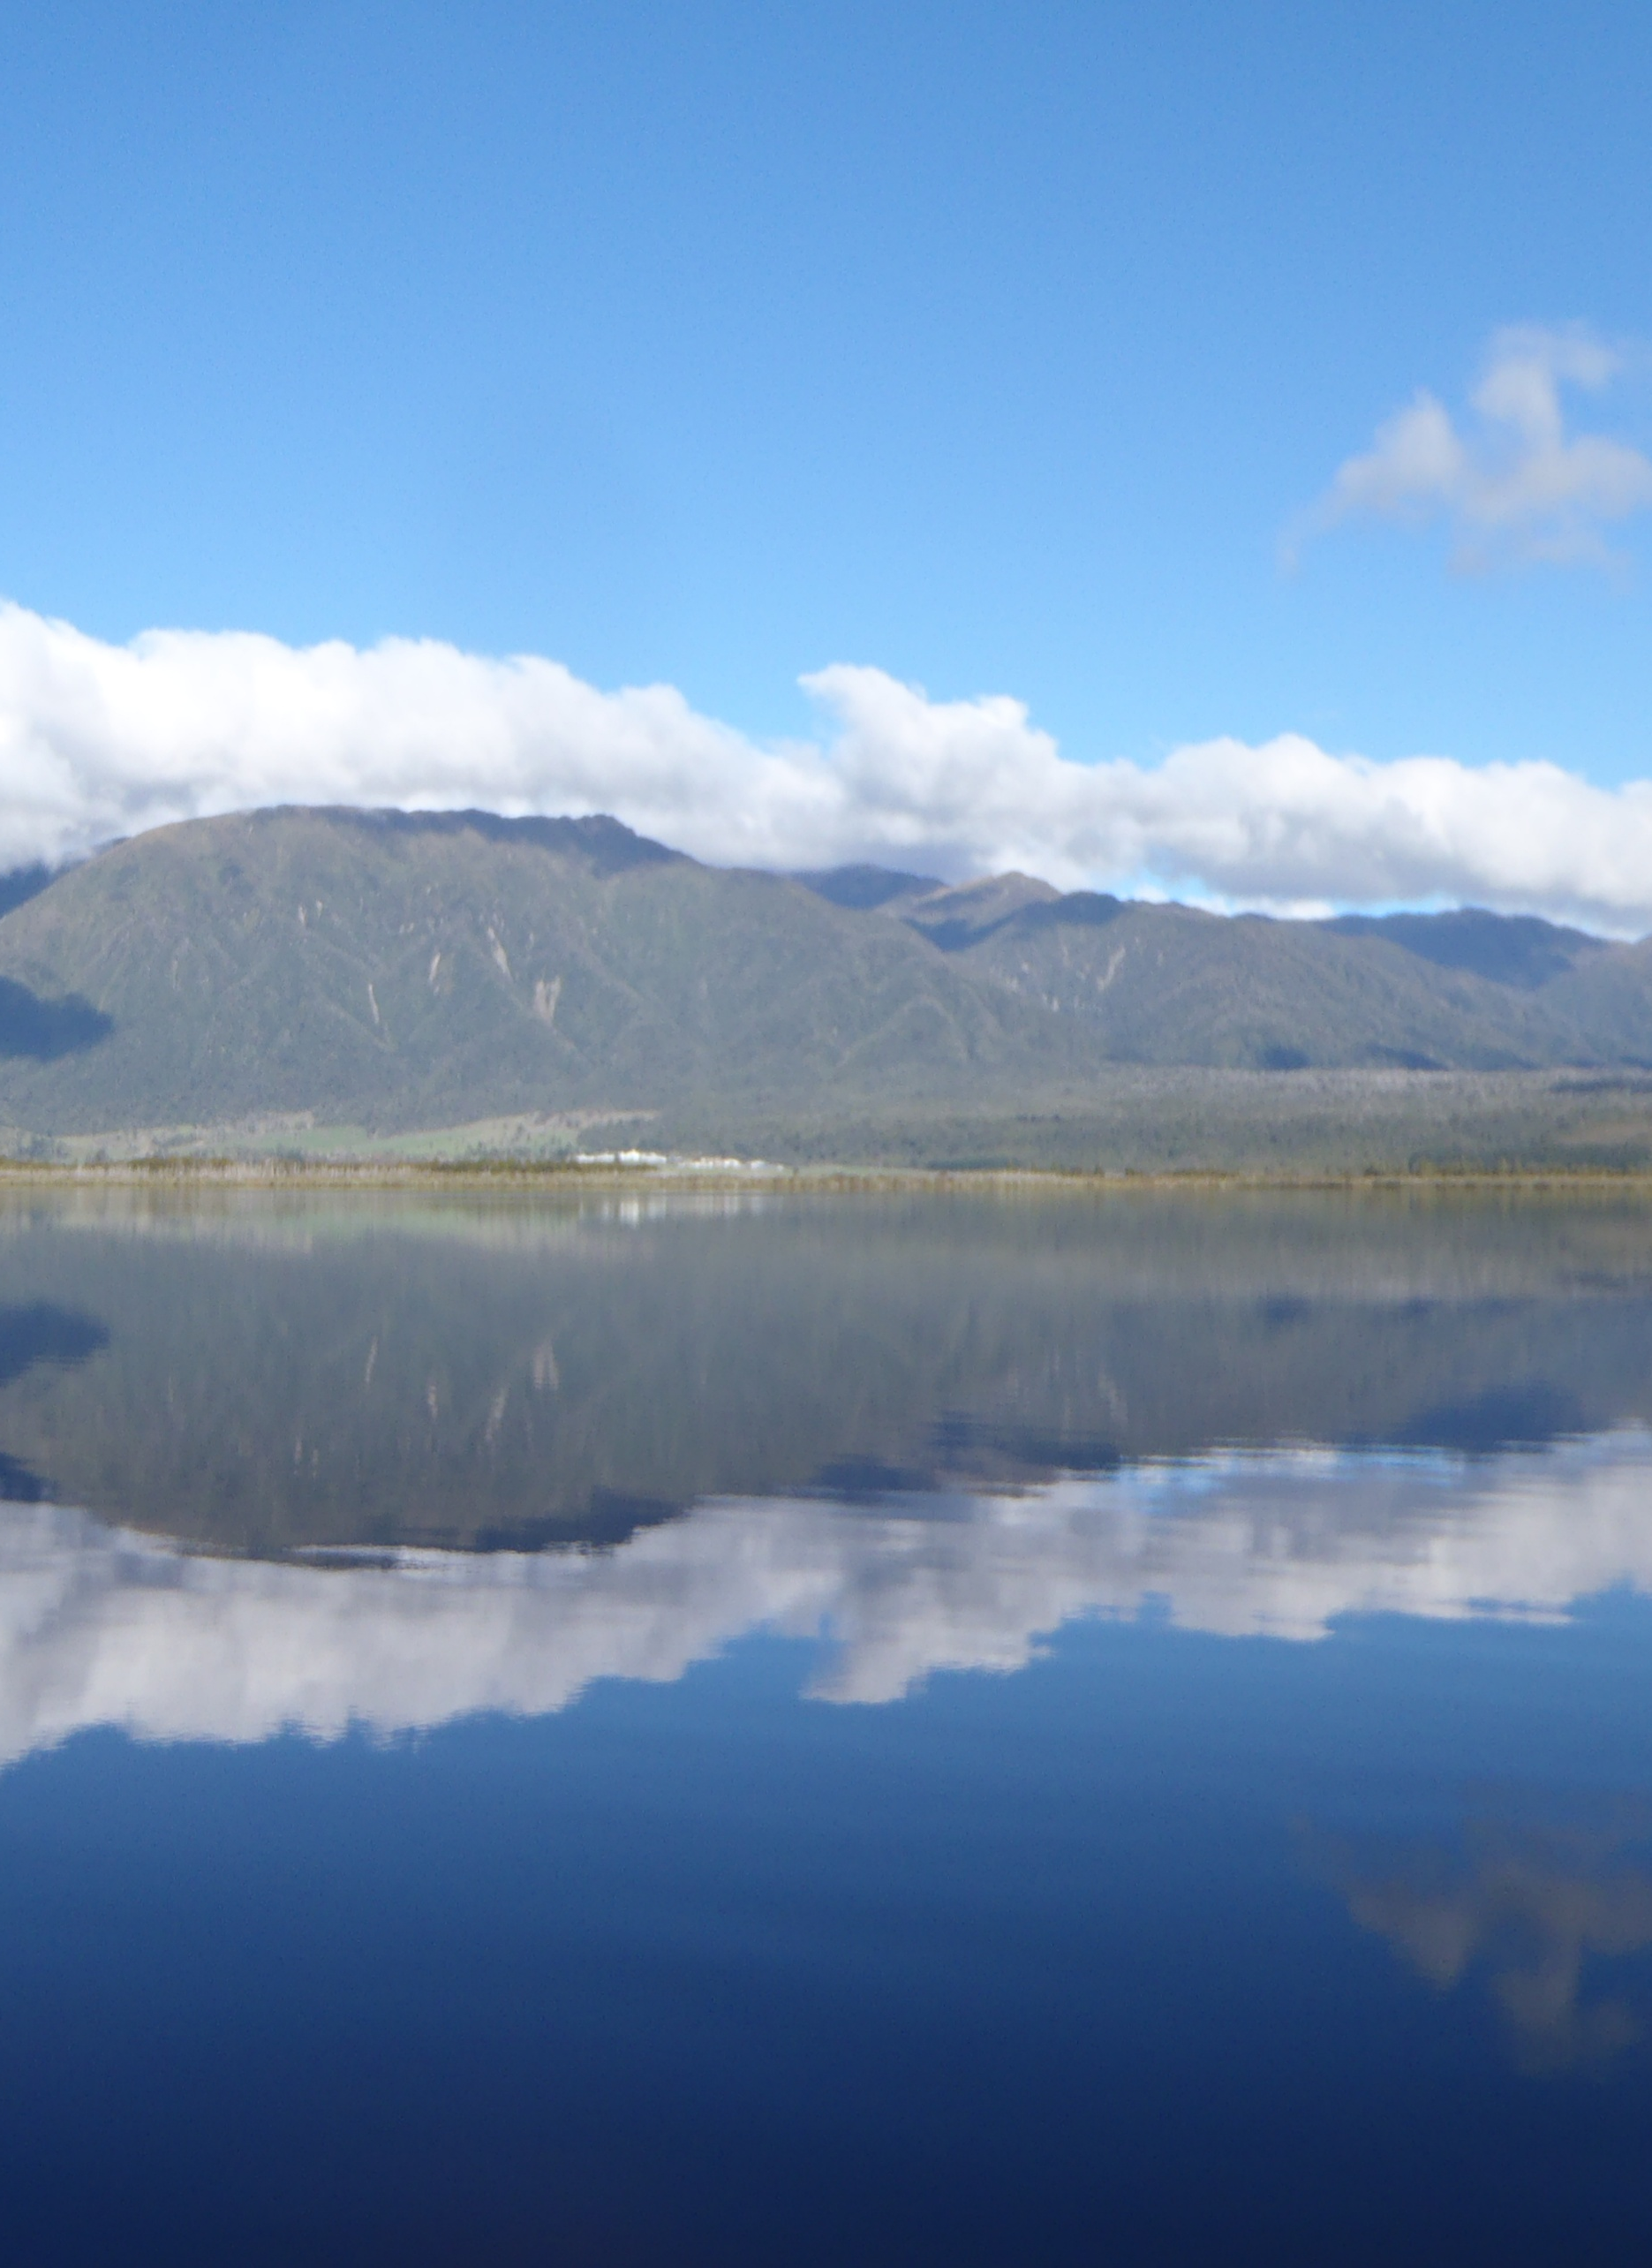


State of the environment monitoring
Waterway health and quality
State

November 2025



Prepared by: WCRC Environmental Quality Team
For: West Coast Regional Council

For enquires contact: Jonny Horrox, Principal Scientist, Environmental Quality.

Approved for release by: Shanti Morgan Date: 22 November, 2025

Acknowledgements (alphabetical):
Fergus McCallum
Shanti Morgan
Emma Perrin-Smith
Rachel Roxburgh
Harvey Rubbo
Serena Sun

Disclaimer
This technical report has been prepared for the use of West Coast Regional Council as a reference document and as such does not constitute Council’s policy.
Council requests that if excerpts or inferences are drawn from this document for further use by individuals or organisations, due care should be taken to ensure that the appropriate context has been preserved and is accurately reflected and referenced in any subsequent spoken or written communication. While West Coast Regional Council has exercised all reasonable skill and care in controlling the contents of this report, Council accepts no liability in contract, tort or otherwise, for any loss, damage, injury or expense (whether direct, indirect or consequential) arising out of the provision of this information or its use by you or any other party.

Table of Contents
Summary 1
Statement of data verification and liability 2
1. Introduction 3
2. Methods 4
2.1. Program design 4
2.2. Program components 5
2.3. Thresholds and assessment criteria 5
2.3.1. The National Policy Statement for Freshwater Management: Target attribute states 5
2.3.2. Human contact vs. primary contact in freshwater environments 6
2.3.3. Primary contact in marine environments 6
2.3.4. Other attributes 6
2.3.5. Catchment landcover 7
3. Results and discussion 7
3.1. REC 7
3.2. Water quality attributes 8
3.2.1. Temperature 8
3.2.2. Clarity 13
3.2.3. Turbidity 16
1.1.1. Dissolved oxygen 19
3.2.4. pH 23
3.2.5. Ammonia and nitrate 25
3.2.6. Dissolved reactive phosphorus 30
3.2.7. E. coli: human contact. 33
3.2.8. Macroinvertebrates 36
3.2.9. Periphyton cover 39
3.2.10. Primary human contact 41
4. References 43
Appendix A – Individual site data for primary contact recreation monitoring 45

Summary
All water is important and valued by Poutini Ngāi Tahu, whether it is groundwater, coastal water or water flowing in rivers or drains. It is very important to Poutini Ngāi Tahu that the mauri - the life-giving essence - of water is maintained. If water is degraded, it affects mana, as it reduces the ability for hapū to collect and provide safe mahinga kai. Poutini Ngāi Tahu, as mana whenua and kaitiaki, have an inherited responsibility to pass healthy water onto future generations.
The West Coast is renowned for its natural and physical attributes, including its lakes, rivers, and coastal areas. Our water resources provide a range of benefits supporting agriculture, industry, tourism, and the health and well-being of people and communities. Reduced water quality increases risks to public health and affects our ability to use freshwater environments for recreational and commercial purposes. Natural factors, such as climate, geology, and topography help determine how human pressures affect the state of water quality and ecosystem health in a particular waterbody. The types of pressures vary, for example, faecal contamination versus nutrients versus sediment discharges, which will impact on a waterbody’s values in different ways.
Councils main water quality focus is on the West Coasts network of waterways, with other significant programs covering lakes, and coastal primary contact recreation. Council’s first and foremost duty is to measure and report on what is the highest priority for Poutini Ngāi Tahu and the local community. Council also has a responsibility to obey national regulations that dictate what should be monitored and how. The The National Policy Statement for Freshwater Management 2020 (NPSFM), has a dominant role in directing what we measure and more critically, the thresholds we apply to determine what is adequate in terms of water quality and ecosystem health.
The proportion of anthropogenic landcover was used to compare to a range of water quality and aquatic health attributes. Sites with less anthropogenic landcover were likely to have better dissolved oxygen regimes, lower nutrients, less faecal contamination, and better macroinvertebrate health.
The West Coast generally has a cool, wet climate but thermal stress can occur periodically in some streams (CRI > 22°C), at which point sensitive species are at risk. Risk factors include: reduced riparian shade; small size and a lack of cool sources like springs or forested hill country; and climatic extremes.
Suspended sediment was assessed using measures of clarity (as per the NPSFM 2020), and turbidity. The majority of monitoring sites had good clarity. Naturally occurring dissolved organic matter can reduce clarity in some waterways and care is needed to avoid attributing clarity reductions from this to suspended sediment. The relationship between anthropogenic landcover and clarity was not strong suggesting that individual activities and natural factors play a significant role.
Dissolved oxygen can vary widely over the course of a day, and assessment requires continuous datasets e.g. every 15 minutes, not every month. Plant and algal proliferations were likely to be a common cause of low dissolved oxygen when nutrients, light, warmth, and stable flows encouraged high biomass.
A suite of intrinsic factors can exacerbate real or perceived reductions in water quality. Low gradient, slow flowing waterways tend to be warmer, have less oxygen, more aquatic plants and poorer macroinvertebrate health. Dissolved organic matter, known for its brown colouration, can reduce pH and clarity significantly in absence of any suspended sediment.
Nutrient levels in West Coast waterways were not toxic but could reach concentrations high enough to promote plant and algal proliferations. This was most likely during the warmer months, demonstrated by oxygen fluctuations observed from Nov-March. Outside of these months, proliferations were less likely as suggested by results from monthly periphyton/algal biomass assessments.
A large number of sites scored poorly under the NPSFM Escherichia coli (E. coli) criteria for human contact. Anthropogenic sources (human and ruminant) are causing problems, but birds, high rainfall, and statistical methodology are also contributing to these poor results. Suitability for primary contact (swimming) was also impacted by the same causes, but was safe at most sites, most of the time. Lakes had the lowest pathogen risk, followed by ocean beaches, then rivers, and estuaries last.
Macroinvertebrate communities can be affected by a wide range of factors. A range of different anthropogenic causes are likely to reduce macroinvertebrate community health, and these could be exacerbated by intrinsic factors.

Statement of data verification and liability
The West Coast Regional Council recognizes the importance of good quality data. This comprehensive surface water quality technical report provides interpretation of results from the West Coast Regional Council Surface Water Quality Monitoring Program and is a summary of relevant information available at the time the report was produced.
Data collection and management systems follow systematic quality control procedures. International Accreditation New Zealand laboratories carried out sample analysis, excluding field analysis. When possible expert staff have been involved in each stage of the monitoring process.
While every attempt has been made to ensure the accuracy of the data and information presented, the West Coast Regional Council does not accept any liability for the accuracy of the information. It is the responsibility of the user to ensure the appropriate use of any data or information from the text, tables or figures. Not all available data or information is presented in the report. Only information considered reliable, of good quality, and of most importance to the readers has been included.

- Introduction
West Coasters have strong connections to water across Te Tai Poutini, and our freshwater environments hold immense significance for Poutini Ngāi Tahu. Water is highly valued, providing us with drinking water, farming and mining, recreation and wellbeing, and habitat for a diverse range of native plants and animals. Improving and sustaining water resources and the health of our freshwater ecosystems is therefore of great importance.
Aims of the West Coast monitoring program are:
- To determine the health of surface waters in the West Coast region in reference to accepted standards (for public health, recreational, and ecological values).
- To identify short and long-term trends in water quality.
- To assess potential for environmental effects and compare them to relevant guidelines and standards.
- To understand the nature of surface water quality issues in order to provide information that enables defensible management responses to be enacted. Such responses include seeking reviews for Regional Council resource management plans, regulations, and resource consent conditions.
The National Policy Statement for Freshwater Management 2020 (NPSFM) provides a national framework for how freshwater is to be managed across the country. It applies to all freshwater (including groundwater) and, to the extent they are affected by freshwater, to receiving environments such as estuaries and the coastal marine area. The NPSFM (2020) includes a framework for assessing many key attributes associated with water quality and ecosystem health.
Water is a taonga (treasure) to Poutini Ngāi Tahu and having the ability to exercise tino rangatiratanga over water within their takiwā is of upmost importance to them. The Ngāi Tahu ki uta ki tai (from the mountains to the sea) practice, supported also in the NPSFM (2020), recognises the connections between land, groundwater, surface water and coastal water. It is very important to Poutini Ngāi Tahu that the mauri - the life-giving essence - of water is maintained. If water is degraded, it impacts mana as it reduces the ability for hapū to collect and provide safe mahinga kai so they can manaaki their visitors. Poutini Ngāi Tahu, as mana whenua and kaitiaki, have an inherited responsibility to pass healthy water onto future generations.
Te Mana o te Wai is a concept underpinned by the NPSFM (2020) that refers to the fundamental importance of water and recognises that protecting the health of freshwater protects the health and well-being of the wider environment. It protects the mauri of the wai. Te Mana o te Wai is about restoring and preserving the balance between the water, the wider environment, and the community.
The West Coast’s land cover profile is characterised by a predominance of natural landcover types. The bulk consists of forest cover (about two thirds of land area), of which most is indigenous forest (LCDB 2020). Other types include: A substantial area of grassland/other herbaceous vegetation cover (17% of land area), half of which is tussock grassland; scrub/shrubland cover, predominantly comprised of indigenous scrub/shrubland; and a relatively substantial area of natural bare/lightly vegetated surfaces (e.g. gravel or rock, permanent snow and ice).
Only a relatively small proportion of West Coast landcover is anthropogenic or influenced significantly by human activity. Approximately 12% of the region consists of landscapes significantly modified by human activity, including exotic grassland (7%), exotic forest (2%), exotic scrub/shrubland (1%), cropping/horticulture (<1%), artificial bare surfaces (<1%), and urban areas (<1%) (Land Cover Database, version 6.0).
- Methods
  - Program design
The monitoring program must work within a number of constraints. Given the limited resources available, quarterly sampling was the norm until autumn 2016. Since then, sampling frequency has increased among sites to monthly, which is the sampling frequency for all sites in the program as of 2025.
Sampling protocols have changed alongside an increase in sampling frequency. Previously, sampling only occurred at median flow so very little was known about water quality following rain or flood events. Sampling currently occurs on a preset schedule so that sites are sampled at the same time each month irrespective of weather and flows.
The monitoring program targets areas where the most significant human pressures are while maintaining a subset of reference sites in low impact and pristine areas. Sites in the program were chosen to try to achieve a balance within and between the following criteria:
(a) Geographical spread throughout the West Coast region;
(b) Range of waterway sizes represented (from large main-stem rivers to small creeks);
(c) Range of different environmental pressures represented at different sites;
(d) In areas with human health relevance (such as for recreation or drinking) or significant ecological values.
In order to address its aims while working within the constraints mentioned above, design of the monitoring program involved choosing attributes that were informative for assessing health and quality for a range of values. These values have been dictated by the local community, central government environmental standards, and policy statements.
  - Program components
The Surface Water Quality Monitoring Program has involved the collection of data from rivers, lakes and the ocean since the mid-nineties. The overall program contains many individual components (Table 1).
Table 1: Components of the surface water quality monitoring program as of 2024. An asterisk denotes those components that are covered in this report.
Monitoring area | Attribute | Timing
Waterways | E. coli, physical and chemical attributes * | Monthly
Waterways | Periphyton * | Monthly
Waterways | Macroinvertebrates * | Annual
Waterways | Habitat | Annual
Waterways | Continuous pH, oxygen, turbidity, conductivity * | November-March, >7 days@ 15-minute intervals
Waterways | Continuous temperature * | Permanent, 15-minute interval
Contact recreation – rivers, lakes, and coastal | E. coli or Enterococci * | November-March, weekly
Lakes | E. coli, physical and chemical attributes | Lake Brunner – monthly  Other lakes - annual
Lakes | Submerged plant assessment | 3-5 years

The majority of effort has been and continues to be invested into sampling a range of streams and rivers across the region. The National Institute of Water and Atmospheric Research’s (NIWA) National River Water Quality Network has four sites within the West Coast region that have been sampled monthly since 1989, and data from this program has been incorporated into analysis presented in this report.
Lake Brunner is a particular area of focus where monthly monitoring has been conducted at a range of sites in the lake and in its tributaries. Tributaries of Lake Brunner are included here, but synthesis of sampling in the lake itself is covered in a separate report.
  - Thresholds and assessment criteria
    - The National Policy Statement for Freshwater Management: Target attribute states
The NPSFM has target attribute states for a range of attributes e.g. ammonia, clarity, and dissolved oxygen. Each attribute has four bands ranging from A to D. Human contact is the one exception with five E. coli bands. The precise definition of these bands varies among attributes, but to generalize, A is good and D is poor. We have used these bands as a reference for a range of attributes measured by the West Coast Regional Council (WCRC).
In 2014, the New Zealand Government produced the National Policy Statement for Freshwater Management (NPSFM), which was later amended in 2017 and 2020. The NPSFM provides direction on how local and regional authorities, including the WCRC, should carry out their responsibilities for managing freshwater under the Resource Management Act 1991.
    - Human contact vs. primary contact in freshwater environments
Human health for recreation is listed in the NPSFM as a compulsory national value of freshwater. Fecal bacteria are indicators for the presence of pathogens that can harm people when they come into contact with water. The NPSFM has two separate tables in the National Objectives Framework (NOF) that list thresholds (attribute states) for bacterial health. The first is for human contact, for all freshwaters, which we have applied to our monthly river sampling network data.
The second table provides specific thresholds for primary contact sites e.g. swimming. These thresholds are very similar to the single sample criteria provided by the Microbiological Water Quality Guidelines for Marine and Freshwater Recreational Areas (MfE 2003), which we have used for our primary contact reference threshold. This data comes from WCRC’s primary contact water quality program that tests some of the West Coasts well-used bathing sites. The program involves the weekly collection of water quality samples between November and March.
    - Primary contact in marine environments
As the NPSFM covers freshwater, both the human contact and primary contact NOF tables use E. coli bacteria as the attribute. For marine primary contact we have followed the Microbiological Water Quality Guidelines for Marine and Freshwater Recreational Areas (MfE 2003), using the bacteria Enterococci and the thresholds it recommends. E. coli has been used for monitoring in brackish estuaries as all the estuarine sites in the program tend more to the freshwater end of the spectrum.
    - Other attributes
The NPSFM (2020) stipulates a range of attributes that should be measured, along with thresholds to assess them, and determine whether the various values associated with freshwater are supported. There are other attributes and thresholds, not included in the NPSFM, that are applicable. This includes temperature and the percentage saturation of dissolved oxygen.
Potential for a temperature NOF was investigated by the government but it was not implemented. The Cox-Rutherford Index (CRI) was proposed to evaluate the suitability of stream temperature regimes on aquatic health (Davies-Colley et al. 2013). The CRI is calculated using the 5 hottest days in a year. Many of the WCRC’s monitoring sites have multiple years of continuous data (15-minute intervals), thus a spread of annual CRI’s can be presented. The thresholds for Maritime Climates (18⁰C, 20⁰C, 24⁰C), have been used (Davies-Colley et al. 2013).
Both the Macroinvertebrate Community Index (MCI) and Quantitative Macroinvertebrate Community Index (QMCI) are part of the NPSFM NOF for freshwater monitoring and are complementary tools for assessing stream health. It should be noted that for the calculation of QMCI scores, some older SQMCI categorical data has been used. This is due to a shift in sorting protocols from P1 coded abundance to P2 200 Fixed Count + Scan for Rare Taxa (Stark et al. 2001).
    - Catchment landcover
Landcover is derived from the New Zealand Land Cover Database. The New Zealand LCDB (2020) is a classification of the country's land cover derived from satellite imagery, with 33 mainland land cover classes. We have designated these classes as either natural or anthropogenic and summed the proportion of these two groups in each of the catchments where monitoring is undertaken. This allows us to examine the relationship between our sampling data and the extent of human activity upstream of that sampling.
- Results and discussion
  - River Environment Classification
The 2005 Regional Council State of the Environment report covered Regional Council data records up until 2004–2005, conducting analysis under the River Environment Classification (REC) framework (Snelder et al. 2010). The REC system groups rivers with similar physical and biological characteristics for management and research purposes. This GIS-based classification uses factors like climate, topography, geology, and land cover to define a nested hierarchy of river segments. It provides a framework for resource management by allowing different river classes to be treated as similar to one another.
The REC was used to group sites by climate, source of flow, geology, land cover, and stream order. Relationships between these REC classes and water quality were investigated. It is worth mentioning this work as it is useful for describing some fundamental characteristics of West Coast waterways.
Many significant differences in physical, chemical, and biological water quality attributes were observed between the REC classes of: source of flow, geology, land cover, and stream order. Patterns observed for these attributes amongst REC classes suggested that streams could be characterised as:
- Streams with a hill source of flow; hard sedimentary or plutonic geology; often incorporating larger rivers; with higher, less variable water quality; brown trout more abundant.
- Lowland streams (low elevation source of flow); higher turbidity, nutrients, and temperature (which may not solely have been a response of human activity); smaller, more variable and susceptible to impact; potentially higher fish and invertebrate diversity.
- Streams draining predominantly agricultural catchments (sub-set of lowland streams); comparatively poorer water quality with fewer sensitive macroinvertebrate taxa.
- Stream catchments with soft sedimentary geology; higher turbidity; distinctive physically and chemically from other geology classes; smaller size; lower source of flow.
  - Water quality attributes
Freshwater quality attributes are measurable physical, chemical, and biological properties used to determine the health of an aquatic ecosystem and its suitability for uses like drinking, swimming, or supporting aquatic life. The WCRC measures a broad range of key attributes that can be used to assess how well various values are catered for. As an example, faecal bacteria like E. coli and Enterococci indicate pathogen risk to people and livestock should they swim or consume the water. Suspended sediment impacts on amenity (unsightly, unsafe to swim), and ecology (abrasion of gills, difficulty finding prey, reduced productivity).
    - Temperature
Temperature strongly influences water composition, because it affects the equilibrium point (e.g. equilibrium solubility of dissolved oxygen), and the rates of physico-chemical and biochemical reactions (e.g. the rate of dissolved oxygen consumption by bacterial respiration). Temperature profoundly affects aquatic ecosystems because, besides the effects on oxygen and other chemical constituents (e.g., ammonia), growth of most organisms is a function of temperature. There is an optimum temperature for growth rate, below which growth falls slowly. Our main concern is for temperatures above the growth optimum, because such temperatures impose thermal stress on organisms, and lethal temperatures can be reached only slightly higher than (perhaps 5⁰C above) the growth optimum (Davies-Colley et al. 2013). Temperatures higher than the optimum become increasingly stressful because of effects on cellular function, with enzymes becoming denatured.
Under the REC, all West Coast waterways are defined climatically as cool/wet or cool/extremely wet. While this may appear reassuring, temperatures high enough to cause thermal stress in aquatic organisms do occur. Fundamentally, a closer proximity to the ocean lowers temperatures in summer and increases them in winter (Figure 1). Conditions are typically warmer and drier to the north and further inland (at low altitudes), but as altitude increases temperatures decrease (Macara 2016). A range of smaller scale site specific factors come into play like stream size, shading, brown colouration, flow rate, and spring recharge. Climatic variability plays a key role, where normally cool and wet weather can deviate to dry and hot over summer. It is usually during these periods that the highest CRI’s are observed. CRI essentially indicates the maximum temperatures observed in a waterway reach.
The majority of continuous temperature monitoring sites are in the Grey River catchment (Arnold and Grey, Figure 2). Sites within this catchment show a wide range of CRI scores as the sites vary greatly in size, source of flow, shading, and distance from the sea. The Orangipuku River is one of the coolest rivers in summer due to a dominant spring fed supply. This strong groundwater derived source leads to relatively warm temperatures in winter. Sawyers Ck is a third order stream near Greymouth, which has two monitoring sites – one in the town, near a tidal lagoon, and the other in forested hill country. While these sites are less than 4 km apart, the effect of reduced riparian shade is significant on this smaller, slow flowing waterway, with respective median CRI’s of 16.4⁰C and 21.7⁰C. Maximum CRI’s for these sites are further apart 17.4⁰C and 22.9⁰C (Table 2).
The Hohonu River (4th order) is a similar example further inland in the Grey River catchment. There are two sites on this river, 9 km apart. One site is located at the base of steep, forest clad hill country and the other downstream in flatter country with reduced riparian cover. As well as the effect of reduced riparian shade, additions of dark dissolved organic matter (DOM) and slower water velocities contribute to warming and temperature increases (Williamson et al. 2015). Upstream to downstream median CRI’s are 16.5⁰C and 23.4⁰C, with maximum CRI’s for these sites at 17.2⁰C and 25.9⁰C, respectively. The lower Hohonu site consistently had CRI’s that will have caused some occasional stress for sensitive species. While less common, there are hot periods every few years that will have caused significant thermal stress and loss of ecological integrity at this site.
Summer maximums were the highest in the north of the region, in the Buller catchment and Karamea area (Figure 2). None of these sites have significant cool spring recharge and do have notable brown colouring associated with DOM. The four warmest waterways were smaller 3rd order streams with slower water velocities and reduced riparian shading. These occasionally had significant thermal stress. The coolest waterway was a small, hill fed stream with an indigenous forest catchment. Two sites were located on the large (5-6 order) Inangahua River. The majority of the catchment is clad in indigenous forest but the main channel has little riparian shade. Both locations in the Inangahua River typically reached summer maximums of ~21.5⁰C. All sites in the Buller catchment and Karamea area consistently reached maximums that would cause some stress and eliminate sensitive species, on occasions. While they varied in terms of size, velocity, and distance from the coast, all these sites were in areas with a warmer summer climate.
Westland spring fed waterways had lower summer maximums due to their abundant supply of groundwater recharge. The exception, regarding source, is Okutua Stream, but its entire catchment is covered with indigenous lowland forest. These sites are located the farthest south among those in the monitoring program.
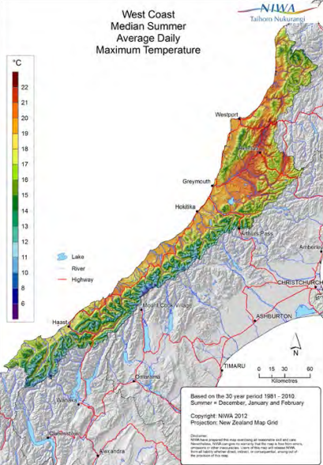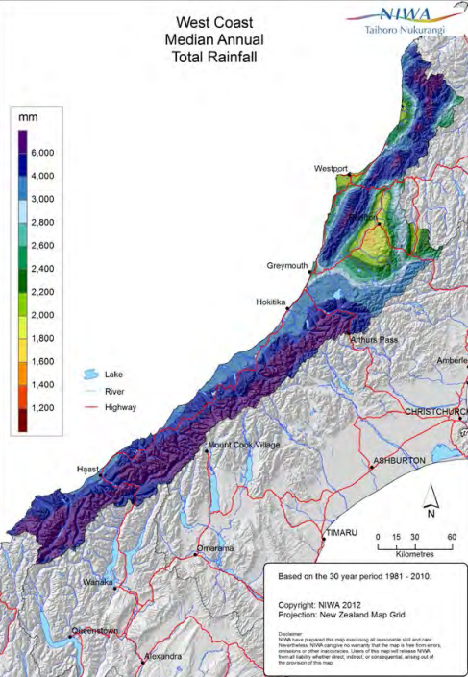
Figure 1: Left: West Coast median summer (December, January and February) average daily maximum temperature. Right: West Coast median annual total rainfall, 1981–2010. From Macara (2016).

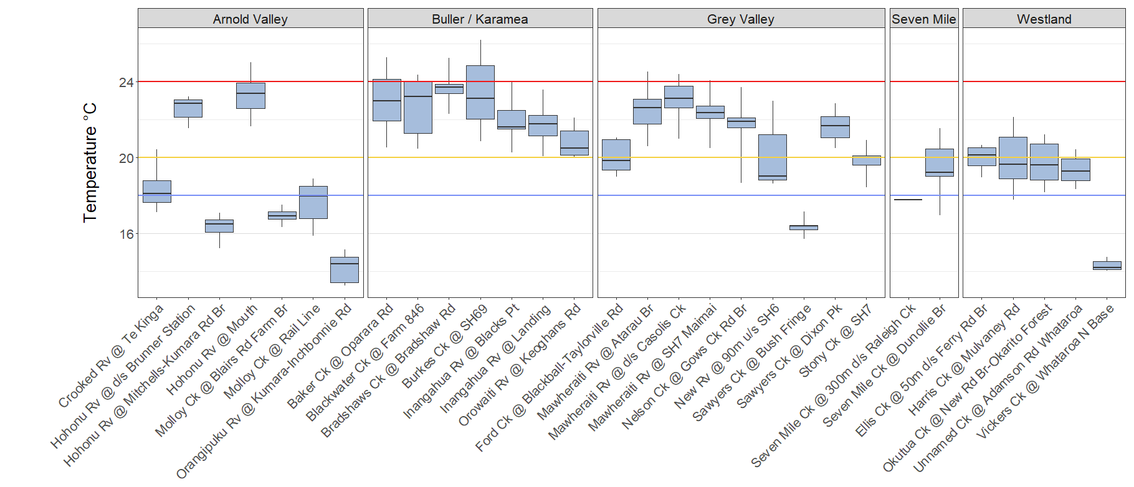
Figure 2. Water temperature, annual CRI’s (calculated on the 5 hottest days in summer), for individual Council monitoring program sites that have continuous temperature data (minimums and maximums excluded). Sites are grouped into geographical areas. Temperature ranges are: Beneath blue line, ≤ 18°C – Optimal / Cool, represents good thermal conditions for sensitive aquatic invertebrates (e.g., mayflies, stoneflies). Minimal thermal stress; supports high biodiversity; Beneath yellow line, 18–20°C – Minor thermal stress on occasion (clear days in summer) affecting particularly sensitive organisms such as certain insects and fish; Beneath red line, 20–24°C – Some thermal stress on occasions, with elimination of certain sensitive insects and absence of certain sensitive fish; Over red line, ≥ 24°C – Significant thermal stress on a range of aquatic organisms. Risk of local elimination of keystone species with loss of ecological integrity.

Site | Number of years | Temperature C |  |  | Area
 |  | Median of annual CRI’s | Min CRI | Max CRI
Vickers Ck @ Whataroa N Base | 3 | 14.2 | 14.0 | 14.8 | Westland
Orangipuku Rv @ Kumara-Inchbonnie Rd | 12 | 14.4 | 13.2 | 15.5 | Arnold Valley
Sawyers Ck @ Bush Fringe | 6 | 16.4 | 15.6 | 17.4 | Grey Valley
Hohonu Rv @ Mitchells-Kumara Rd Br | 4 | 16.5 | 15.0 | 17.2 | Arnold Valley
Molloy Ck @ Blairs Rd Farm Br | 7 | 16.9 | 16.2 | 17.6 | Arnold Valley
Seven Mile Ck @ 300m d/s Raleigh Ck | 1 | 17.8 | 17.8 | 17.8 | Seven Mile
Molloy Ck @ Rail Line | 3 | 18.0 | 15.6 | 19.0 | Arnold Valley
Crooked Rv @ Te Kinga | 13 | 18.1 | 16.9 | 20.6 | Arnold Valley
New Rv @ 90m u/s SH6 | 3 | 19.0 | 18.6 | 23.4 | Grey Valley
Seven Mile Ck @ Dunollie Br | 7 | 19.2 | 16.1 | 21.8 | Seven Mile
Unnamed Ck @ Adamson Rd Whataroa | 8 | 19.3 | 18.2 | 20.6 | Westland
Okutua Ck @ New Rd Br-Okarito Forest | 6 | 19.6 | 18.0 | 21.3 | Westland
Harris Ck @ Mulvaney Rd | 10 | 19.6 | 17.4 | 22.7 | Westland
Ford Ck @ Blackball-Taylorville Rd | 5 | 19.9 | 18.9 | 21.1 | Grey Valley
Stony Ck @ SH7 | 9 | 20.0 | 17.8 | 21.4 | Grey Valley
Ellis Ck @ 50m d/s Ferry Rd Br | 4 | 20.2 | 18.8 | 20.7 | Westland
Orowaiti Rv @ Keoghans Rd | 5 | 20.5 | 20.0 | 22.3 | Buller / Karamea
Inangahua Rv @ Blacks Pt | 9 | 21.6 | 19.5 | 25.0 | Buller / Karamea
Sawyers Ck @ Dixon Pk | 10 | 21.7 | 20.2 | 22.9 | Grey Valley
Inangahua Rv @ Landing | 9 | 21.8 | 19.7 | 24.4 | Buller / Karamea
Nelson Ck @ Gows Ck Rd Br | 9 | 21.9 | 16.9 | 24.4 | Grey Valley
Mawheraiti Rv @ SH7 Maimai | 12 | 22.4 | 20.3 | 25.1 | Grey Valley
Mawheraiti Rv @ Atarau Br | 7 | 22.6 | 20.4 | 25.0 | Grey Valley
Hohonu Rv @ d/s Brunner Station | 3 | 22.8 | 21.4 | 23.3 | Arnold Valley
Baker Ck @ Oparara Rd | 7 | 23.0 | 20.1 | 25.6 | Buller / Karamea
Burkes Ck @ SH69 | 10 | 23.1 | 20.6 | 26.6 | Buller / Karamea
Mawheraiti Rv @ d/s Casolis Ck | 10 | 23.1 | 20.8 | 24.7 | Grey Valley
Blackwater Ck @ Farm 846 | 7 | 23.2 | 20.4 | 24.4 | Buller / Karamea
Hohonu Rv @ Mouth | 11 | 23.4 | 21.4 | 25.9 | Arnold Valley
Bradshaws Ck @ Bradshaw Rd | 7 | 23.7 | 21.9 | 25.8 | Buller / Karamea
Table 2: Cox Rutherford Limit (CRI) categories. Dark green, ≤ 18°C – Optimal / Cool, represents good thermal conditions for sensitive aquatic invertebrates (e.g., mayflies, stoneflies). Minimal thermal stress; supports high biodiversity; Light green, 18–20°C – Minor thermal stress on occasion (clear days in summer) affecting particularly sensitive organisms such as certain insects and fish; Orange, 20–24°C – Some thermal stress on occasions, with elimination of certain sensitive insects and absence of certain sensitive fish; Red, ≥ 24°C – Significant thermal stress on a range of aquatic organisms. Risk of local elimination of keystone species with loss of ecological integrity.

    - Clarity
Water clarity is a measure of how transparent water is, or how far light can penetrate through it. It indicates the optical quality of water, which is important for aquatic ecosystems, visual amenity, and photosynthesis. The WCRC measures clarity using a horizontal black disk and clarity tube.
The two main factors reducing clarity in West Coast waterways are suspended sediment, and dissolved organic matter (DOM), also known as ‘tea stain’. Both of these affect clarity, but only suspended sediment affects turbidity measurements, which don’t detect dissolved substances like DOM. Regardless, the NPSFM selected clarity rather than turbidity as a surrogate measure for suspended sediment. We have picked clarity as the attribute for assessing suspended fine sediment, as per the NPSFM NOF. This table adjusts assessments according to the dominant catchment geology.
While streams with very high DOM can be problematic, clarity for the most part works well as a surrogate for suspended sediment. West Coast waterways often have suspended sediment levels that are lower than the detection limits of turbidity meters and gravimetric methods like total suspended solids. However, the WCRC does measure turbidity as it can be complimentary when suspended sediment concentrations are high.
There was no clear relationship between the amount of anthropogenic landcover, median clarity, or NOF attribute state across catchments with anthropogenic landcover. Waterways with no anthropogenic landcover were in the A band although there were exceptions. Okutua Stream had reduced clarity, despite low sediment levels, due to very high concentrations of DOM. This is a natural phenomenon apparent in many West Coast waterways.
The Orowaiti River sites were affected by a large slip in the headwaters, that occurred during 2021. The Buller River @ Te Kuha and Grey River @ Dobson are very large river sites (7th order). Despite the relative lack of anthropogenic landcover, it is difficult to know what human activities could be affecting clarity at these locations given their large catchments. It may be that a larger catchment has a higher chance of receiving fine, easily suspendable sediments. Flows and velocities may take longer for to drop after a flood, which helps maintain sediment in suspension.
There were sites that has a high proportion of anthropogenic landcover and also had high clarity. A key factor here is that sites in the program with 80-100% anthropogenic cover were all spring fed, among Westland’s flat alluvial plains. Despite being surrounded by intensive agriculture these streams retained high clarity and low suspended sediment levels. Good clarity was observed for most spring fed streams in the West Coast region. Flows in these streams are disproportionately high relative to their catchment size, allowing for greater dilution of sediment inputs. They also drain lower gradient, less erosion prone terrain.
Overall, the majority of monitoring sites had good clarity. Twenty percent of sites were classified as having ‘Moderate to high impact of suspended sediment on instream biota. Sensitive fish species may be lost.’ These exceptions were driven by high DOM, current and historic mining, natural slips, and other earthworks. Five sites had clarities below the national bottom line, which describes this state as ‘High impact of suspended sediment on instream biota. Ecological communities are significantly altered, and sensitive fish and macroinvertebrate species are lost or at high risk of being lost’. These were all surrounded by intensive agriculture but lacked the significant spring recharge that buffered other farmland streams. Several of these sites drained low gradient, swampy land, that was predisposed to erosion and turbidity. The remainder were small waterways, in catchments where ongoing land disturbance and/or mining had increased suspended sediment levels (Table 3).
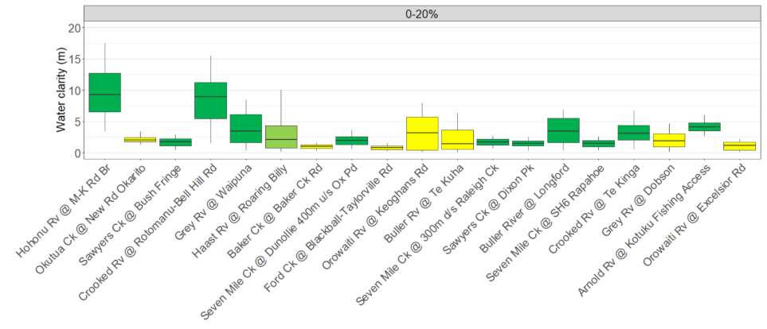
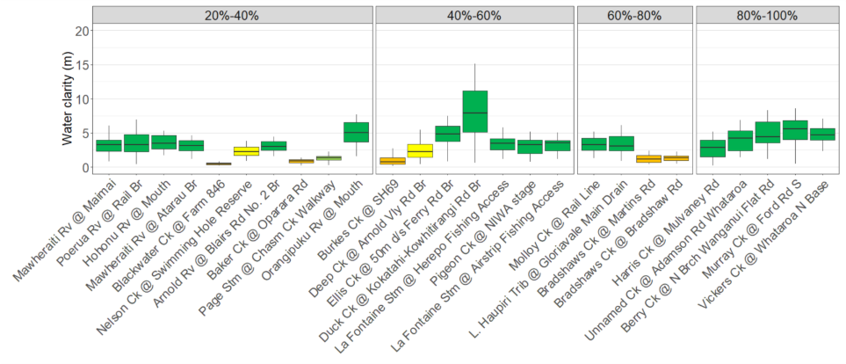
Figure 3. Clarity (black disc and clarity tube combined). Sites grouped according to proportion of anthropogenic land cover, with the proportion increasing from left to right (minimums and maximums excluded). Box colors represent NPSFM (2020) NOF categories: Green = A, Minimal impact of suspended sediment on instream biota. Ecological communities are similar to those observed in natural reference conditions; Light green = B, Low to moderate impact of suspended sediment on instream biota. Abundance of sensitive fish species may be reduced; Yellow = C, Moderate to high impact of suspended sediment on instream biota. Sensitive fish species may be lost.; Orange = D, High impact of suspended sediment on instream biota. Ecological communities are significantly altered and sensitive fish and macroinvertebrate species are lost or at high risk of being lost.
Table 3 Suspended fine sediment NOF grades for Regional Council monitoring program sites. Calculated as 5 yearly medians, year ending 2024. Box colors represent NPSFM (2020) NOF categories: Green = A, Minimal impact of suspended sediment on instream biota. Ecological communities are similar to those observed in natural reference conditions; Light green = B, Low to moderate impact of suspended sediment on instream biota. Abundance of sensitive fish species may be reduced; Yellow = C, Moderate to high impact of suspended sediment on instream biota. Sensitive fish species may be lost.; Orange = D, High impact of suspended sediment on instream biota. Ecological communities are significantly altered and sensitive fish and macroinvertebrate species are lost or at high risk of being lost.

Site Name | Overall NOF 2024 | Site Name | Overall NOF 2024
Arnold Rv @ Blairs Rd No. 2 Br | A | L. Haupiri Trib @ Gloriavale Main Drain | A
Arnold Rv @ Kotuku Fishing Access | A | La Fontaine Stm @ Airstrip Fishing Access | A
Baker Ck @ Baker Ck Rd | D | La Fontaine Stm @ Herepo Fishing Access | A
Baker Ck @ Oparara Rd | D | Mawheraiti Rv @ Atarau Br | A
Berry Ck @ N Brch Wanganui Flat Rd | A | Mawheraiti Rv @ SH7 Maimai | A
Blackwater Ck @ Farm 846 | D | Molloy Ck @ Rail Line | A
Bradshaws Ck @ Bradshaw Rd | D | Murray Ck @ Ford Rd S | A
Bradshaws Ck @ Martins Rd | D | Nelson Ck @ Swimming Hole Reserve | C
Buller River @ Longford | A | Okutua Ck @ New Rd Br-Okarito Forest | D
Buller Rv @ Te Kuha | C | Orangipuku Rv @ Mouth | A
Burkes Ck @ SH69 | D | Orowaiti Rv @ Excelsior Rd | D
Crooked Rv @ Rotomanu-Bell Hill Rd | A | Orowaiti Rv @ Keoghans Rd | D
Crooked Rv @ Te Kinga | A | Page Stm @ Chasm Ck Walkway | B
Deep Ck @ Arnold Vly Rd Br | C | Pigeon Ck @ NIWA stage | A
Duck Ck @ Kokatahi-Kowhitirangi Rd Br | A | Poerua Rv @ Rail Br | A
Ellis Ck @ 50m d/s Ferry Rd Br | A | Sawyers Ck @ Bush Fringe | A
Ford Ck @ Blackball-Taylorville Rd | D | Sawyers Ck @ Dixon Pk | A
Grey Rv @ Dobson | C | Seven Mile Ck @ 300m d/s Raleigh Ck | A
Grey Rv @ Waipuna | A | Seven Mile Ck @ Dunollie 400m u/s Ox Pd | A
Haast Rv @ Roaring Billy | C | Seven Mile Ck @ SH6 Rapahoe | A
Harris Ck @ Mulvaney Rd | A | Unnamed Ck @ Adamson Rd Whataroa | A
Hohonu Rv @ Mitchells-Kumara Rd Br | A | Vickers Ck @ Whataroa N Base | A
Hohonu Rv @ Mouth | A

    - Turbidity
Turbidity is a measure of the cloudiness or haziness of a liquid, like water, caused by suspended particles such as silt, clay, algae, and organic matter. It quantifies how much light is scattered by these particles. Higher turbidity means more suspended particles, resulting in a cloudier liquid that scatters more light. Turbidity is not a direct count by weight of particles (like total suspended solids), but an optical measurement of how much light is scattered by them.
There was no obvious relationship between the amount of anthropogenic landcover in a catchment and median turbidity. However, turbidity ranges were smaller in catchments with little or no anthropogenic landcover (Figure 4). It should be noted that the typical duration of data collection was 2 weeks with 15-minute sampling frequencies. Heavy rainfall may or may not have occurred in that time period.
The three sites with the poorest turbidity all had unusual circumstances (Figure 5). Ford Creek receives acid mine drainage (AMD) from the historic Blackball mine. The mine provides a constant supply of dissolved iron, from underground tunnels, that promptly precipitates into a fine sediment (iron oxide).
The lower reaches of Blackwater Creek are fed by a large drainage network built to drain what was once a swamp and is now grazing.
The Orowaiti River, particularly the upper reaches, traditionally has had low turbidity but a very large slip in the headwaters in 2021 led to a large turbidity increase from 2020 to 2021 (annual means of 0.7 FNU to 69 FNU, respectively). This began to recover in 2025, with a mean of 14 NTU.

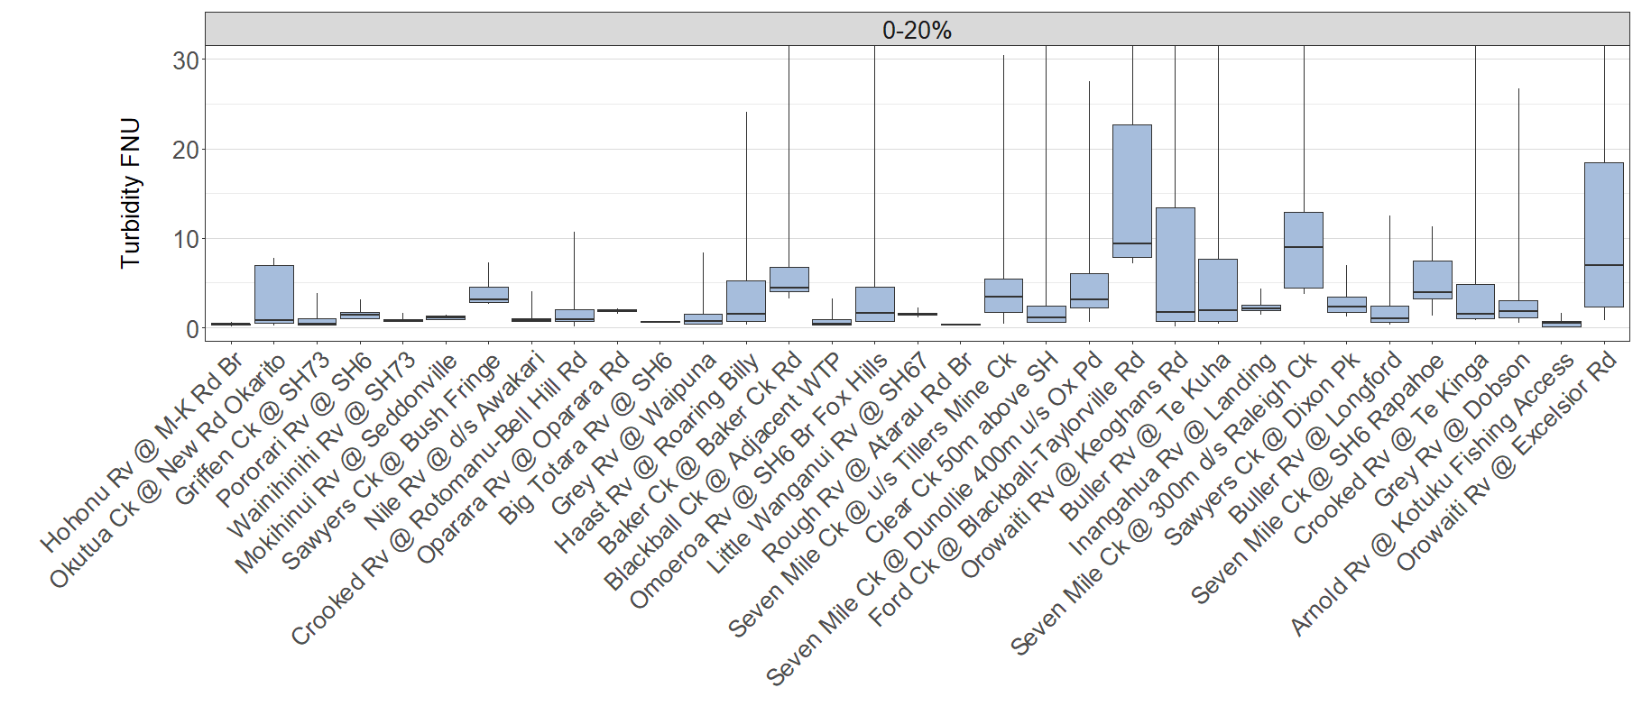
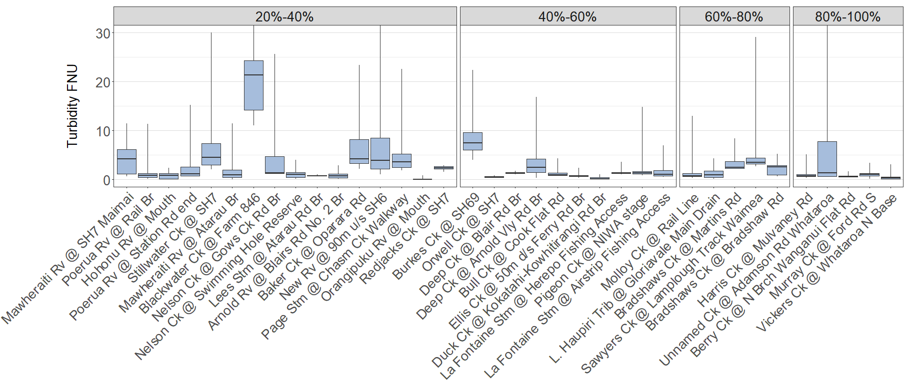

Figure 4. Turbidity data for sites where there is continuous data available (minimums and maximums excluded). Sites grouped according to proportion of anthropogenic land cover, with the proportion increasing from left to right. The Y-axis limit has been capped to 30 FNU in order to provide greater resolution.
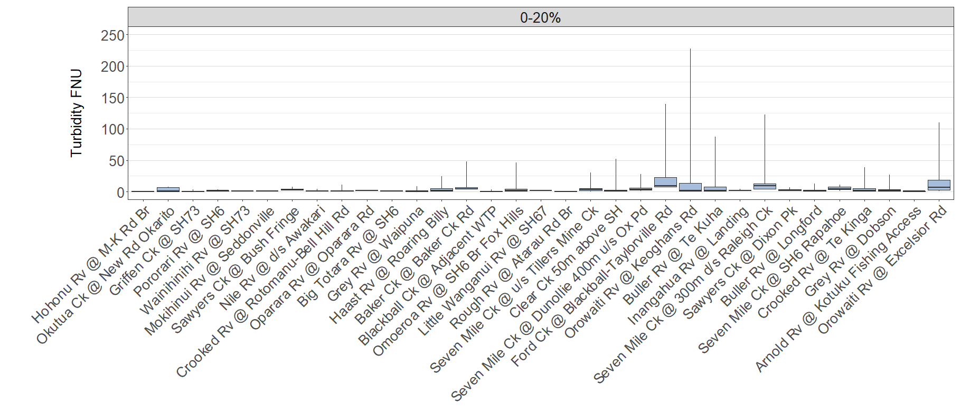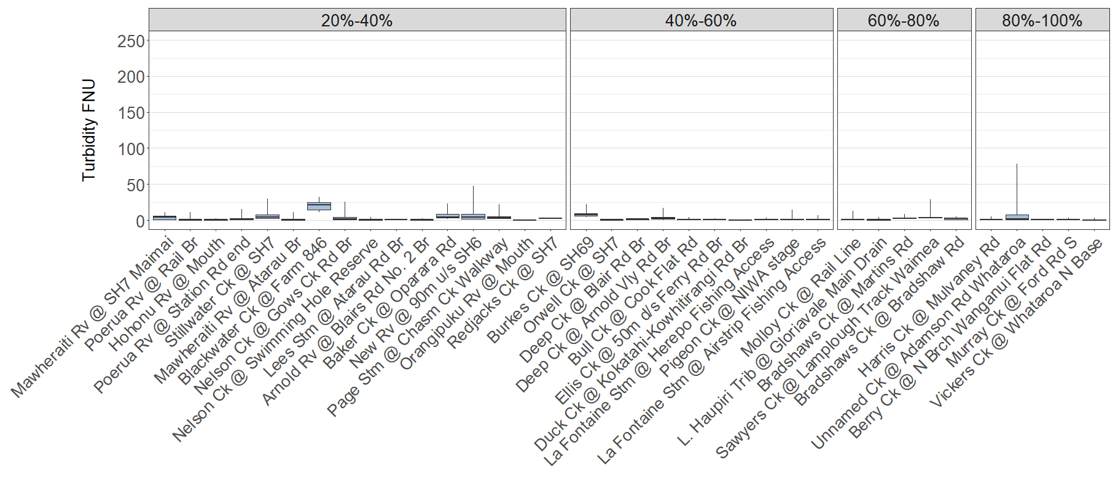

Figure 5. Turbidity data for sites where there is continuous data available (minimums and maximums excluded). Sites grouped according to proportion of anthropogenic land cover, with the proportion increasing from left to right. The Y-axis limit has been extended to 260 FNU in order to show the 95% percentile range for all sites.

    - Dissolved oxygen
The WCRC measures dissolved oxygen (DO) in streams in both milligrams per litre (mg/L), and percent saturation. Milligrams per litre is an absolute measure of how much oxygen is present, whereas percent saturation indicates how much oxygen is present relative to the atmosphere (100%) at a given temperature. Warmer water holds less oxygen so 100% saturation at 25⁰C has less oxygen than 100% saturation at 10⁰C, which is 8.26 mg/L and 11.3 mg/L, respectively. If saturation is less than 100%, then there is less oxygen in the water than what would be expected in ideal environmental conditions. Super saturation (>100%), can occur when significant photosynthesis boosts oxygen saturation to levels above what would be possible in air at that temperature. A clear, slow flowing stream on a sunny afternoon, with little turbulence and filled with aquatic plants, would be a candidate for supersaturation.
DO is important because it is necessary for the survival of aquatic life, like fish and other organisms that require it for respiration. A lack of DO can stress or kill aquatic organisms. High levels indicate a healthy environment, but this does not include our example with high plant biomass and photosynthesis. While DO is high in the afternoon, this will drop to much lower levels on dark when photosynthesis ceases and there is only respiration (oxygen use). Monitoring of DO occurs from November to March to capture periods that are warmer and sunnier.
Sites with less anthropogenic land cover had healthier dissolved oxygen regimes (Figure 6; Table 4).A broad range of factors can reduce DO, including: Increased nutrients and less riparian shading increases plant/algal growth, and subsequent consumption of oxygen at night by plants; less riparian shading directly reduces water temperatures, warmer water having a lower oxygen carrying capacity; low gradient streams with little in the way of turbulence and reoxygenation from the atmosphere; oxidation of organic material by bacteria in the water column; a significant contribution to the stream from low DO groundwater (Abell and Doucet, 2024). A favourable DO regime included a median of 9-10 mg/L, but importantly, also had limited variation around this mark. It is the lack of variation rather than the median that is most indicative of healthy conditions. A small DO range indicates that many of the negative aforementioned drivers of low DO are not having a significant effect.
Four sites were in the D attribute state, below the national bottom line. At this level there can be significant, persistent stress on a range of aquatic organisms caused by dissolved oxygen exceeding tolerance levels. Likelihood of local extinctions of keystone species and loss of ecological integrity. Contributing factors included: high nutrients, stable flows and a lack of shade leading to plant proliferations and early morning DO troughs; low gradients/velocities exacerbating warming and a lack of reoxygenation from the atmosphere; warm climate and intrinsically warm water (with the exception of Murray Creek), that promotes plant/algal growth and holds less oxygen.
Patterns in percent oxygen saturation largely mimicked absolute quantities of oxygen (mg/L) (Figure 7). Exceptions included some strongly spring fed streams that had reduced saturation as a result of low oxygen levels in the groundwaters feeding them (e.g. Duck Creek). Duck Creek has high clarity and oxygen deficits associated partly with nighttime plant respiration, but a lack of midday oxygen peaks some suggests suppression from low DO groundwater sources. Others showed signs of instream respiration associated with non-photosynthetic organisms like bacteria (Blackwater Creek), where turbidity and organic loadings were high, and velocities very low.
Dissolved oxygen was acceptable at most sites either posing no chance of stress or occasional minor stress on sensitive organisms caused by short periods (a few hours each day) of lower dissolved oxygen.
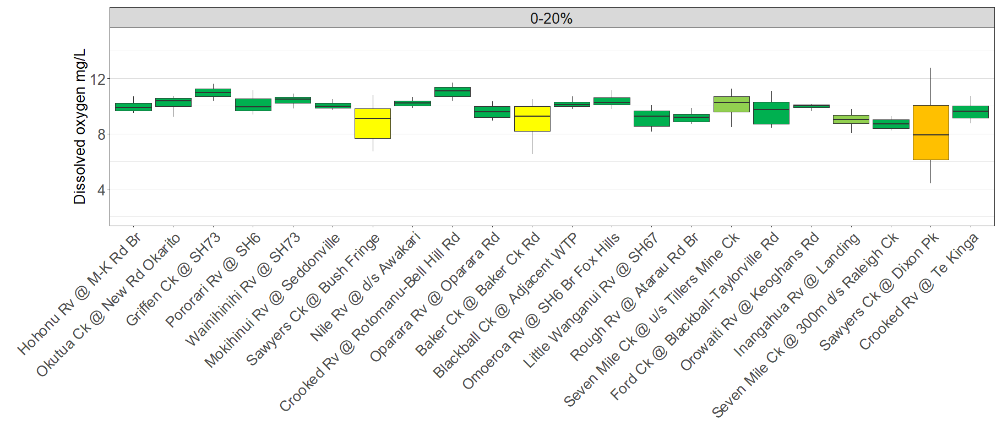
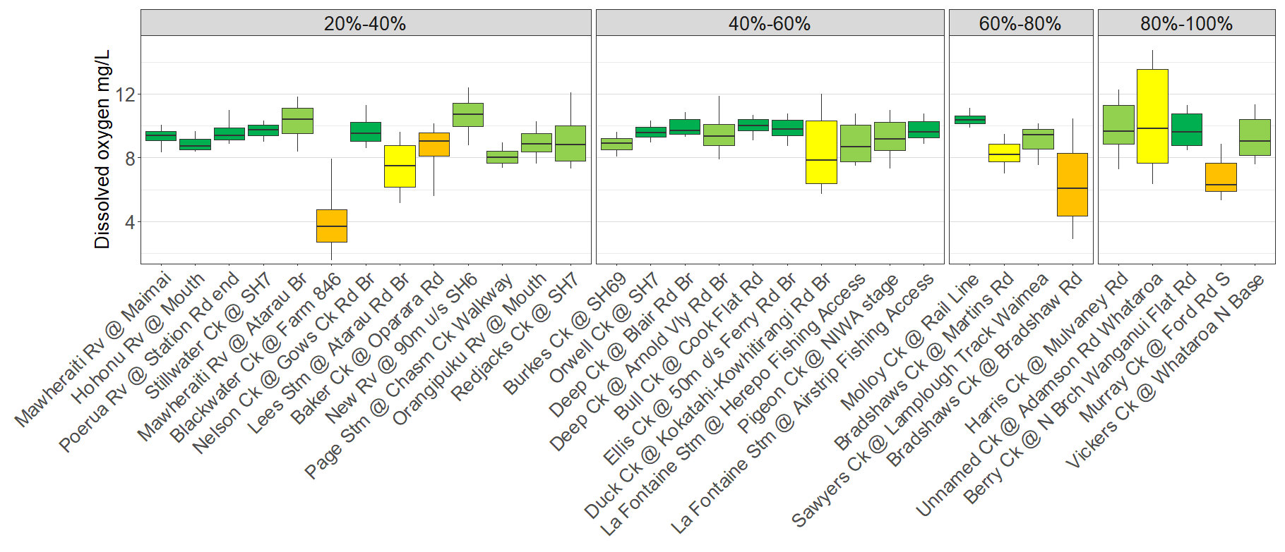
Figure 6. Dissolved oxygen (mg/L) for sites that have continuous data available (minimums and maximums excluded). Sites grouped according to proportion of anthropogenic land cover, with the proportion increasing from left to right. Box colors represent NPSFM (2020) NOF categories: Green = A, No stress caused by low dissolved oxygen on any aquatic organisms that are present at matched reference (near-pristine) sites; Light green = B, Occasional minor stress on sensitive organisms caused by short periods (a few hours each day) of lower dissolved oxygen. Risk of reduced abundance of sensitive fish and macroinvertebrate species; Yellow = C, Moderate stress on a number of aquatic organisms caused by dissolved oxygen levels exceeding preference levels for periods of several hours each day. Risk of sensitive fish and macroinvertebrate species being lost; Orange = D, Significant, persistent stress on a range of aquatic organisms caused by dissolved oxygen exceeding tolerance levels. Likelihood of local extinctions of keystone species and loss of ecological integrity.

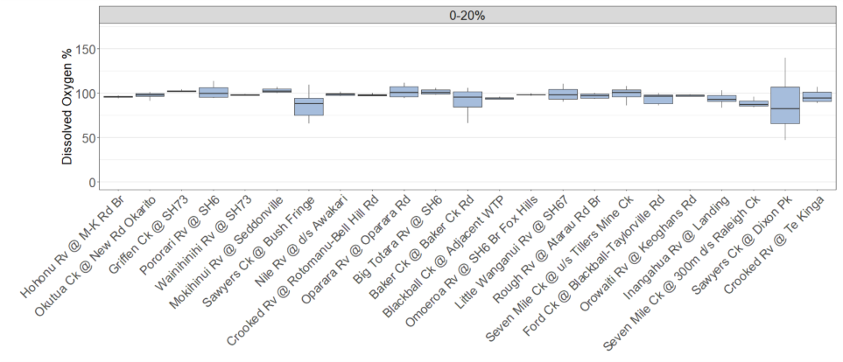
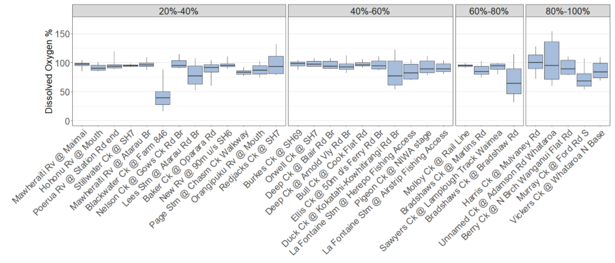
Figure 7. Dissolved oxygen (percent saturation) for sites that have continuous data. Sites grouped according to proportion of anthropogenic land cover, with the proportion increasing from left to right. Minimums and maximums are excluded.

Table 4: NOF categories for dissolved oxygen (mg/L), 2014-2024. Box colors represent NPSFM (2020) NOF categories: Green = A, No stress caused by low dissolved oxygen on any aquatic organisms that are present at matched reference (near-pristine) sites; Light green = B, Occasional minor stress on sensitive organisms caused by short periods (a few hours each day) of lower dissolved oxygen. Risk of reduced abundance of sensitive fish and macroinvertebrate species; Yellow = C, Moderate stress on a number of aquatic organisms caused by dissolved oxygen levels exceeding preference levels for periods of several hours each day. Risk of sensitive fish and macroinvertebrate species being lost; Orange = D, Significant, persistent stress on a range of aquatic organisms caused by dissolved oxygen exceeding tolerance levels. Likelihood of local extinctions of keystone species and loss of ecological integrity.
Site | 1 day min | 7-day mean min | Overall NOF 2024 | Site | 1 day min | 7-day mean min | Overall NOF 2024
Baker Ck @ Baker Ck Rd | B | C | C | Mawheraiti Rv @ Atarau Br | B | B | B
Baker Ck @ Oparara Rd | D | C | D | Mawheraiti Rv @ SH7 Maimai | A | A | A
Berry Ck @ N Brch Wanganui Flat Rd | A | A | A | Mokihinui Rv @ Seddonville | A | A | A
Big Totara Rv @ SH6 | A | A | A | Molloy Ck @ Rail Line | A | A | A
Blackball Ck @ Adjacent WTP | A | A | A | Murray Ck @ Ford Rd S | D | D | D
Blackwater Ck @ Farm 846 | D | D | D | Nelson Ck @ Gows Ck Rd Br | A | A | A
Bradshaws Ck @ Bradshaw Rd | D | D | D | New Rv @ 90m u/s SH6 | B | B | B
Bradshaws Ck @ Martins Rd | B | C | C | Nile Rv @ d/s Awakari | A | A | A
Bull Ck @ Cook Flat Rd | A | A | A | Okutua Ck @ New Rd Br-Okarito Forest | A | A | A
Burkes Ck @ SH69 | A | B | B | Omoeroa Rv @ SH6 Br Fox Hills | A | A | A
Crooked Rv @ Rotomanu-Bell Hill Rd | A | A | A | Oparara Rv @ Oparara Rd | A | A | A
Crooked Rv @ Te Kinga | A | A | A | Orangipuku Rv @ Mouth | B | B | B
Deep Ck @ Arnold Vly Rd Br | B | B | B | Orowaiti Rv @ Keoghans Rd | A | A | A
Deep Ck @ Blair Rd Br | A | A | A | Orwell Ck @ SH7 | A | A | A
Duck Ck @ Kokatahi-Kowhitirangi Rd Br | B | C | C | Page Stm @ Chasm Ck Walkway | B | B | B
Ellis Ck @ 50m d/s Ferry Rd Br | A | A | A | Pigeon Ck @ NIWA stage | B | B | B
Ford Ck @ Blackball-Taylorville Rd | A | A | A | Poerua Rv @ Station Rd end | A | A | A
Griffen Ck @ SH73 | A | A | A | Pororari Rv @ SH6 | A | A | A
Harris Ck @ Mulvaney Rd | B | B | B | Redjacks Ck @ SH7 | B | B | B
Hohonu Rv @ Mitchells-Kumara Rd Br | A | A | A | Rough Rv @ Atarau Rd Br | A | A | A
Hohonu Rv @ Mouth | A | A | A | Sawyers Ck @ Bush Fringe | B | C | C
Inangahua Rv @ Landing | B | B | B | Sawyers Ck @ Dixon Pk | D | D | D
La Fontaine Stm @ Airstrip Fishing Access | A | A | A | Sawyers Ck @ Lamplough Track Waimea | B | B | B
La Fontaine Stm @ Herepo Fishing Access | B | B | B | Seven Mile Ck @ 300m d/s Raleigh Ck | A | A | A
Lees Stm @ Atarau Rd Br | C | C | C | Seven Mile Ck @ u/s Tillers Mine Ck | B | B | B
Little Wanganui Rv @ SH67 | A | A | A | Stillwater Ck @ SH7 | A | A | A

    - pH
The geology and source of a water often determine its pH. The pH is an important ‘master variable’ because it affects other variables and is often needed to interpret other variables (Davies-Colley 2012). Ammonia toxicity is affected by pH because the proportion of the toxic un-ionised form, NH₃, of total ammoniacal nitrogen is primarily controlled by pH and temperature.
Maxima in pH and dissolved oxygen occur in the late afternoon when photosynthesis dominates whereas minima occur in the early morning when respiration is dominant (Wilcock and Chapra 2005). During periods of base flow, in many streams with abundant plant biomass (macrophytes, phytoplankton or periphyton), strong daily cycles of dissolved oxygen and pH coincide. This is due to carbonic acid, a small proportion of which comes from carbon dioxide. When significant photosynthesis occurs carbon dioxide is consumed and oxygen produced, hence there is less carbonic acid and correspondingly a lower pH. The opposite occurs at night.
On the West Coast, low pH can occur in streams for several other reasons other than algal/plant activity and carbonic acid concentrations, including organic and inorganic acids (McDiffett 1996). Many West Coast waterways have low pH’s due to the high rainfall leaching organic acids from wetlands and native forests (Collier and Winterbourn 1990). Acid mine drainage (AMD) is a factor affecting some sites in the WCRC monitoring program. AMD results from the oxidation of pyrite in rocks that accompany Brunner coal measures and is characterized by low pH, sometimes as low as 2-4, usually accompanied by elevated concentrations of dissolved metals such as iron, aluminium and zinc.
A study of pH across New Zealand concluded that the range of pH encountered in New Zealand lowland streams was unlikely to have a major impact on the distribution of most native freshwater fish (West et al. 1997). Consideration for a pH NOF was made by MfE (Davies-Colley 2013,) but not incorporated into the NPSFM. We have used this framework for pH levels over 7 but not for those under 7 due to the regions often naturally low pH levels.
Most streams in the WCRC monitoring program had a pH below 8.0. Examples where it consistently went higher occured in spring fed streams with substantial submerged plant biomass (e.g. Unnamed Creek @ Adamson Road). Alternatively, catchments with significant quantities of limestone geology have elevated pH as the calcium carbonate neutralises hydrogen ions (e.g. Porarari River). AMD was a causal factor in lowering pH at Page Stream, while organic acids created low pH levels in Okutua Stream. Okutua Stream is in the lowland Okarito Forest, and while logging has occurred in parts of this forest historically, significant regeneration has occurred and now has a catchment of ~100% indigenous forest.
There was no relationship between landcover type and median pH levels but the greatest pH variation was observed in streams with significant anthropogenic activity. This could be due to a lack of riparian shade combined with increased nutrients, leading to increased plant/algal growth and carbon dioxide (carbonic acid) fluctuations.

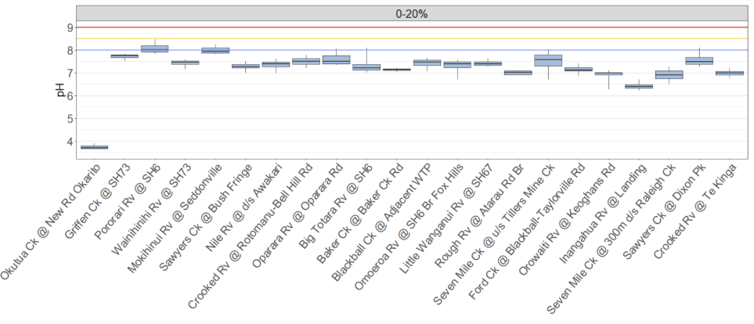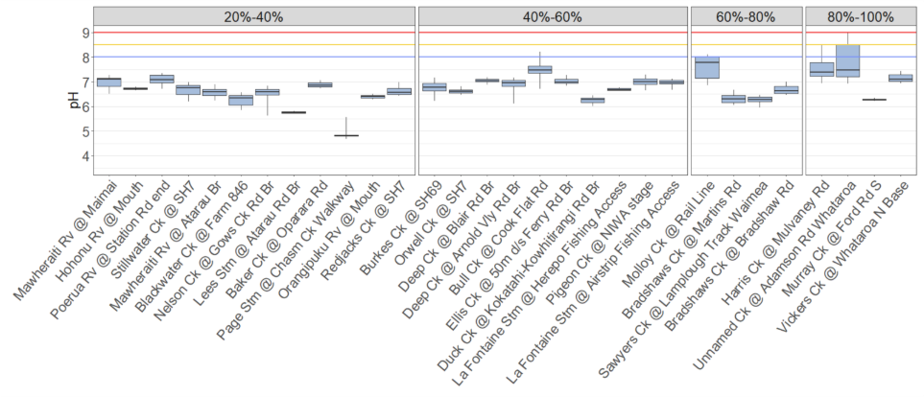

Figure 8. pH levels for a range of WCRC monitoring sites. Sites grouped according to proportion of anthropogenic land cover, with the proportion increasing from left to right. Minimums and maximums have not been displayed.

    - Ammonia and nitrate
Nitrogen is an essential nutrient required for plant growth. Total nitrogen consists of all nitrogen forms found in waterways. Nitrate and ammonia are highly soluble components of total nitrogen and are readily used by plants and algae for grow. They can leach from land to rivers, particularly when conditions are wet. Too much nitrogen can cause excessive algal growth or be toxic. In agricultural catchments, nitrate generally comes from nitrogen fertilizer and livestock urine, while ammonia comes more from point-sources such as discharges from sewerage treatment plants, farm dairy effluent, and industrial operations.
Ammonia levels at all West Coast monitoring sits were predominantly in the A attribute band, which provides a ‘99% species protection level: No observed effect on any species tested’ (Table 5; Figure 9). The remainder of sites were in the B band: ‘95% species protection level: Starts impacting occasionally on the 5% most sensitive species’. Three sites with elevated median ammonia were directly downstream of municipal sewerage oxidation pond discharges. The remainder of sites with higher ammonia were in catchments containing intensive farmland, and often this combined with peaty soils where swampy areas had been converted to pasture (e.g. Blackwater Creek). No sites were in the C or D band for ammonia or nitrate, thus no sites were below the NPSFM national bottom line for these attributes.
Nitrate levels have been low in West Coast waterways when using the NPSFM nitrate NOF framework as a benchmark (Figure 10; Table 6). Nitrate is highly soluble and in the West Coast’s wet or extremely wet climate is readily leached to surface waters via groundwater pathways. A pattern can be observed between anthropogenic landcover of 20% or less, 20%-40%, and over 40%, where nitrate is clearly increasing with anthropogenic landcover. However, nitrate toxicity for aquatic fauna is unlikely anywhere on the West Coast.
Elevated nitrate may promote unwanted algal and plant growth when at concentrations well below toxicity thresholds set by the NPSFM. A range of studies in Aotearoa have considered what an appropriate level of dissolved inorganic nitrogen (DIN) is for managing nuisance algal growth. DIN is nitrate and ammonia combined. As the vast majority of DIN in West Coast streams consists of nitrate, we can apply these DIN thresholds to West Coast nitrate data. Matheson et al. (2012) proposed <0.05 mg/L for DIN as the most stringent, low risk safeguard,with up to <0.3 mg/L as a more lenient higher risk threshold. Following on from this Matheson et al. (2016) proposed the same <0.05 mg/L for DIN as the most stringent, low risk safeguard, and up to <0.2 mg/L as a more lenient high-risk threshold. Storey et al. (2017) suggested a slightly higher low risk DIN threshold of <0.09 mg/L for the Ruamahanga River – a warmer, drier catchment compared to anything on the West Coast.
West Coast monitoring sites in catchments with 20% or less anthropogenic landcover normally met all the above thresholds. At 20%-40% anthropogenic landcover, a mixture of median nitrate levels were observed, some close to low-risk thresholds and some at or above those designated as high risk. From 40% and over, nitrate levels were typically around the high-risk DIN threshold mark, or above. This could indicate that nitrate is likely to be at levels capable of exacerbating algal growth in West Coast waterways when anthropogenic landcover is over 40% of the catchment, and other factors are conducive (e.g. adequate light, warmth, phosphorus, and stable flow regimes).

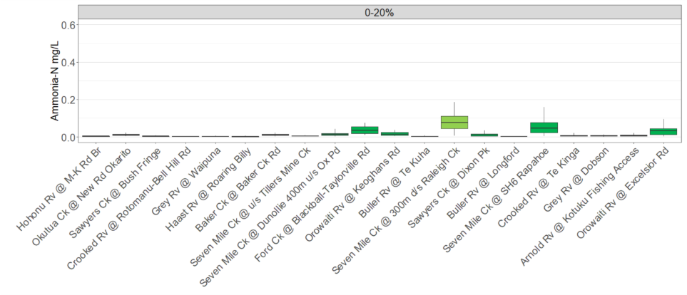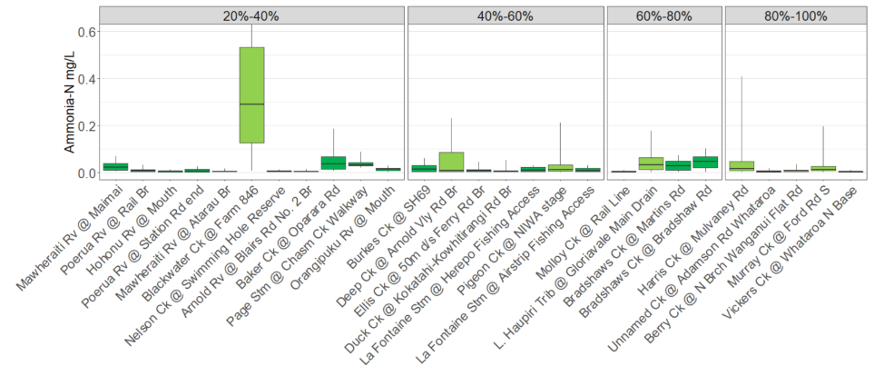

Figure 9. Ammonical nitrogen. Sites grouped according to proportion of anthropogenic land cover, with the proportion increasing from left to right. Minimums and maximums have not been displayed. Box colors represent NPSFM (2020) NOF categories: Green = A, 99% species protection level: No observed effect on any species tested.; Light green = B, 95% species protection level: Starts impacting occasionally on the 5% most sensitive species.

Table 5. Ammonical nitrogen NOF grades. Calculated as 5 yearly medians and maximums (year ending 2023). Box colors represent NPSFM (2020) NOF categories: Green = A, 99% species protection level: No observed effect on any species tested.; Light green = B, 95% species protection level: Starts impacting occasionally on the 5% most sensitive species.

Site name | Median | 95%ile | Overall NOF | Site name | Median | 95%ile | Overall NOF
Arnold Rv @ Blairs Rd No. 2 Br | A | A | A | L. Haupiri Trib @ Gloriavale Main Drain | A | B | B
Arnold Rv @ Kotuku Fishing Access | A | A | A | La Fontaine Stm @ Airstrip Fishing Access | A | A | A
Baker Ck @ Baker Ck Rd | A | A | A | La Fontaine Stm @ Herepo Fishing Access | A | A | A
Baker Ck @ Oparara Rd | A | A | A | Mawheraiti Rv @ Atarau Br | A | A | A
Berry Ck @ N Brch Wanganui Flat Rd | A | B | B | Mawheraiti Rv @ SH7 Maimai | A | A | A
Blackwater Ck @ Farm 846 | B | B | B | Molloy Ck @ Rail Line | A | A | A
Bradshaws Ck @ Bradshaw Rd | A | A | A | Murray Ck @ Ford Rd S | A | B | B
Bradshaws Ck @ Martins Rd | A | A | A | Nelson Ck @ Swimming Hole Reserve | A | A | A
Buller River @ Longford | A | A | A | Okutua Ck @ New Rd Br-Okarito Forest | A | A | A
Buller Rv @ Te Kuha | A | A | A | Orangipuku Rv @ Mouth | A | A | A
Burkes Ck @ SH69 | A | A | A | Orowaiti Rv @ Excelsior Rd | A | A | A
Crooked Rv @ Rotomanu-Bell Hill Rd | A | A | A | Orowaiti Rv @ Keoghans Rd | A | A | A
Crooked Rv @ Te Kinga | A | A | A | Page Stm @ Chasm Ck Walkway | A | A | A
Deep Ck @ Arnold Vly Rd Br | A | B | B | Pigeon Ck @ NIWA stage | A | B | B
Duck Ck @ Kokatahi-Kowhitirangi Rd Br | A | A | A | Poerua Rv @ Rail Br | A | A | A
Ellis Ck @ 50m d/s Ferry Rd Br | A | A | A | Sawyers Ck @ Bush Fringe | A | A | A
Ford Ck @ Blackball-Taylorville Rd | A | A | A | Sawyers Ck @ Dixon Pk | A | A | A
Grey Rv @ Dobson | A | A | A | Seven Mile Ck @ 300m d⁄s Raleigh Ck | A | B | B
Grey Rv @ Waipuna | A | A | A | Seven Mile Ck @ Dunollie 400m u⁄s Ox Pd | A | A | A
Haast Rv @ Roaring Billy | A | A | A | Seven Mile Ck @ SH6 Rapahoe | A | A | A
Harris Ck @ Mulvaney Rd | A | B | B | Seven Mile Ck @ u/s Tillers Mine Ck | A | A | A
Hohonu Rv @ Mitchells-Kumara Rd Br | A | A | A | Unnamed Ck @ Adamson Rd Whataroa | A | A | A
Hohonu Rv @ Mouth | A | A | A | Vickers Ck @ Whataroa N Base | A | A | A

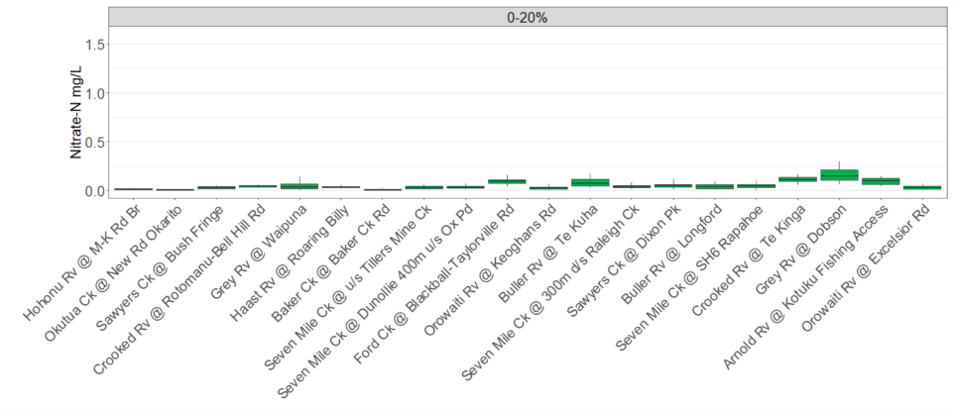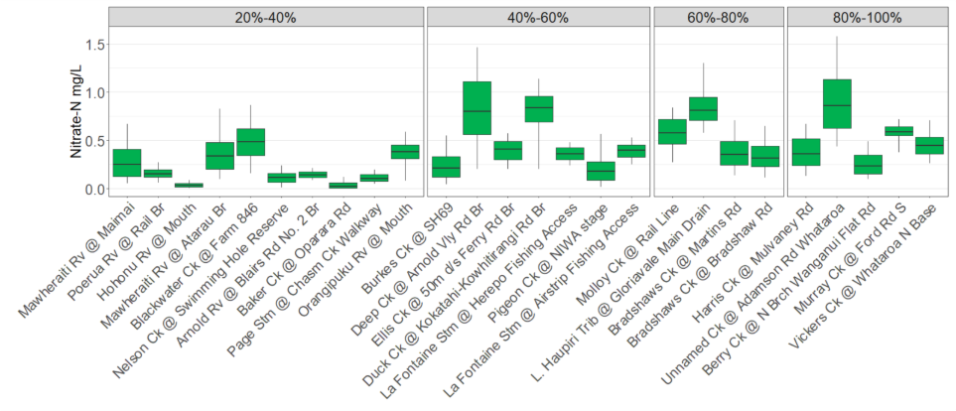

Figure 10. Nitrate nitrogen data for individual Regional Council monitoring program sites where there is discrete data available. (minimums and maximums excluded). Graph group sites based on the proportion of anthropogenic land cover, box colors represent NOF categories: A. Green = A state, High conservation value system. Unlikely to be effects even on sensitive species.

Table 6 Nitrate NOF grades for individual Regional Council monitoring program sites, calculated as a 5 yearly median and 95th percentile (displayed as year ending of 5 year block of data, year ending 2023). Green = A state, High conservation value system. Unlikely to be effects even on sensitive species.

Site name | Median | 95th percentile | Site name | Median | 95th percentile
Arnold Rv @ Blairs Rd No. 2 Br | A | A | L. Haupiri Trib @ Gloriavale Main Drain | A | A
Arnold Rv @ Kotuku Fishing Access | A | A | La Fontaine Stm @ Airstrip Fishing Access | A | A
Baker Ck @ Baker Ck Rd | A | A | La Fontaine Stm @ Herepo Fishing Access | A | A
Baker Ck @ Oparara Rd | A | A | Mawheraiti Rv @ Atarau Br | A | A
Berry Ck @ N Brch Wanganui Flat Rd | A | A | Mawheraiti Rv @ SH7 Maimai | A | A
Blackwater Ck @ Farm 846 | A | A | Molloy Ck @ Rail Line | A | A
Bradshaws Ck @ Bradshaw Rd | A | A | Murray Ck @ Ford Rd S | A | A
Bradshaws Ck @ Martins Rd | A | A | Nelson Ck @ Swimming Hole Reserve | A | A
Burkes Ck @ SH69 | A | A | Okutua Ck @ New Rd Br-Okarito Forest | A | A
Crooked Rv @ Rotomanu-Bell Hill Rd | A | A | Orangipuku Rv @ Mouth | A | A
Crooked Rv @ Te Kinga | A | A | Orowaiti Rv @ Excelsior Rd | A | A
Deep Ck @ Arnold Vly Rd Br | A | A | Orowaiti Rv @ Keoghans Rd | A | A
Duck Ck @ Kokatahi-Kowhitirangi Rd Br | A | A | Page Stm @ Chasm Ck Walkway | A | A
Ellis Ck @ 50m d/s Ferry Rd Br | A | A | Pigeon Ck @ NIWA stage | A | A
Ford Ck @ Blackball-Taylorville Rd | A | A | Poerua Rv @ Rail Br | A | A
Harris Ck @ Mulvaney Rd | A | A | Sawyers Ck @ Bush Fringe | A | A
Hohonu Rv @ Mitchells-Kumara Rd Br | A | A | Sawyers Ck @ Dixon Pk | A | A
Hohonu Rv @ Mouth | A | A

    - Dissolved reactive phosphorus
- Nutrient supply is a controlling factor in the pro-
- liferation of aquatic macrophytes and algae associated
- with eutrophication of streams and rivers (Carpenter
- et al. 1998). Bioavailability of either nitrogen (N)
- or phosphorus (P) often limits macrophyte and algal
- growth rates (Schindler et al. 2008). Bioavailability
- can be split into three components: the relative
- abundance of N and P (indicated by N:P ratios), the
- concentrations of N and P, and the chemical forms
- of N or P (Wetzel 2001).
-  Redeldetal.(1963)publisheddatathatindicated
- a molar ratio of carbon (C), N and P of 100:16:1 was
- 986 New Zealand Journal of Marine and Freshwater Research, 2009, Vol. 43
- reasonably constant during phytoplankton growth.
- This ratio is commonly used as a general indicator
- of plant and algal growth potential in marine and
- freshwater systems (Schindler et al. 2008).
Nutrient supply is a controlling factor in the pro-
liferation of aquatic macrophytes and algae associated
with eutrophication of streams and rivers (Carpenter
et al. 1998). Bioavailability of either nitrogen (N)
or phosphorus (P) often limits macrophyte and algal
growth rates (Schindler et al. 2008). Bioavailability
can be split into three components: the relative
abundance of N and P (indicated by N:P ratios), the
concentrations of N and P, and the chemical forms
of N or P (Wetzel 2001).
 Redeldetal.(1963)publisheddatathatindicated
a molar ratio of carbon (C), N and P of 100:16:1 was
986 New Zealand Journal of Marine and Freshwater Research, 2009, Vol. 43
reasonably constant during phytoplankton growth.
This ratio is commonly used as a general indicator
of plant and algal growth potential in marine and
freshwater systems (Schindler et al. 2008).
Nutrient supply is a controlling factor in the proliferation of aquatic macrophytes and algae associated with eutrophication of streams and rivers. Bioavailability of either nitrogen (N) or phosphorus (P) often limits macrophyte and algal growth rates.
Phosphorus is an essential nutrient for plants and is a natural component of healthy rivers when at low concentrations. Agricultural and urban land use can add phosphorus to waterways, which may cause excessive algal growth and have a negative effect on river habitats. Council monitors both total phosphorus and dissolved reactive phosphorus. Dissolved reactive phosphorus (DRP) is the form of phosphorus immediately available to support plant and algae growth.
The NPSFM (2020) provides a NOF for DRP in waterways, to protect against nuisance algal growth, and which has been applied to the DRP data collected at Council monitoring sites (Table 7; Figure 11). A similar pattern as nitrate, albeit less pronounced, can be observed between anthropogenic landcover of 20% or less, 20%-40%, and over 40%, where phosphorus increases with anthropogenic landcover. At 20% or less anthropogenic landcover the majority of sites are in the A or B band, with one in the C band. Above 20% a greater number of sites are in the C and D bands. Sites in the C band risk having ecological communities impacted. If other conditions favour eutrophication, DRP enrichment may cause increased algal and plant growth, loss of sensitive macro-invertebrate and fish taxa, and high rates of respiration and decay. Fifteen percent of monitoring sites were below the National Bottom Line for DRP, in the D band. At this point ‘ecological communities are impacted by substantial DRP elevation above natural reference conditions. In combination with other conditions favouring eutrophication, DRP enrichment drives excessive primary production and significant changes in macroinvertebrate and fish communities, as taxa sensitive to hypoxia are lost’.
The Redfield ratio (Redfield et al. 1963), is considered to be the optimum ratio of N and P for plant growth, which is a molar ratio of N:P of 16:1. Around 76% of waterways monitored by South Island regional councils were found to be phosphorus limited, with a higher figure likely for the West Coast (Mcdowell et al. 2009). Given the likelihood of P limitation in most West Coast waterways, many stream reaches with over 40% of anthropogenic landcover were likely to have P concentrations above thresholds that could contribute to aquatic plant and algal proliferations.

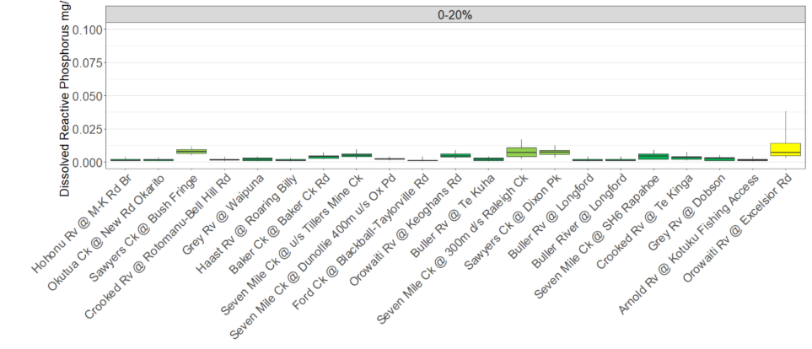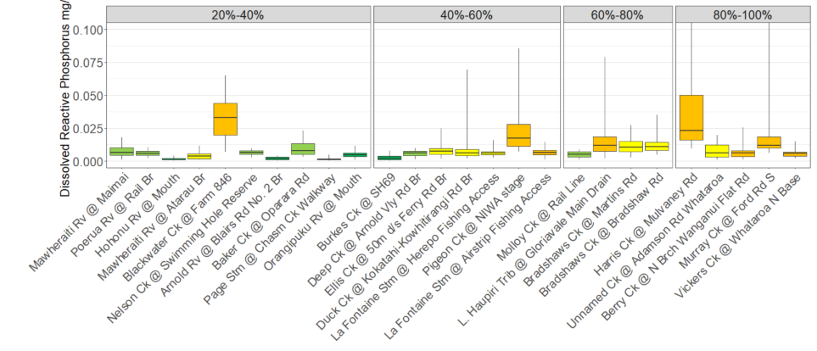

Figure 11. Dissolved reactive phosphorus. Sites grouped according to proportion of anthropogenic land cover, with the proportion increasing from left to right. Minimums and maximums are excluded. Box colors represent NPSFM (2020) NOF categories: Green = A, Ecological communities and ecosystem processes are similar to those of natural reference conditions. No adverse effects attributable to dissolved reactive phosphorus (DRP) enrichment are expected; Light green = B, Ecological communities are slightly impacted by minor DRP elevation above natural reference conditions. If other conditions also favour eutrophication, sensitive ecosystems may experience additional algal and plant growth, loss of sensitive macroinvertebrate taxa, and higher respiration and decay rates; Yellow = C, Ecological communities are impacted by moderate DRP elevation above natural reference conditions. If other conditions also favour eutrophication, DRP enrichment may cause increased algal and plant growth, loss of sensitive macro-invertebrate and fish taxa, and high rates of respiration and decay; Orange = D, Ecological communities impacted by substantial DRP elevation above natural reference conditions. In combination with other conditions favouring eutrophication, DRP enrichment drives excessive primary production and significant changes in macroinvertebrate and fish communities, as taxa sensitive to hypoxia are lost.

Table 7 Dissolved reactive phosphorus NOF grades for individual Regional Council monitoring program sites, calculated as a 5 yearly median and 95th percentile (displayed as year ending of 5 year block of data, year ending 2023). Refer Figure 11 for NOF category descriptions.
Site Name | Median | 95%ile | Overall NOF
Arnold Rv @ Blairs Rd No. 2 Br | A | A | A
Arnold Rv @ Kotuku Fishing Access | A | A | A
Baker Ck @ Baker Ck Rd | A | A | A
Baker Ck @ Oparara Rd | B | A | B
Berry Ck @ N Brch Wanganui Flat Rd | B | D | D
Blackwater Ck @ Farm 846 | D | D | D
Bradshaws Ck @ Bradshaw Rd | C | C | C
Bradshaws Ck @ Martins Rd | C | C | C
Buller River @ Longford | A | A | A
Buller Rv @ Te Kuha | A | A | A
Burkes Ck @ SH69 | A | A | A
Crooked Rv @ Rotomanu-Bell Hill Rd | A | A | A
Crooked Rv @ Te Kinga | A | A | A
Deep Ck @ Arnold Vly Rd Br | B | A | B
Duck Ck @ Kokatahi-Kowhitirangi Rd Br | B | C | C
Ellis Ck @ 50m d/s Ferry Rd Br | B | C | C
Ford Ck @ Blackball-Taylorville Rd | A | A | A
Grey Rv @ Dobson | A | A | A
Grey Rv @ Waipuna | A | A | A
Haast Rv @ Roaring Billy | A | A | A
Harris Ck @ Mulvaney Rd | D | D | D
Hohonu Rv @ Mitchells-Kumara Rd Br | A | A | A
Hohonu Rv @ Mouth | A | A | A
L. Haupiri Trib @ Gloriavale Main Drain | C | D | D
La Fontaine Stm @ Airstrip Fishing Access | B | D | D
La Fontaine Stm @ Herepo Fishing Access | B | C | C
Mawheraiti Rv @ Atarau Br | B | C | C
Mawheraiti Rv @ SH7 Maimai | B | A | B
Molloy Ck @ Rail Line | B | A | B
Murray Ck @ Ford Rd S | C | D | D
Nelson Ck @ Swimming Hole Reserve | B | A | B
Okutua Ck @ New Rd Br-Okarito Forest | A | A | A
Orangipuku Rv @ Mouth | A | A | A
Orowaiti Rv @ Excelsior Rd | B | C | C
Orowaiti Rv @ Keoghans Rd | A | A | A
Page Stm @ Chasm Ck Walkway | A | A | A
Pigeon Ck @ NIWA stage | C | D | D
Poerua Rv @ Rail Br | B | A | B
Sawyers Ck @ Bush Fringe | B | A | B
Sawyers Ck @ Dixon Pk | B | A | B
Seven Mile Ck @ 300m d/s Raleigh Ck | B | A | B
Seven Mile Ck @ Dunollie 400m u/s Ox Pd | A | A | A
Seven Mile Ck @ SH6 Rapahoe | A | A | A
Seven Mile Ck @ u/s Tillers Mine Ck | A | A | A
Unnamed Ck @ Adamson Rd Whataroa | B | C | C
Vickers Ck @ Whataroa N Base | B | D | D

    - E. coli: human contact.
Water contaminated with faeces from warm-blooded animals can be a risk for people and stock that are drinking or coming into contact with it. The presence of E. coli in water indicates contamination from faecal matter. Concentrations of E. coli are used to estimate the risk of disease-causing organisms like campylobacter, in freshwaters.
The purpose of the E. coli target attribute states in the National Objectives Framework (NOF) under the NPSFM for human contact is to provide a compulsory attribute for assessing freshwater suitability for activities involving direct human contact, such as swimming, kayaking, and other recreation. To reiterate, this differs from the NOF for primary contact, which applies to primary contact recreation sampling sites surveyed weekly from November to March each year.
Unlike the other NOF compulsory attributes, the NOF for human contact has 5, not 4, attribute bands for E. coli, ranging from A to E. There is no National Bottom Line, but there is an expectation under the legislation that a site will be improved to a point where it moves up at least one attribute band.
Sites where there was little of no anthropogenic landcover had E. coli levels in the A band. This changed rapidly with the introduction of human activity (Figure 12), with most sites sitting in the E band once past 10% anthropogenic landcover, and all sites in E band after 40%. The E band describes infection risk as ‘for more than 30% of the time the estimated risk is ≥50 in 1,000 (>5% risk). The predicted average infection risk is >7%’.
The NOF for human contact criteria for determining attributes states uses four statistical categories, and the one generating the poorest score is used for the final attribute state score. One of these categories uses the 95th percentile and another a median (Table 8). Not only does the 95th percentile consistently score in a much poorer band than other statistical measures like the median, but it often puts a site into the E band when the median score is an A. The West Coast has a wet to very wet climate and the high rainfall is conducive to regular surface run-off into waterways. Climate projections are for the West Coast to get wetter and receive more heavy rainfall events (MfE 2018), which could further exacerbate poor E. coli results. There were several sites with an A for the median and an E for the 95th percentile. This suggested that while E. coli performance was often favourable, as few as 1 in 20 high results would be enough to trigger this. Hence one significant rain event during sampling could be sufficient to generate an E band rating.
The obvious source of faecal contamination is ruminants and people, both of which are consistently detected when the source of the E. coli is determined using eDNA testing in areas with significant contamination. However, avian markers are also often present. These birds are wild and largely beyond our ability to manage. Many common, more adaptable species of waterfowl maybe more abundant in lowland areas that coincide with human activity (Wang et al. 2021).
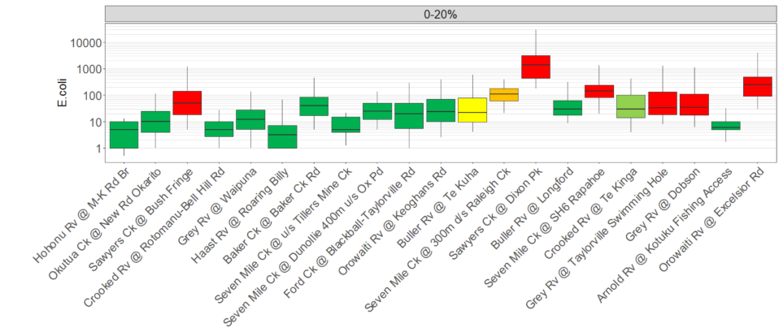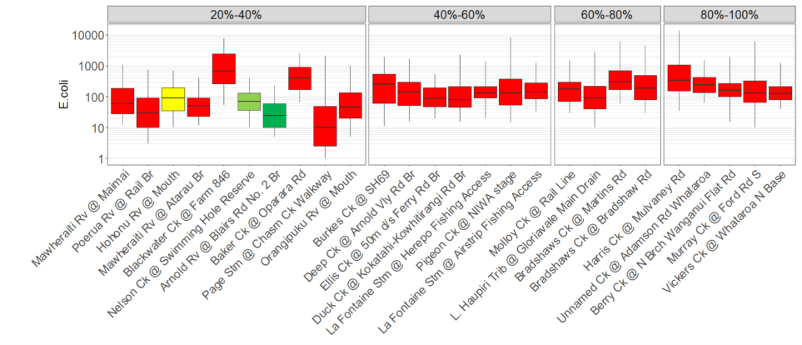
Figure 12. E. coli (minimums and maximums excluded). Sites grouped according to proportion of anthropogenic land cover, with the proportion increasing from left to right. Box colors represent NPSFM (2020) NOF categories: Green = A, For at least half the time, the estimated risk is <1 in 1,000 (0.1% risk). The predicted average infection risk is 1%; Light green = B, For at least half the time, the estimated risk is <1 in 1,000 (0.1% risk). The predicted average infection risk is 2%; Yellow = C For at least half the time, the estimated risk is <1 in 1,000 (0.1% risk). The predicted average infection risk is 3%; Orange = D, 20-30% of the time the estimated risk is ≥50 in 1,000 (>5% risk). The predicted average infection risk is >3%; Red = E, For more than 30% of the time the estimated risk is ≥50 in 1,000 (>5% risk). The predicted average infection risk is >7%.

Table 8 E. coli 5 yearly NOF grades for individual monitoring program sites 2019 – 2023 (displayed as year ending of 5 year block of data). Refer to Figure 12 for NOF categories.
Site Name | Median | 95%ile | % >260 | % >540 | Overall NOF
Arnold Rv @ Blairs Rd No. 2 Br | A | A | A | A | A
Arnold Rv @ Kotuku Fishing Access | A | A | A | A | A
Baker Ck @ Baker Ck Rd | A | A | A | A | A
Baker Ck @ Oparara Rd | E | E | E | E | E
Berry Ck @ N Brch Wanganui Flat Rd | D | E | B | C | E
Blackwater Ck @ Farm 846 | E | E | E | E | E
Bradshaws Ck @ Bradshaw Rd | E | E | D | D | E
Bradshaws Ck @ Martins Rd | E | E | E | E | E
Buller River @ Longford | A | A | A | A | A
Buller Rv @ Te Kuha | A | B | B | C | C
Burkes Ck @ SH69 | D | E | D | D | E
Crooked Rv @ Rotomanu-Bell Hill Rd | A | A | A | A | A
Crooked Rv @ Te Kinga | A | B | A | B | B
Deep Ck @ Arnold Vly Rd Br | D | E | D | D | E
Duck Ck @ Kokatahi-Kowhitirangi Rd Br | A | E | B | D | E
Ellis Ck @ 50m d/s Ferry Rd Br | A | E | B | B | E
Ford Ck @ Blackball-Taylorville Rd | A | A | A | A | A
Grey Rv @ Dobson | A | E | B | C | E
Grey Rv @ Taylorville Swimming Hole | A | E | A | C | E
Haast Rv @ Roaring Billy | A | A | A | A | A
Harris Ck @ Mulvaney Rd | E | E | E | E | E
Hohonu Rv @ Mitchells-Kumara Rd Br | A | A | A | A | A
Hohonu Rv @ Mouth | A | C | A | C | C
L. Haupiri Trib @ Gloriavale Main Drain | A | E | B | D | E
La Fontaine Stm @ Airstrip Fishing Access | D | E | D | D | E
La Fontaine Stm @ Herepo Fishing Access | D | E | C | C | E
Mawheraiti Rv @ Atarau Br | A | B | E | E | E
Mawheraiti Rv @ SH7 Maimai | A | E | B | C | E
Molloy Ck @ Rail Line | D | E | B | C | E
Murray Ck @ Ford Rd S | D | E | C | D | E
Nelson Ck @ Swimming Hole Reserve | A | B | A | B | B
Okutua Ck @ New Rd Br-Okarito Forest | A | A | A | A | A
Orangipuku Rv @ Mouth | A | E | B | C | E
Orowaiti Rv @ Excelsior Rd | E | E | D | D | E
Orowaiti Rv @ Keoghans Rd | A | A | A | A | A
Page Stm @ Chasm Ck Walkway | A | E | B | C | E
Pigeon Ck @ NIWA stage | D | E | D | C | E
Poerua Rv @ Rail Br | A | E | A | C | E
Sawyers Ck @ Bush Fringe | A | E | A | C | E
Sawyers Ck @ Dixon Pk | E | E | E | E | E
Seven Mile Ck @ 300m d/s Raleigh Ck | D | A | A | A | D
Seven Mile Ck @ Dunollie 400m u/s Ox Pd | A | A | A | A | A
Seven Mile Ck @ SH6 Rapahoe | D | E | B | C | E
Seven Mile Ck @ u/s Tillers Mine Ck | A | A | A | A | A
Unnamed Ck @ Adamson Rd Whataroa | E | E | E | E | E
Vickers Ck @ Whataroa N Base | D | E | D | D | E

    - Macroinvertebrates
Freshwater invertebrates include organisms such as crustaceans, molluscs, worms, and freshwater insects. Invertebrates perform important ecosystem services, become food for native fish and birds, and have biodiversity value in their own right. They are affected by impacts on water and habitat quality; therefore, they are useful indicators of stream health. The Macroinvertebrate Community Index (MCI) and Quantitative Macroinvertebrate Community Index (QMCI) are part of the NPSFM NOF for freshwater monitoring. Both indices use the same taxa scores, which are allocated on a scale of 1 to 10, depending on their pollution tolerance. However, while the MCI only uses presence/absence data, the QMCI also utilizes the abundance of each taxa prior to calculating a final score. Smaller numbers equal poorer quality.
While not always the case, it was typical for QMCI scores to be poorer than MCI scores (Table 9). Both the MCI and QMCI showed a similar overall declining trend with increasing anthropogenic landcover, but there were individual exceptions (Figure 13). Additionally, the difference between high and lower quality sites was often much greater for QMCI versus MCI scores. The reason for this is that not only did many of the poorer quality sites have a higher occurrence of low scoring taxa, but that these low scoring taxa were more numerous, leading to more profound differentiation between good and poor sites.
Macoinvertebrate community structure can be affected by many factors. These can work collectively, and it is often hard to tease them apart. Changes in community structure are often attributed to ‘water quality’ but this should be defined more carefully. Contaminants in the water like dissolved metals, ammonia and nitrate toxicity, and organic pollution are not normally high enough in West Coast waterways to have direct effect on most macroinvertebrate taxa. However, increased nutrients may assist with algal growth that affects habitats and oxygen regimes. Increases in deposited and suspended fine sediment reduce habitat and food quality for more sensitive (aka high scoring) taxa. Water that is warmer and slower flowing is less suitable for sensitive species. Hence differences in habitat rather than water quality per se are most likely what regulate community structure among most West Coast waters.
Spatially, the origin of what has influence on macroinvertebrates, at the location they are sampled, could be at a reach or catchment scale. Examples of reach scale would be: Riparian shade adjacent to the sampling point that limits algal growth and improves habitat; or adjacent bank erosion smothering the sampling point in fine sediment (cobbles are preferable to sand and silt). Catchment scale examples include: Accumulating nutrient enrichment and fine sediment from multiple upstream sources; rising water temperatures resulting from a collective lack of riparian shade. The overall downward gradient of MCI and QMCI scores in response to increasing anthropogenic landcover suggests the importance of catchment scale factors.
It is important to note the role of intrinsic characteristics, which are beyond the control of people, and can exacerbate impacts from human activity. Examples are: soft, erodible geology prone to erosion and generation of fine sediment (e.g. Sawyers Ck @ Bush Fringe); small lowland streams that have limited assistance from cool mountain headwater supply or spring recharge (e.g. Burke Ck and Baker Ck @ Oparara); low gradient streams with low water velocities (desirable macroinvertebrates like high velocities in order to get enough oxygen), that are prone to aquatic plant proliferations (e.g. Bradshaws and Blackwater Creeks). Such characteristics can exacerbate or ameliorate the impact from anthropogenic activities. A large number of WCRC sampling sites have relatively small amounts of anthropogenic cover in the catchment. Such sites are normally in the A or B attribute bands. Despite a largely pristine catchment, some form of human influence can’t be ruled out for those that are not in the A band but intrinsic factors may also push scores below the A band. As few WCRC monitoring sites have zero anthropogenic landcover, this is hard to test, but two such sites were in the B band for MCI. The B band designates quality as a ‘macroinvertebrate community indicative of mild organic pollution or nutrient enrichment. Largely composed of taxa sensitive to organic pollution/nutrient enrichment.’
Four sites in the 0-20% anthropogenic cover group scored particularly poorly. Sawyers Ck @ Dixon Park is in a highly developed urban area. Sewerage overflows are common, combined with stormwater inputs, earthworks, and other sources of contaminants. The other three sites are on large rivers, monitored by NIWA. These sites, the Grey River @ Waipuna in particular, have good water quality and it must be a habitat feature that is causing poor scores. For Waipuna in particular, the nature of habitat at the sampling location maybe responsible for these low scores. For the remaining sites below the National Bottom Line (D band), that are in catchments with over 20% anthropogenic landcover, it is predominantly factors like earthworks (fine sediment inputs), significant loss of nutrients, lack of riparian protection, and instream habitat alteration, that are likely to impact on macroinvertebrate communities.

Table 9. MCI and QMCI grades for individual Regional Council monitoring program sites, calculated as a 5 yearly median (displayed as year ending of 5 year block of data, year ending 2023).
Site name | MCI median | QMCI median | Site name | MCI median | QMCI median
Baker Ck @ Baker Ck Rd | B | B | La Fontaine Stm @ Airstrip Fishing Access | C | C
Baker Ck @ Oparara Rd | C | D | La Fontaine Stm @ Herepo Fishing Access | C | C
Berry Ck @ N Brch Wanganui Flat Rd | C | C | Mawheraiti Rv @ Atarau Br | B | A
Bradshaws Ck @ Bradshaw Rd | D | D | Mawheraiti Rv @ SH7 Maimai | B | B
Buller Rv @ Longford | C | D | Molloy Ck @ Rail Line | B | B
Buller Rv @ Te Kuha | C | D | Murray Ck @ Ford Rd S | C | B
Burkes Ck @ SH69 | C | D | Nelson Ck @ Swimming Hole Reserve | B | A
Crooked Rv @ Rotomanu-Bell Hill Rd | B | A | Okutua Ck @ New Rd Br-Okarito Forest | B | A
Crooked Rv @ Te Kinga | B | A | Orangipuku Rv @ Mouth | B | A
Deep Ck @ Arnold Vly Rd Br | B | B | Orowaiti Rv @ Keoghans Rd | B | B
Duck Ck @ Kokatahi-Kowhitirangi Rd Br | B | A | Page Stm @ Chasm Ck Walkway | C | D
Ellis Ck @ 50m d/s Ferry Rd Br | B | B | Poerua Rv @ Rail Br | B | A
Ford Ck @ Blackball-Taylorville Rd | B | B | Sawyers Ck @ Bush Fringe | B | A
Grey Rv @ Dobson | C | D | Sawyers Ck @ Dixon Pk | C | D
Grey Rv @ Waipuna | B | D | Seven Mile Ck @ 300m d/s Raleigh Ck | B | C
Haast Rv @ Roaring Billy | C | B | Seven Mile Ck @ Dunollie 400m u/s Ox Pd | B | A
Harris Ck @ Mulvaney Rd | C | C | Seven Mile Ck @ u/s Tillers Mine Ck | A | A
Hohonu Rv @ Mitchells-Kumara Rd Br | A | A | Unnamed Ck @ Adamson Rd Whataroa | D | D
Hohonu Rv @ Mouth | B | A | Vickers Ck @ Whataroa N Base | C | C

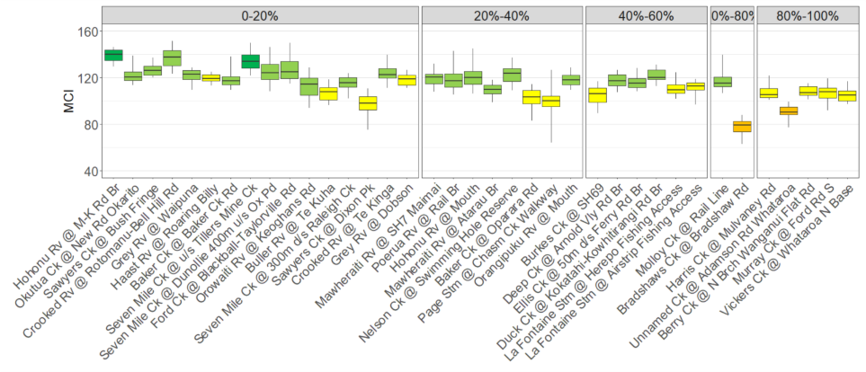
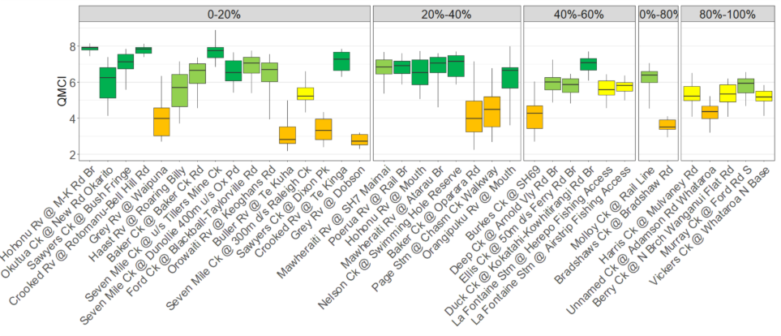
Figure 13 (MCI) and (QMCI). Data for monitoring program sites (minimums and maximums excluded). Sites grouped according to proportion of anthropogenic land cover, with the proportion increasing from left to right. Box colors represent NPSFM (2020) NOF categories: Green = A Macroinvertebrate community, indicative of pristine conditions with almost no organic pollution or nutrient enrichment; Light green = B, Macroinvertebrate community indicative of mild organic pollution or nutrient enrichment. Largely composed of taxa sensitive to organic pollution/nutrient enrichment; Yellow = C, Macroinvertebrate community indicative of moderate organic pollution or nutrient enrichment. There is a mix of taxa sensitive and insensitive to organic pollution/nutrient enrichment; and Orange = D, Macroinvertebrate community indicative of severe organic pollution or nutrient enrichment. Communities are largely composed of taxa insensitive to inorganic pollution/nutrient enrichment.

    - Periphyton cover
The NPSFM (2020) has a NOF with attribute bands for periphyton. Periphyton is a community of algae, bacteria, fungi, and detritus attached to submerged surfaces in streams, rivers, and lakes. Algae are the mainstay of measurable bulk periphyton biomass in West Coast waterways and the driver of excessive periphyton. Hence the weight of chlorophyll a on a known area of streambed is used to estimate the biomass of periphyton.
Periphyton forms a slimy or filamentous layers on rocks, wood, and plants in the stream. It is a primary producer in freshwater ecosystems, providing an important food source for many macroinvertebrates, thus supporting the food chain. However, too much periphyton: Negatively alters habitat for many aquatic fauna; reduced oxygen at night; and reduces amenity value.
Periphyton biomass is assessed via measuring the weight of chlorophyll a removed from a known area of river substrate. A subset of our monitoring sites are assessed monthly, when stream flows are low enough to allow access. Okutua Stream is a reference site with no human activity upstream. Its waters are cool and low in nutrients. The channel at the sampling site and across the whole catchment is well shaded by tall mature trees. As a result, periphyton concentrations were negligible (Figure 14).
Most sites were in the A or B band, indicating rare or occasional algal blooms. There were two exceptions (Table 10). Sawyers Creek, despite its forested headwaters, lacks riparian shade as it winds through urban Greymouth. It is small and slow flowing in its lower reaches, receiving nutrients from sewerage overflows and farming. While not excessively warm (median CRI ~22ᵒC), mild, coastal temperatures are suitable for faster algal growth and greater biomass.
Unnamed Ck @ Adamsons Rd is a small spring fed stream with no significant riparian shade, high nutrient concentrations, stable flows with minimum scouring and bed movement, and narrow annual temperature range.

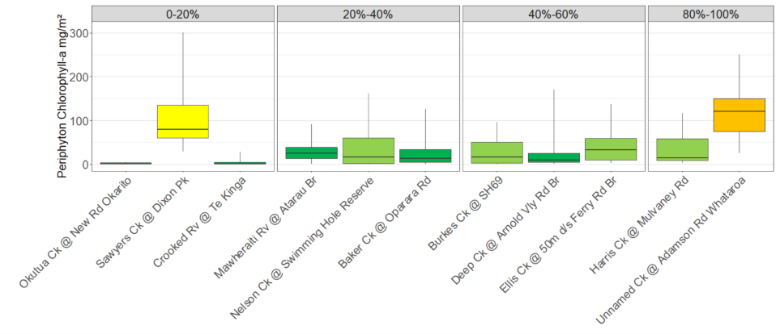
Figure 14. Periphyton (minimums and maximums excluded). Sites grouped according to proportion of anthropogenic land cover, with the proportion increasing from left to right. Green = A, Rare blooms reflecting negligible nutrient enrichment and/or alteration of the natural flow regime or habitat., Light green = B, Occasional blooms reflecting low nutrient enrichment and/or alteration of the natural flow regime or habitat; Yellow = C, Periodic short-duration nuisance blooms reflecting moderate nutrient enrichment and/or moderate alteration of the natural flow regime or habitat; Orange = D, Regular and/or extended-duration nuisance blooms reflecting high nutrient enrichment and/or significant alteration of the natural flow regime or habitat.

Table 10 Periphyton NOF grades for individual Regional Council monitoring program sites, calculated as a 3 yearly 92% percentile (displayed as year ending of 3 year block of data, year ending 2023).
Site Name | NOF
Baker Ck @ Oparara Rd | A
Burkes Ck @ SH69 | B
Crooked Rv @ Te Kinga | A
Deep Ck @ Arnold Vly Rd Br | A
Ellis Ck @ 50m d/s Ferry Rd Br | B
Harris Ck @ Mulvaney Rd | B
Nelson Ck @ Swimming Hole Reserve | B
Okutua Ck @ New Rd Br-Okarito Forest | A
Sawyers Ck @ Dixon Pk | C
Unnamed Ck @ Adamson Rd Whataroa | D
Mawheraiti Rv @ Atarau Br | A

    - Primary human contact
Water contaminated with faeces from warm-blooded animals can be a risk for people and stock that are drinking or coming into contact with it. The presence of faecal bacteria like E. coli and Enterococci in water indicates contamination from faecal matter. Concentrations of these bacteria are used to estimate the risk of disease-causing organisms like campylobacter.
From November to March, Council monitors E. coli and Enteroccocci at rivers, lakes, and coastal beaches used for swimming. Council applies criteria from the Ministry for the Environments microbiological water quality guidelines for marine and freshwater recreational areas (MfE 2003), to this data, which is similar to the NPSFM NOF for primary contact.
Rivers and estuaries were more frequently unsuitable for swimming (Figure 15), particularly during, and shortly after, rain events when compared to lakes and ocean beaches. Lakes had the highest quality and lowest pathogen risk. (Figure 15). Results for individual sites have been provided in Appendix A, Figures 16 to 20).
All river and lagoon sites are located in places that are downstream of a large number of potential pathogen sources. Faecal source tracking using DNA markers for E. coli animal origin, undertaken by Council to investigate potential sources of contamination, identified bovine, human and avian sources of contamination at all sites tested, at some point in time e.g. the Orowaiti Lagoon. Some sources were more prevalent, with a higher occurrence or stronger signal within a sample. Shingle Beach samples were dominated by human and bovine. Bovine was most prevalent at Marrs Beach, but avian was often present. These DNA tests are predominantly presence/absence with some ability to estimate the strength of the source within a sample. Sewerage and septage discharges, and agricultural run-off, were likely sources, particularly when weather had been wet. It was then that overflows and surface run-off were likely to occur – swimming in rivers and estuaries during and shortly after rain events always presents a higher pathogen risk. While shellfish are seldom tested for faecal bacteria or viruses, these results are a form of proxy indicator for shellfish palatability. Thorough cooking will kill faecal pathogens, but there maybe a risk of illness if shellfish are not cooked prior to consumptiopn in locations with higher bacterial levels.

Figure 15: Contact recreation monitoring data from 2020-2025. The number of samples in each of the three swimmability categories is presented as a percentage of the total number of samples collected over the 5 year period. Some sites have 10 samples per season (50 samples total) and other sites 20 samples (100 samples total).

- References
Abell, J. and Doucet, C. 2024. Hypoxic events in freshwater ecosystems: A literature review to inform regional management and policy. Waikato Regional Council Technical Report 2024/19.
Collier, K.J. and Winterbourn, M.J. 1990. Structure of epilithon in some acidic and circumneutral South Westland streams. New Natural Sciences, 17, 1-11.
Davies-Colley, R., Verburg, V., Hughes, A., Storey, R. 2012. Freshwater monitoring protocols and quality assurance (QA). National Environmental Monitoring and Reporting (NEMaR) Variables, Step 2. No. 96 p.
Davies-Colley, R., Franklin, P., Wilcock, B., Clearwater, S., & Hickey, C. 2013. National Objectives Framework – Temperature, dissolved oxygen & pH: Proposed thresholds for discussion. National Institute of Water & Atmospheric Research Ltd. NIWA Client Report No: HAM2013-056. https://environment.govt.nz/assets/publications/Files/national-objective-framework-temperature-dissolved-oxygen-ph-2013.pdf
LCDB v5.0 - Land Cover Database version 5.0, Mainland, New Zealand. 2020. https://dc.niwa.co.nz:/niwa_dc/srv/api/records/b17898ea-14e5-448a-b7d7-b65f29203714
Macara, G. R., 2016. The Climate and Weather of the West Coast, 2nd edition. NIWA SCIENCE AND TECHNOLOGY SERIES, NUMBER 72. https://niwa.co.nz/sites/default/files/West_Coast_Climatology_NIWA_web.pdf
Matheson, F., Quinn, J., Hickey, C. 2012. Review of the New Zealand instream plant and nutrient guidelines and development of an extended decision making framework: Phases 1 and 2 final report. NIWA Report for the Ministry of Science and Innovation Envirolink Fund: 127. http://www.envirolink.govt.nz/assets/Uploads/Review-of-the-NZ-instream-plant-and-nutrientguidelines-and-development-of-an-extended-decision-making-framework.pdf
Matheson, F., Quinn, J., Unwin, M. 2016. Review of the New Zealand instream plant and nutrient guidelines and development of an extended decision-making framework: Phase 3 final report. NIWA Report for the Ministry of Science and Innovation Envirolink Fund: 117. http://www.envirolink.govt.nz/assets/Uploads/R9-3-Instream-plant-and-nutrient-guidelines-Phase-3- report3.pdf
McDiffett, W. 1996. Benthic faunas of streams of low pH but contrasting water chemistry in New Zealand. Hydrobiologia. https://doi.org/10.1007/BF00018114
Mcdowell, R.W., Larned, S., Houlbrooke, D. 2009. Nitrogen and Phosphorus in New Zealand Streams and Rivers: Control and Impact of Eutrophication and the Influence of Land Management. New Zealand Journal of Marine and Freshwater Research - N Z J MAR FRESHWATER RES. 43. 985-995.
Ministry for the Environment. 2003. Microbiological Water Quality Guidelines for Marine and Freshwater Recreational Areas. Ministry for the Environment Manatu Mo Te Taiao. PO Box 10-362, Wellington, New Zealand. https://environment.govt.nz/assets/Publications/Files/microbiological-quality-jun03.pdf
Ministry for the Environment. 2018. Climate Change Projections for New Zealand: Atmosphere Projections Based on Simulations from the IPCC Fifth Assessment, 2nd Edition. Wellington: Ministry for the Environment. https://www.mfe.govt.nz/sites/default/files/media/Climate%20Change/Climate-change-projections-2nd-edition-final.pdf
New Zealand Government. 2020. National Policy Statement for Freshwater Management 2020. Wellington: New Zealand Government, August 2020. 70 p. https://environment.govt.nz/assets/publications/Freshwater/NPSFM-amended-october-2024.pdf
Redfield, A.C., Ketchum, B.H., Richards, F.A., 1963. The influence of organisms on the composition of seawater. In: Hill MN ed. The sea, vol. 2. New York, Wiley Interscience. Pp. 26–79.
Snelder, T., Biggs, B. and Weatherhead, M. 2010. New Zealand River Environment Classification User Guide. Ministry for the Environment, PO Box 10-362, Wellington, New Zealand. https://environment.govt.nz/assets/publications/acts-regs-and-policy-statements/rec-user-guide-2010.pdf
Stark, J. D., Boothroyd, I. K. G, Harding, J. S., Maxted, J. R., Scarsbrook, M. R. 2001. Protocols for sampling macroinvertebrates in wadeable streams. New Zealand Macroinvertebrate Working Group Report No. 1. Prepared for the Ministry for the Environment. Sustainable Management Fund Project No. 5103. 57p.
Storey, R., Perrie, A., Wood, S., Hicks, M. 2017. Effects of land and water management on ecological aspects of major rivers in the Ruamahanga River catchment. NIWA Report for Greater Wellington Regional Council: 113. Verburg, P. 2009. Effects of nutrient loading in Lake Brunner. NIWA Client Report: HAM2009-137 Sept 2009.
Wang, X., Li, X., Ren, X., Jackson, M.V., Fuller, R.A., Melville, D.S., Amano, T. and Ma, Z. 2021. Effects of anthropogenic landscapes on population maintenance of waterbirds. Conservation Biology. https://doi.org/10.1111/cobi.13808
Wilcock, R.J.; Chapra, S.C. 2005. Diel changes of inorganic chemistry in a macrophyte dominated, softwater stream. Marine and Freshwater Research 56(8): 1165-1174.
Williamson, C. E. et al. 2015. Ecological consequences of long-term browning in lakes. Science Reports. 5, 18666; doi: 10.1038/srep18666.

Appendix A – Individual site data for primary contact recreation monitoring

Figure 16: Contact recreation monitoring data for river sites, full record. Units are E. coli/100 ml, logarithmic scale.

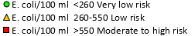

Figure 17: Contact recreation monitoring data for lagoon sites, full record. Units are E. coli/100 ml, logarithmic scale.

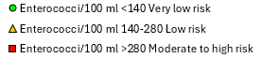
Figure 18: Contact recreation monitoring data for coastal beach sites, full record. Units are Enterococci/100 ml, logarithmic scale.

Figure 19: Contact recreation monitoring data for coastal beach sites, full record, continued. Units are Enterococci/100 ml, logarithmic scale.

Figure 20: Contact recreation monitoring data for coastal beach sites, full record, continued. Units are Enterococci/100 ml, logarithmic scale.

