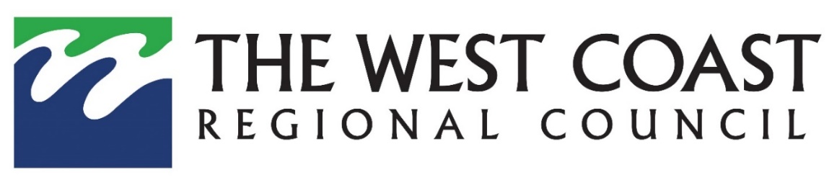

Draft 2024-2034 West Coast Regional Land Transport Plan Consultation

Submission form – what do you think?

The West Coast Regional Council is currently seeking feedback on the Draft 2024-2034 West Coast Regional Land Transport Plan.
Your details
First name: ______________________ Surname: __________________________________________
Address: ____________________________________________________________________________
_____________________________________________________________________________________
Phone: __________________________ Email: ____________________________________________

Are you submitting as an individual or on behalf of an organisation? (tick one)

󠄌 Individual 󠄌 Organisation _____________________________

Do you wish to speak in support of your submission at a hearing? (tick one)
󠄌 Yes 󠄌 No

Signature of submitter_________________________

Date______________________________

All submissions are made available for public inspection.

Note that your submission, and any information you supply as part of your submission, is considered public information and will be made available in reports and documents relating to this process. It may also be published on our website.

All submissions must be received by the West Coast Regional Council no later than 5.00pm, Thursday 28 March 2024.

The West Coast Regional Transport Committee would like to know:
Tick your position in relation to this Draft 2024 RLTP:

- Is the proposed strategic direction for the next ten years appropriate?

󠄌 Yes 󠄌 No

- Are there any other State Highway projects that need to be addressed?

󠄌 Yes 󠄌 No

My submission is:

If you have additional sheets, please provide them with this submission.

Post a submission:  Draft RLTP 2024 Submissions  West Coast Regional Council  PO Box 66,  Greymouth 7840 | Drop into our office:  388 Main South Road, Paroa  between 8.00am and 4.30pm weekdays | Email:  info@wcrc.govt.nz | Complete submission online:  www.wcrc.govt.nz/community/consultation and complete the online form

Need help?
West Coast Regional Council – Freephone 0508 800 118

