Draft Regional Speed Management Plan
Submission form

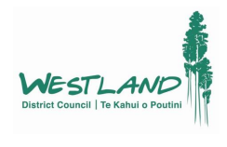
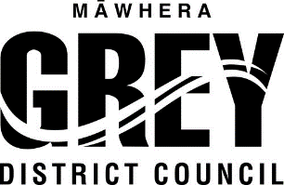
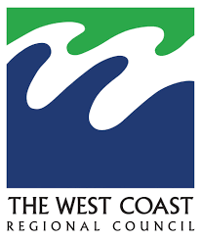

We are consulting on the West Coast Draft Regional Speed Management Plan and want to hear your views on traffic speeds on some of our local roads, and what you think about the proposed changes to speeds in the Draft Plan. Your feedback is appreciated and will help to inform decisions on the final Speed Management Plan.

Name _____________________________________________________________________

Email ______________________________________________________________________

Address ______________________________________________________________________

Gender (please circle) Male Female Gender Diverse Prefer not to say

Age Group (please circle) 14-18 19-25 26-30 31-39 40-49 50-59 60-69 70+

Prefer not to say

- Which District would you like to provide feedback on?

Buller Grey Westland

- What is your relationship to the Buller/Grey/Westland District?
- I live in the area
- I work in the area
- I own or manage a business in the area
- I go to school or an education facility in the area
- I drop my children off here for school or daycare
- I come here for shopping
- I access community or health services in the area
- I visit friends in the area
- I do recreational activities in the area (e.g. running, attending class at a fitness centre, etc.)
- I travel through the area
- Whakapapa to the area
- Other (please specify) _______________________________

- How do you usually travel? (Tick all that apply)
- By foot
- By private vehicle
- By bicycle
- By moped
- By wheelchair or mobility scooter
- By driving services, such as Total Mobility
- By taxi
- Other (please specify) _______________________________

- How safe do you feel current speed limits are in the West Coast Region?

Very unsafe Unsafe Neutral Safe Very Safe

- Our Speed Management Plan aims to reduce the harm and severity of injuries caused when accidents happen on our roads. Do you agree with this general aim?

- Strongly disagree Disagree Agree Strongly agree

- What do you think should happen to speed limits on our rural local roads? Rural local roads are roads outside of our towns which are not State Highways, and generally have higher speeds.

Increase speed limits Keep speed limits the same Decrease speed limits

- What do you think should happen to speed limits on urban local roads? Urban local roads are roads in our towns, around houses, schools, and shops, which generally have lower speeds, and are not State Highways.

Increase speed limits Keep speed limits the same Decrease speed limits

- Regulation has recently required us to lower speeds around all schools in the District by 2027. Do you agree with the proposed approach to lowering local road speed limits around schools?

Yes No

- Do you have any comments on local road speeds in the District you are submitting on?

If you have additional sheets, please provide them with this submission.

Send your completed submission form to the relevant District Council:

Buller District Council  PO Box 21  Westport 7866  info@bdc.govt.nz  Ph: 0800 807 239 | Grey District Council  PO Box 382  Greymouth 7840  info@greydc.govt.nz  Ph:03 769 8600 | Westland District Council  Private Bag 704  Hokitika 7842  council@westlanddc.govt.nz  Ph: 0800 474 834 | West Coast Regional Council  PO Box 66,  Greymouth 7840  info@wcrc.govt.nz  Ph: 0508 800 118

