Phil Hearing
Hi, My name is Phil Mitchell. My wife and I are the owners of 2 Upper Kokatahi Road, and the owners and residents of 4 Upper Kokatahi Road. I oppose the proposal which I stated succinctly in my initial submission statement.
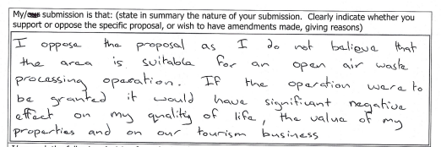
My wife and I have been forced to do far more research into the Resource management act and composting operations in the last few months, than I ever wanted to do, but have found a vast amount of information that reinforces my statement that the proposed area is not suitable.
Most significantly, is that it would be in breach of the RMA. This is because the RMAs purpose is to promote the sustainable management of natural resources by avoiding any adverse effects of activities on the environment. It further defines the environment as including amenity values and these are defined as, I quote, “those natural or physical qualities and characteristics of an area that contribute to people's appreciation of its pleasantness, aesthetic coherence, and cultural and recreational attributes.”
From this explanation given in a document from the Ministry for the Environment, titled “Good Practice Guide for Assessing and Managing Odour”, I firmly believe that there is no way an industrial composting facility will not adversely affect all four of the points defined as environment in section 2 of the Resource Management Act, and especially amenity value.
Our experts have already spoken about the proposed air, soil, and health impacts of this proposal, but I urge you to also consider the daily lives of those living in close proximity to the proposed industrial waste processing facility.
Why do I say that I believe there will be an effect? Well, in my experience, compost stinks. The process is taking decaying matter and turning it into dirt, so trying to say that it won’t smell doesn’t add up to me.
I’ve grown up with compost in as far as my dad has always been a gardener. Veges from the garden was a staple in our house growing up. Thinking back on it though, the compost heap on our property growing up was always at the furthest corner of the garden from the house. It would never occur to any home gardener to put it close to the house, why? Because of its inherent unpleasantness.
I’m also a qualified butcher, although I don’t work in that industry now, I have experience in working in abattoirs. And even now I supply our own meat from our own livestock. This is relevant because I have had first hand experience dealing with paunch grass. In early discussions with members of the community, many others hadn’t. In fact, a number had never heard of it and didn’t know what it was. Others thought it was just another species of grass like rye grass or clover. Whoever named paunch grass did an excellent job of making it sound far less offensive than it is. The partially digested stomach and intestine contents of a slaughtered animal doesn’t have the same charm, in title as in contact with it. It smells. There is no denying that. It smells as soon as a recently killed animal is opened and it will not improve in the time it will take to collect, transport, store, and prepare it for composting.
I’ve also worked on dairy farms and know that the wood chip bedding of a calf raising shed is also odorous. You can always smell the calf shed before approaching it, and so at least two of the proposed feedstocks are smelly before they even get mixed together. It’s also appropriate to mention rotting silage, this would not be kept anywhere near living spaces. On farms most accommodations are not next to the calf sheds, so why should we be made to accept living next to such an odour. Any claims that the process will not have an odour or affect nearby residents could only at best be put down to Olfactory fatigue, more commonly known as nose blindness.
An example of this walking into a café and been hit by the strong but pleasant smell of coffee and pastries, within 15 minutes that powerful scent fades into the background. But in reality, it hasn’t disappeared from the air, it has only disappeared from your perception. The next person that walks in is hit with the same strong odour. Now I ask you to consider if our brain does this with pleasant smells, it’s going to do it with foul odours.
One of my concerns with granting this consent, is that visitors, guests or potential property buyers will be hit with the negative effect of this, and poor reviews, leading to unlettable accommodation or unsaleable property will result from granting this consent.
Another concern with this consent is in my understanding the process of the application has not been correctly applied. A resource consent must be obtained before starting a project, this project has been underway for some time now. According to the website environment.govt.nz “if you need a resource consent, you must get it before starting your project. If you start before you have consent, you risk prosecution.
The applicants have not adequately consulted with affected parties, as already mentioned, there were those who did not know what paunch grass was. There also seems to be discrepancies as to what is to be included in the feedstock. This does not provide me any confidence that proper controls will be adhered to.
My request is that the consents be refused.

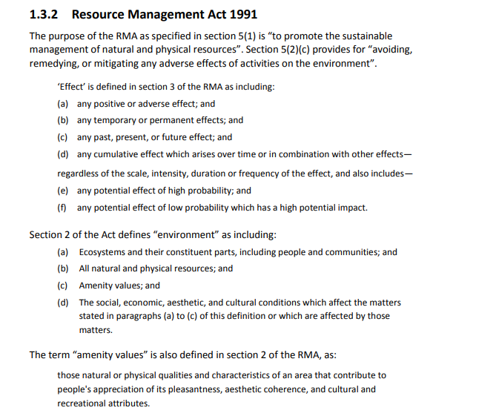
From: https://environment.govt.nz/assets/Publications/good-practice-guide-odour.pdf

