Final 29.08.2025
COMPOST PROCESS OVERVIEW:
The Von Ah Compost Yard uses a method of composting referred to as Static Pile composting.
Static Pile composting is a method of breaking down organic waste into compost by piling it up into long, narrow windrows and allowing bacteria to decompose the material. The windrows are turned regularly to expose them to air, light, and heat, which helps microorganisms break down the waste into compost. By regularly monitoring temperature and turning the piles, adequate aeration is provided to promote microbial activity, accelerate decomposition and maintain temperatures inside an ideal range (50-60°C).
By choosing a carbon source with a suitable particle size to mix with the organic waste material and sufficient turning, aerobic conditions are achieved in the windrow to accelerate decomposition, control odours and generate high temperatures, which kill pathogenic bacteria and produce a humus-like product. The Von Ah Compost Yard processes solid animal waste effluent plant solids (paunch grass, stockyard solids and sludges) and woodchips to produce a composted soil conditioner.
This document provides standards, hazards and additional information for each step of the process, as well as key details of the compost yard infrastructure.
Below is a high-level process flow overview of the process.
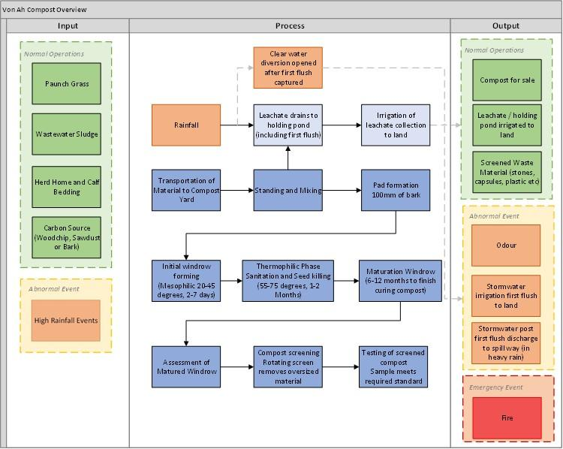

Item | BULKING AGENT: WOOD BLEND
Standard | - Bulking material (principal carbon source):  - Woodchip
Hazard(s) | - Too many fines (e.g., sawdust) adversely affect aeration by filling interstices when blended with paunch grass/sludges to make a compost pile.
Comment(s) | - Woodchip provides porosity, structure, and beneficial microbial activity, i.e., suitable texture for aeration and biological activity.  - Particle size influences the bulk density.  - Whilst sawdust generally has an economic advantage over bark-chips or woodchips it creates aeration issues through compaction and also results in a much lower grade product as a commercial soil conditioner or growing medium - woodchip provides for a longer retention of nitrogen in final saleable compost material.

Item | MIXING: BLENDING WASTE WITH BULKING AGENT
Standard | - Organic waste material (sludge/paunch) must be placed in a mixing bunker on arrival at the compost yard to ensure any leachate is directed to the leachate collection system  - Organic waste material must be covered with woodchips in a mixing bunker as soon as possible. To reduce odour and seagull scavenging.  - Mix waste material and woodchip ratio by volume 1:1.  - The material must be well mixed to create a uniform blend, allowing for greater consistency in the composting process.  - The material in the mixing bunker prior to moving to the windrow formation should not exceed 16 hours.  - Record the volume of the raw material loader diary and add it to the RAW MATERIAL RECORD SPREADSHEET
Hazard(s) | - Odour - If incoming material is too rotten and odorous, it should be rejected and the client informed of the breach of agreement.  - Odour beyond the boundary of the operation is in breach of our consent  - If waste material is too wet, inform the provider to ensure organic waste is suitable to receive (no free-flowing liquid)  - Too much moisture can impact the compost process, reaching the required temperatures, and can lead to excessive leaching  - If organic waste material is not well mixed, it may impact the composting process  - If not enough woodchip is added, then the correct carbon-to-nitrogen ratio will not be met, impacting composting efficiency and nitrogen conversion, causing odour in the form of ammonia gas.
Comment(s) | - Woodchip is used as it creates large pore sizes in the mix to allow airflow.  - Moisture of blend when ready for transfer to windrow: Can be around the water-holding capacity of the ingredients (60 to 65% (w/w))  - Proper mixing is essential - a uniform homogenous mixture helps ensure effective aeration, avoiding preferential flow paths and potential pockets in an anaerobic state, i.e., without air..  - Ensuring adequate woodchip is used to achieve a 1:1 ratio is essential to make sure the correct carbon-to-nitrogen ratio is achieved.  - Woodchip is also useful to help with the absorption of any leachate from the raw material  - Mixing in the bunker will allow for heavy vehicle impacts to be managed in one location.

Item | BED PREPARATION
Standard | - Windrow area overlaid with a bed of woodchip:  - Bed depth of 100 to 200 mm  - Lay the bed in sections to prevent driving over the base too often. (i.e. back right corner > front right corner > back left corner > front left corner)  - Inspect the leachate drains to ensure they are clear
Placement of bark bed | 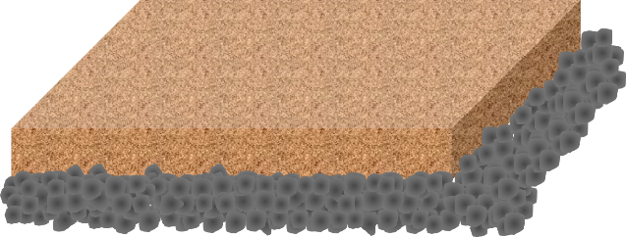
Hazard(s) | - Compaction adversely affects aeration and leachate collection  - Uneven bases can impact air flow and may create pockets within composting material, creating hot and cold spots.
Comment(s) | - Minimise the time loader on the bark base to minimise compaction

Item | FORMING WINDROW
Standard | - The blended material is to be placed on the woodchip pad on top of the pre-prepared woodchip base and formed into a windrow.  - Height - 2.5 m  - Width – 7.5 m  - Length - 18 to 20 m  - Volume – 100 to 200 m³  - Windrow overlaid with a 150 to 300 mm cover blanket of finished compost, either:  - screened, oversized finished compost;  - unscreened finished compost or  - woodchip  - Temperature probe to be inserted into windrow(s), record windrow temps:  - ½ way along the windrow  - ½ way up the windrow  - horizontally to a depth of 1 m - penetrating the inner composting pile  - Ensure the marker peg is placed in the pile:  - helps ensure traceability  - The marker peg is moved with the pile/windrow through the curing/maturation phase  - The window is not turned until the temperature reaches 50°C.  - The temperature should be reached within 1 week
Placement of blended material | 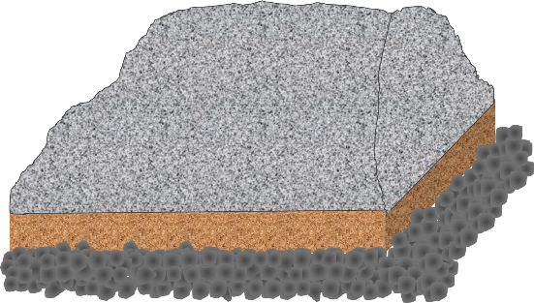
Placement of cover blanket of finished compost or wood chips | 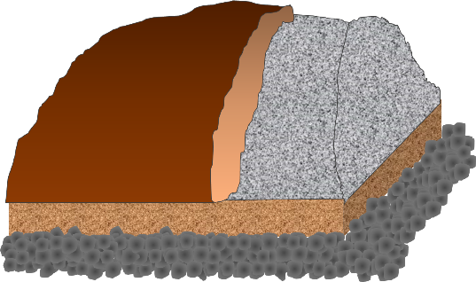
Hazard(s) | - Compaction adversely affects the evenness of pore size and airflow.  - Uneven mixing and/or compaction during the development of the windrow heap may cause pockets within composting material creating hot and cold spots.  - If a cover blanket of finished compost or wood chips is not applied, there is potential for odours and/ or attracting birds during the mesophilic / thermophilic phase.  - The temperature of windrows could get too hot or cold if temperature probes are not inserted and monitored, even while forming
Comment(s) | - The concept of the static pile windrow is that the dimensions of the pile, along with the well-mixed and porous nature of the feedstock, allow airflow through the pile via convection as the microorganisms begin decomposition of the organic material.  - Formation of the windrow is the beginning mesophilic stage of the static pile composting process, when microorganisms break down organic materials, and the compost pile heats up  - Windrow size has an effect on the rate of composting - small piles are prone to excessive heat loss / large piles can be too hot or suffer compaction.  - Minimise the time loader on the bark base to minimise the risk of compaction – load from the side.  - Covering with unscreened compost discourages birds, which can pick up material and drop them a distance away – reducing potential vectors.

Item | THERMOPHILIC PHASE
Standard | - Windrow temps are to be recorded daily  - The time/temperature profile is recorded  - Windrows are to be at the thermophilic temperature range within 7 days of windrow formation  - The thermophilic stage can last up to 2 months  - Windrows are to be turned on an as-needed basis – ideally weekly, when in the optimal temperature range  - Windrows are not to be turned when the wind is blowing in the direction of neighbours  - A windsock is to be installed next to the compost yard and used to gauge the suitability of wind direction before turning  - Optimum temperature range – 50 to 60°C  - Destroy germination seeds in the material  - Disinfects the compost  - Required to meet NZS4454 “Composts, soil conditioners and mulches” to allow public sales (NZ Compost Standard for pasteurisation 55 °C + for at least 15 days)
 | 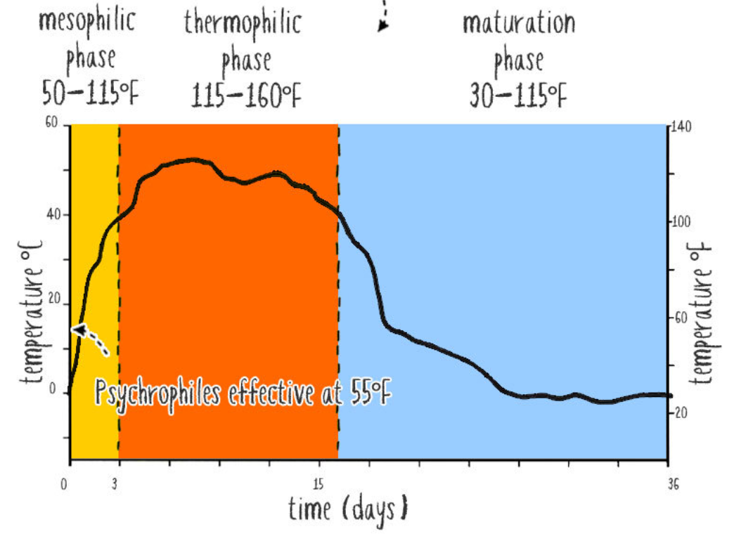
Hazard(s) | - Odour – the first few turns of the windrows in the thermophilic phase pose the greatest risk of odours – ensure adequate temperatures are reached and wind conditions are suitable before turning  - Temperature greater than 85 °C is to be avoided:  - Risk of killing working bacteria  - Risk of combustion in the pile  - Inefficient composting  - The temperature is not reaching the optimal level:  - Incomplete destruction of pathogens  - Odour generation – under anaerobic conditions  - pad failure  - Uneven/minimal aeration may create poor composting and anaerobic conditions, creating odours  - Poor thermophilic phase can result in a longer maturation time to stabilise compost for sale
Comment(s) | - Internal temperature should reach 50°C in 7 days  - >50°C in 3 days, if not, then investigate, remix and reform the windrow – potentially add new material  - Controlled temperatures via sufficient turning increase composting efficiency, and the time it takes to have a stabilised product is 6-12 months, as opposed to 18 months  - Temperature management is the main process variable by which the composting process will be managed – pH, moisture content, and oxygen concentration measurements can be taken if compost performance falls outside of the prescribed operating conditions (i.e. temperature and odour).  - Besides adequate mixing and recipe development to ensure correct carbon-to-nitrogen ratios and pH levels are achieved, temperature is the most important variable to control as it will drive moisture, oxygen and pH performance in the piles.  - Turning piles add oxygen to the pile, moderates temperatures by releasing heat and provides aerobic conditions for beneficial microorganisms, ensuring moisture is retained in the pile by stopping it from drying out.  - A properly running heap will likely billow steam on cooler days  - By the time the windrows are at temperature and have been turned a few times, the risk of odour will be decreased and the compost will develop a sweet, earthy smell – flies and birds are no longer attracted.

Item | CURING PILE / MATURATION PILE
Standard | - Once thermophilic temperatures become harder to maintain:  - Combine two thermophilic piles to create one maturation pile – 3 to 4 m high.  - Mix piles to ensure all material is well combined  - Keep transfer and mixing to a minimum on a windy day  - Turn the windrow every 2 to 4 weeks for 6 to 8 turns to help release heat / add air to the pile, prevent anaerobic activity and continue thorough mixing of materials.  - Ensure the marker peg is moved and placed in the curing/maturation pile, including moving and re-placing when the pile is turned  - Manually monitor temperature on a weekly basis and record  - Any stockpiled cured compost should be turned every 4 to 6 months  - Test for completion of maturation:  - ammonia  - nitrate-nitrogen
Hazard(s) | - Reaction slowing down – once the process stops, it is hard to restart  - Uneven/minimal aeration may result in poor composting and anaerobic conditions, creating odours  - Turning may reintroduce pathogens, which survive in cooler zones.  - If test results show the pile is not mature:  - Place the pile back several turns in the cycle
Comment(s) | - The maturing stage allows the material to be physically broken up and composting to continue until a state of stability is reached:  - Curing allows the remaining organisms to convert any ammonia to nitrates – mature compost has nitrate-nitrogen greater than ammonia.  - When compost is mature, it should have a good earthy smell (no sharp ammonia) and be a dark, rich colour.  - A ring of white ash-like material near the outside of the windrow is a sign that the composting process is working well and is a fungi-like microorganism.  - Temperature monitoring ensures optimal processing has occurred. Temperature should decrease over time  - Conditions for maturing pile size are different from those for thermophilic stage:  - Larger piles continue composting faster for longer than small piles  - achieve product stability and maturity sooner  - Turning ensures all material goes through the composting process in the pile's interior and breaks up any lumps that may form

Item | SCREEN CURED COMPOST
Standard | - Screen the cured/matured compost in preparation for sale:  - screen size around 6mm  - screened, stored, ready for sale  - tailings stored for use as cover for an thermophili pile  - Any stockpiled compost should be turned every 4 to 6 months to maintain an aerobic state  - Ensure the marker peg is placed in the cured pile:  - Ensures production records for any sales  - ensures a log of tailings re-use  - Prior to sale, ensure cured and screened compost is sampled and tested:  - One sample per 500 m³ of screened compost  - Test for:  - Moisture – 45 to 55%  - TKN – 0.9 to 1.5%  - Total Carbon - 15 to 30%  - Carbon: Nitrogen ratio - 20 to 30:1  - Extract:  - pH – 6 to 7.5  - Conductivity – 60 to 360 mS/m  - Ammonia Nitrogen (NH₃-N) - 15 to 30 ppm  - Nitrate Nitrogen (NO₃-N) – 40 to 100 ppm  - Nitrate: Ammonia ratio – 3:1  - Germination:  - Radish - 80 to 100 %  - Tomato - 80 to 100 %  - Pathogens:  - E.coli - <100 MPN/g
Hazard(s) | - Not mature enough for screening:  - continue maturing/curing  - Finished product outside specified limits  - may dictate sale options  - may require blending
Comment(s) | - The finished product should meet all requirements for sale

INFRASTRUCTURE PARAMETERS:

Item | LEACHATE COLLECTION SYSTEM
Standard | - All new material is to be mixed in the mixing bunker, with leachate flowing into the leachate collection system  - The yard is designed and shaped so any leachate in the yard is to flow directly into the leachate collection system.  - The yard and the leachate collection area are lined with plastic to prevent the discharge of contaminants to land or groundwater.  - All leachate and stormwater from the yard and mixing bunker will flow to the leachate collection sump and into the leachate pond.  - The leachate collection system is to be inspected weekly to ensure it is in working order.  - The leachate pond is to be emptied regularly and either applied back over the compost windrows or via sucker truck and irrigated to land, leaving a 20m buffer between any water ways.  - In high rainfall events, the leachate collection pond is to be emptied prior to rainfall to allow capture of the first flush, if necessary. Once the first flush has been irrigated to land, the leachate pond may be set to bypass to the Clearwater diversion drain  - Material received with free-flowing liquid is to be rejected, and a non-conformance is to be issued to the supplier.  - 6 monthly samples of leachate will be collected, and volumes of leachate removed will be recorded
Hazard(s) | - If leachate collection systems are not maintained and regularly inspected, there is a risk of leachate discharges to surface or groundwater.  - Poor management of the leachate collection system could result in odour issues if excessive
Comment(s) | - The leachate collection pond is constructed similarly to the yard surface, with 50mm of compacted gravel and 50mm of compacted sand underneath a plastic liner.  - The leachate collection pond will provide storage for approximately 840m3. The capacity to hold an 80mm rainfall event would be 336m3.  - Using the first flush capture approach, there will be minimal risk of high concentration runoff or gross solids to land or water, as the initial flush of these contaminants will be captured in the leachate collection pond, and any additional clean rainwater can be discharged to land  - Once the system is in the diversion configuration, any further runoff during the high rainfall event will likely be highly diluted from the high rainfall.  - Along the clean water diversion drainage system, native plants and other vegetation will be planted along 110m of the drain to further filter out any gross solids or contaminants. Native plants will consist of flaxes, rushes and sedges to act as an artificial wetland.  - With this being a new process, there is potential to install windrow covers in high rainfall events to prevent leaching. This will be reviewed when the management plan is reviewed and a decision will be made if this becomes a requirement of the operation.

Item | YARD SURFACE
Standard | - The yard surface is approximately 4,200m2.  - The yard was constructed by digging 250mm out of the paddock and building the base of the yard with 250mm of 40mm screened compacted gravel with 50mm of sand on top. It is sloped to allow flow into the leahcate collection sump.  - A 30mu liner was then placed over the entire yard to prevent any leachate from entering the groundwater.  - On top of the plastic liner, a further 50 mm of sand was placed, with a final 100mm of 40mm screened and compacted gravel placed on top.  - Surrounding the yard will be a 1.5m high bund around the compost yard that will be planted up in native plants, trees and other vegetation to provide screening for dust and odour.  - The yard surface will be maintained regularly and will have a 5-yearly overhaul
Hazard(s) | - Discharge to Land or water if the yard surface is not well-maintained
Comment(s) | - Correct maintenance of the compost yard will ensure leachate and runoff flows to the collection system and pond, and will prevent ponding

Item | IRRIGATION
Standard | - Establish the area to irrigate from the Farm Management App.  - Irrigation volume and location are to be recorded for each irrigation event (i.e. what paddock)  - Wind direction is to be checked prior to the irrigation event to prevent spray drift and risk of odour impacts on neighbours, and no discharges are to be made if the wind is blowing in the direction of neighbours  - The application rate shall not exceed 20mm in depth  - Irrigation will not result in surface ponding or drainage to surface water bodies
 | 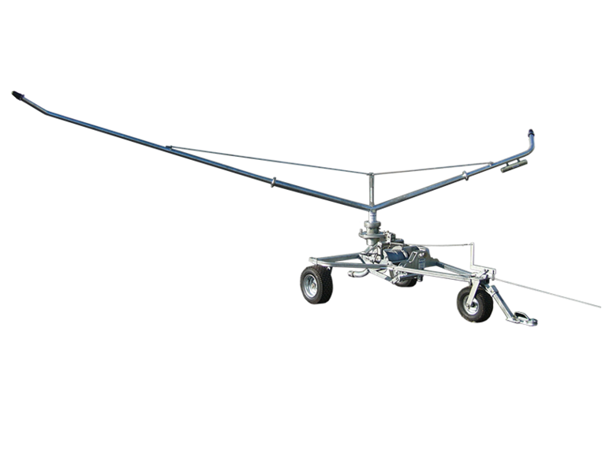
Hazard(s) | - Spray drift from irrigation  - Odour discharges if irrigation is conducted when the wind is blowing directly to a nearby house.  - Ponding and surface drainage to local waterways could impact freshwater ecosystems.  - Nitrogen loadings from the leachate collection system are expected to be relatively low; however, incorrect management of discharge events could result in exceedances of maximum nitrogen application rates (200kgN/Ha/yr)
Comment(s) | - Capturing leachate and runoff from the compost yard and discharging it in a controlled manner via a travelling irrigator is an effective way to capture and utilise nutrients for plant growth  - With the high level of rainfall on the coast, it is expected that the leachate will be relatively low in nutrient concentration

