Von Ah Compost Facility Management Plan

Final
29.08.2025

CONTENTS
1 SCOPE 3
2 COMPLIANCE OBLIGATIONS 3
2.1 Environmental Aspects and Risks 3
3 ROLES AND RESPONSIBILITIES 5
3.1 Emergency Contacts 5
3.2 Roles and Responsibilities 5
4 SITE AND ACTIVITY OVERVIEW 6
4.1 Activity Summary 6
4.2 Compost Process 6
4.3 Yard Construction and Leachate Collection System 8
4.4 Irrigation Management 9
4.5 Process Flow 11
4.6 Site Map 12
5 ACTIVITY REQUIREMENTS AND CONTROLS 13
6 ENVIRONMENTAL PREVENTIVE AND CORRECTIVE ACTION 17
7 MAINTENANCE ACTIVITIES SCHEDULE 19
8 ENVIRONMENTAL MONITORING AND MEASUREMENT 20
9 DEFINITIONS 21
10 COMPLIANCE MATRIX 22

SCOPE
This Compost Management Plan (CMP) applies to all activities relating to composting at the Von Ah Composting site
This compost CMP details this site’s commitment to meeting all compliance obligations and managing the following:
- composting discharges to land, air, and water.
- the activities and operations within the composting site.
- the controls to mitigate potential contaminants or adverse effects from the composting site; and
- identifying and implementing opportunities for improving composting management.

COMPLIANCE OBLIGATIONS
Environmental compliance obligations for composting at the Von Ah Composting site are governed by resource consent requirements and interested-party agreements. Regulatory requirements are understood and embedded in this CMP to ensure compliance is achieved.
See section 7 for further information on how we meet our compliance obligations through specific controls for our activities. Below is an overview of compliance obligations for the Von Ah Composting site.
Interested Party | Obligation | Details
West Coast Regional Council | Resource consent XXXX  (Discharge to Land) | To discharge organic matter to land for the purpose of operating a compost facility.
 | (Discharge to water) | To discharge leachate to land, in circumstances where it may enter water for the purpose of operating a composting facility.
 | (Discharge to air) | To discharge contaminants (including dust and odour) to the air for the purpose of operating a compost facility.
Neighbours / Community | Local area | No Negative impact on neighbours and community from our operations.
Suppliers | Contracts and agreements | Contractual agreements and legal obligations, including compliance, are met

Environmental Aspects and Risks
Environmental aspects are the parts of the operation that interact with the environment or community.
Below is a summary of the risks associated with the composting operation
Significant Aspect |  | Potential Event/Risk |  | Impact/Effect
Abnormal
Composting |  | Discharge to Water / Land- from composting operations resulting in groundwater or surface water contamination, adverse community impact and compliance breach |  | Negatively affect local waterways or groundwater  Inability to discharge  Stop operations/processing  Breach Consent
Composting |  | Discharge to Air – Odour  - Incorrect composting method  - Holding raw product for too long  - Piles go anaerobic |  | Adverse community impact/complaints  Reputational Damage  Breach Consent
Emergency
Abnormal weather event |  | High rainfall events put pressure on the leachate collection system |  | Negatively affect local waterways  Inability to discharge  Incur a fine/additional treatment cost

ROLES AND RESPONSIBILITIES

Emergency Contacts
Contact |  | Business Hours/After Hours
Primary | Marty von Ah | 027 2262835
Council |  | Business Hours/After Hours
District Council | Westland District Council | 03 756 9010
Regional Council | West Coast Regional Council | 03 768 0466

Roles and Responsibilities
 | Site Manager – Marty von Ah | - Overall responsibility for site operation and delegation of roles related to compost management.  - Providing the necessary resources to achieve monitoring and reporting objectives.  - Overall responsibility for the operation and maintenance of services supporting the compost activity on-site
 | Data Manager | - Overseeing monitoring activities, including sampling and data assessment.  - Maintaining a relevant monitoring dashboard and data recording.  - Communicating with relevant internal and external parties, including the council.  - Overseeing environmental event investigations and corrective action management.  - Overseeing that composting discharges comply with resource consent requirements.  - Investigate and report any findings from inspections, incidents, or complaints.  - Undertaking site inspections as required.  - Providing a point of contact for council communication.
Operators |  | - Carry out tasks in a manner that will not adversely impact the surrounding environment.  - Responsible for alerting management to all environmental incidents or hazards, regardless of the nature or scale.

SITE AND ACTIVITY OVERVIEW
The Von Ah Compost operation seeks to enhance and recycle waste organic material from suppliers in a controlled and managed way. The composting operation uses the Static Pile Windrow method. Below is a brief summary of the process.

Activity Summary
The compost operation receives approximately 40-80m³ of organic waste material per week. The material is made up of:
- Paunch Grass
- Bark chip
- Sawdust
- Old baleage and silage
- Used herd home and calf bedding (wood chips & manure)
- Abattoir DAF Wastewater Sludge (industrial)
- Karbon King
- Moss fines

Once the organic waste material enters the compost yard, it undergoes the following process:
- Material collection, transportation and receipt at yard and unloaded in mixing bunker – volumes of organic waste material is recorded for invoicing and compliance purposes.
- Dewatering, Mixing and Blending – raw material is blended with carbon material (ideally bark or woodchip) at a ratio of 1:1.
- Mesophilic Phase – Forming initial windrow with temperature increasing, approx. 2-7 days at 10-50°C.
- Thermophilic Phase – prolonged period at high temperatures. Approx. 2 weeks to 2 months at 50-70°C, no turning required.
- Curing/Maturation Phase – compost moved into large windrows for maturation and finishing. Approx 3 to 9 months at 50-23°C, turn pile every 2-4 weeks (temperature dependent).
- Screening – removal of rubbish contamination and gross solids (i.e. leftover un-broken-down woodchip), so product is ready for sale.
- Storage/Sale – final stage where material is sold and removed off site or is stored until it is able to be sold.

Compost Process
Organic waste material is delivered to the compost facility and unloaded in the mixing bunker to ensure any leachate is collected in the leachate collection system. All incoming organic waste material is recorded in the daily logbook in the loader and in the Raw Materials Record Spreadsheet.
The organic waste material is mixed with a carbon source (ideally bark chip) at a ratio of at least 1:1 to ensure a suitable carbon-to-nitrogen ratio is achieved. The purposes for doing this is to:
- de-water these solids further than mechanical dewatering/thickening.
- create a balanced carbon/nitrogen ratio; AND
- provide a suitable texture for efficient aeration and biological activity.
Should the mixing process be delayed, the raw material is sealed with a layer of cured compost or wood chips to prevent odours. Efforts should be made to ensure that different feedstocks are blended sufficiently in the mixing bunker before composting begins. If this is not achievable due to the timing of different feedstocks arriving on site, the material will sufficiently blend upon further mixing when windrows are turned.
Before the solids-woodchip mixture is put on the compost pad, a 100mm thick bark base is put down to assist with the distribution of air into the pile and absorb any additional leachate. A front-end loader is used to move the mixture onto the compost pad to form a windrow. Each windrow is identified by a marker peg, which is retained for the duration of the curing process. Each windrow is sealed with a layer of cured compost or woodchips for insulation to maintain heat in the pile and odour containment. A temperature of 50°C should ideally be attained within 3 days of placement on the bark base with a maximum delay of 7 days.
Daily temperature readings shall be taken and recorded. Windrow temperature is managed by aeration through regularly turning the windrow from inside to out. Temperature management is the main process variable by which the compost process will be managed – pH, moisture content, and oxygen concentration measurements can be taken if compost performance falls outside of the prescribed operating conditions (i.e. temperature, odour final results). Besides adequate mixing and recipe development to ensure correct carbon to nitrogen ratios and pH levels are achieved, temperature is the most important variable to control as it will drive moisture, oxygen and pH performance in the piles.
During this phase, mesophilic bacteria begin to convert the organic wate material mixture from an ammonia-based product to a nitrate-based product and begin building heat from 20-45 degrees.
Above 55 degree the piles transition to the thermophilic phase. The internal high temperature of the piles kills pathogenic bacteria and weed seeds. The optimum moisture content for bacterial growth of a pile at time of establishment is 60 - 65% (w/w) and a Carbon Nitrogen ratio 25:1.
To enable bacteria to convert the biosolids mixture from an ammonia-based product to a nitrate-based product, the windrow after 7 – 10 days when the temperature is greater than 50 degrees. Routine daily temperature readings are taken for the first 4 weeks to determine the level of activity and whether additional water or turning is required.
Records by marker peg number shall be maintained for temperature history, date of aeration/turning, and moisture addition.
Once the temperature of the windrows begins to decline to below 50 degrees, the bacterial flora in the pile changes from thermophilic back to mesophilic organisms. These organisms are typical solid inhabitants and operate at a lower temperature range to break down complex carbon compounds, yielding the typical musty compost odour. As this transformation takes time, progress is recorded through temperature monitoring. This maturation phase typically takes 6-12 months.
To manage the maturation process, windrows are turned approximately 2 to 4 weeks for 6 to 8 turns to help release heat / add air to the pile, prevent anaerobic activity and continue thorough mixing of materials. At each interval, the windrow is relocated to an adjoining vacant lot and progressively moved from the rear to the front of the facility. Any stockpiled mature compost should be turned every 4 to 6 months.
Turning and rotating windrows redistributes and breaks up lumps of remaining organic matter and ensures a plentiful supply of oxygen for the microorganisms. Turning from the inside out maximises the volume of air dispersed throughout the pile and prevents odour generation.
The rotational system of the maturing phase allows control on the conditions of the windrows. The rotation sequence and turning frequency can be modified to improve the maturity of the compost depending on temperature trends, moisture and results from the laboratory analysis.
Obtaining an analysis of the cured compost is essential for any public sales. Once the compost has cured, a sample must be taken for laboratory analysis and compared to the Physical, chemical and biological requirements for compost in NZS 4454:2005. In the event that analysis determines a limit imbalance, the material shall be recycled through the curing process until the limits are met. Once analysis indicates limits are met, then the material is screened to 20mm diameter and made available for sale.

Yard Construction and Leachate Collection System
The yard surface is shaped to ensure all leachate and stormwater runoff flows directly to the leachate collection system and leachate pond.
The yard surface is approximately 4,200m2. The yard is designed with a slope so that leachate will run off and into the leachate collection sump. It has been constructed by digging 250mm out of the paddock and building the base of the yard with 250mm of 40mm screened compacted gravel with 50mm of sand on top. A 30 μm liner was then placed over the entire yard to prevent any leachate from entering the groundwater. On top of the plastic liner, a further 50 mm of sand was placed, with a final 100mm of 40mm screened and compacted gravel placed on top. Surrounding the yard will be a 1.5m high bund around the compost yard that will be planted up in native trees to provide screening for dust and odour.
Within the yard surface, there is a concrete mixing bunker approximately 50m2 that flows directly to the leachate collection sump. The leachate collection pond is constructed similarly to the yard surface with 50mm of compacted gravel and 50mm of compacted sand underneath a plastic liner. The leachate collection pond will provide storage for approximately 840m3. To put that into scale, an 80mm rainfall event would need a capacity of 336m3.
All leachate and stormwater from the yard and mixing bunker will flow to the leachate collection sump and into the leachate pond.
The normal operation of the leachate collection is a closed system with all run off entering the lined leachate pond, that will be pumped out weekly (or as needed) by a sucker truck and irrigated to land via travelling irrigator. 6 monthly samples of leachate will be collected and volumes of leachate removed will be recorded.
In the case of a high rainfall forecast, the leachate pond fill be sucked out and irrigated to land prior to the rainfall event. The leachate pond will then act as a first flush capture system to capture initial gross solids and leachate. Once the runoff begins to run clear, and depending on the remaining forecast, the operation will bypass the leachate collection pond and discharge to the clearwater diversion drain by closing the outlet to the leachate pond and opening the clearwater diversion drain outlet. Using this approach, there will be minimal risk of high concentration runoff or gross solids to land or water, as the initial first flush of these contaminants will be captured in the leachate collection system, and any additional clean rainwater can be discharged to land. Once the system is in the diversion configuration, any further runoff during the high rainfall event will likely be highly diluted from the high rainfall. With this being a new system, consideration will be made as to whether the windrows will need to be covered for high rainfall events in order to minimise runoff and any negative impacts to the composting process.
Along the clean water diversion drainage system, native plants will be planted along 110m of the drain to further filter out any gross solids or contaminants. Native plants will consist of flaxes, rushes and sedges to act as an artificial wetland.
Maintenance and operational requirements of the yard surface and leachate collections system are included in sections 5, 6 and 7 below.

Irrigation Management
Leachate and runoff captured in the leachate collection system, including first flush capture in high rainfall events, are sucked out of the leachate collection pond and applied over the windrows when additional moisture is needed or by a sucker truck and irrigated to the land via a travelling irrigator.
There are numerous hazards associated with the irrigation of leachate and runoff to land, these include:
- Spray drift from irrigations
- Odour discharges if irrigation is conducted when the wind is blowing directly to a nearby house.
- Ponding and surface drainage to local waterways could impact freshwater ecosystems.
- Excessive nitrogen loadings
Irrigation will be conducted across the 30Ha Duck Creek Farm property. Each discharge event will be recorded to include volume and location of discharge event. Prior to each discharge event operators will check wind direction to ensure it is not blowing towards neighbours causing potential odour or spray drift does issues.
Irrigation application rate is controlled to make sure each discharge event does not result in an application of greater than 20mm in depth. Operators will also ensure no ponding or runoff to surface water ways occur as a result of irrigation by leaving a buffer of no closer than 20m to any water way.
Controls for these activities are recorded in sections 5 and 6.
Maintenance of irrigators and sucker truck fall outside the controls of this management plan and are managed as part of the ongoing operational requirements of Von Ah Contracting Ltd.

Leachate will be applied to the following land areas:
(Note: hectares are estimated and will vary annually)

Annual crops:
- Winter dairy cow brassicas: Applied leading up to sowing in January (3ha).
- Cut and carry maize for dairy cows: Applied leading up to sowing in spring.
Once annual crops are harvested, grass is sown, and these paddocks then enter the Pasture rotation.

Pasture:
- Winter dairy cow grazing area: Applied up to 14 days before cows arrive for winter grazing (3ha). After winter cows exit, apply throughout the remaining year on a rotational basis (30ha)

Process Flow
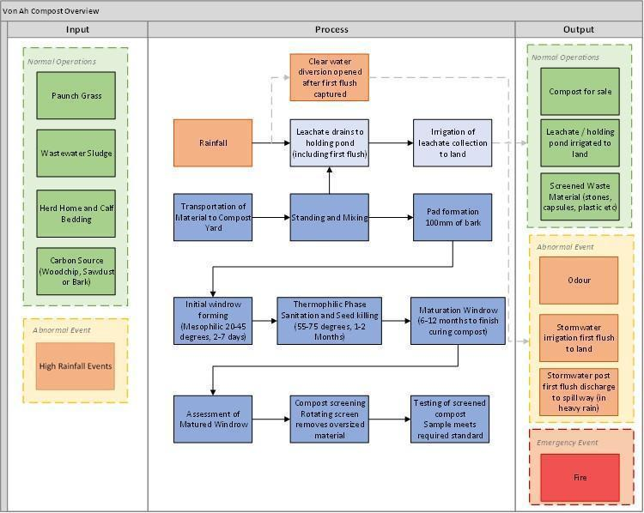
Figure 1 - Simplified process flow of the composting process at Von Ah Composting Site.

Site Map

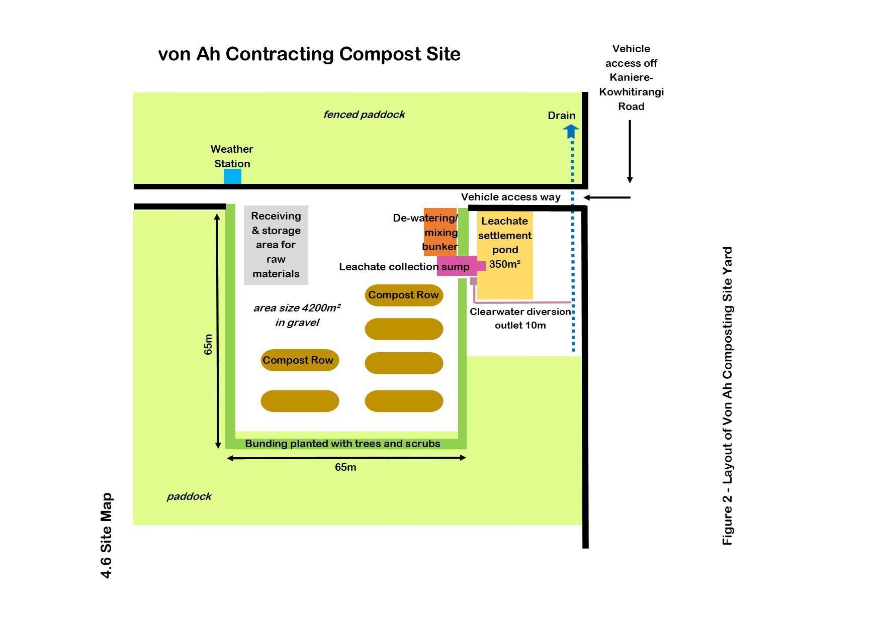

ACTIVITY REQUIREMENTS AND CONTROLS
Compost management activity requirements and controls are detailed below for each sub-activity.
Sub Activity | Requirement | Controls
Dewatering, Mixing and Blending | - If the incoming material is too rotten and odorous, it should be rejected, and the client informed of breach of agreement.  - Raw material is to be stored in a mixing bunker and mixed with a ratio of 1:1 bark or woodchips.  - Mixed material is to be stored for no longer than 6 days to prevent odour.  - Organic waste material must be covered with woodchip in mixing bunker as soon as possible. To reduce odour and seagull scavenging.  - Materials are mechanically combined with a loader to obtain a uniform mix.  - All liquid from the bunker must flow to the leachate collection system.  - Record volume of material received. | - Von Ah compost process document  - Design of the leachate collection system  - Preventive maintenance practices are to be carried out on all equipment.  - Daily log  - Raw Material Record Spreadsheet  - Supplier contracts and agreements  - Training
Forming a bed and building a windrow | - Form a woodchip base of 100mm across the pad to aid air flow and absorb any additional leachate.  - Form initial windrow, height 2.5m, width 7-7.5m, length 20m - approx. 200m³ per row.  - Place a mature compost “blanket” on top of the pile, 150-300mm thick across the whole pile, 22-45m³ per row.  - Temperature probes are to be installed in each windrow on the pad, approximately half along the windrow and half up the windrow, to a depth of 1 meter, penetrating the inner compost pile | - Von Ah compost process document  - Leachate collection system  - Preventative maintenance practices to be carried out on all equipment.  - Raw Material Record Spreadsheet  - Daily Log  - Training
Turning | - Windrows to be turned on an as-needed basis – ideally weekly, when in the optimal temperature range  - Windrows are not to be turned when the wind is blowing in the direction of neighbours  - A windsock is to be installed next to the compost yard and used to gauge the suitability of wind direction before turning  - Optimum temperature range – 50 to 60°C  - Required to meet NZS4454 “Composts, soil conditioners and mulches” to allow public sales (NZ Compost Standard for pasteurisation 55 °C + for at least 15 days) | - Von Ah compost process document  - Leachate collection system  - Preventative maintenance practices to be carried out on all equipment.  - Daily Log  - Training
Curing/Maturation | - Once the thermophilic phase is complete, combine windrows to make a single windrow 3-4 meters high and 30 meters long.  - Turn the pile every 2-4 weeks.  - Manually monitor temperature on a weekly basis and record.  - Any stockpiled cured compost should be turned every 4 to 6 months | - Von Ah compost process document  - Temperature checks  - Daily log  - Training
Screening | - All compost is to be screened before it is removed off-site.  - Compost is not to be screened when wind is blowing toward neighbours to prevent nuisance dust | - Windsock  - Training
Storage | - Store cured compost is to be turned every 4 to 6 months. | - Record keeping
Sale | - Record volumes of compost sold.  - Meets physical, chemical and biological requirements for compost in NZS 4454:2005 | - NZS 4454:2005 guidance
Yard Surface | - The yard is lined to prevent discharges to land  - The yard is regularly maintained to ensure runoff flows to the leachate collection system  - The boundary of the yard will be planted to provide screening of compost activities | - Von Ah compost process document  - Design of the yard and leachate collection system  - Visual inspections  - Maintenance Activities Schedule
Leachate Collection | - Visual inspection of the leachate collection system is conducted weekly.  - All runoff will flow to the collection system.  - Collected leachate is to be sucked out of leachate collection pond and irrigated to land  - 6 monthly samples of leachate will be collected, and volumes of leachate removed will be recorded | - Von Ah compost process document  - Design of the yard and leachate collection system  - Visual inspections  - Maintenance Activities Schedule
Irrigation | - Irrigation volume and location are to be recorded for each irrigation event (i.e. what paddock)  - Wind direction is to be checked prior to the irrigation event - no discharges are to be made if the wind is blowing in the direction of neighbours  - The application rate shall not exceed 20mm in depth  - Irrigation will not result in surface ponding or drainage to surface water bodies | - Von Ah compost process document  - Visual inspections  - Leachate irrigation logbook
Monitoring, record keeping and reporting | - All monitoring to be conducted per WCRC consent compliance requirements.  - All monitoring results are entered into the results spreadsheet.  - Volumes of input materials to be recorded in the daily logbook and raw material spreadsheet.  - Temperature checks to be completed and recorded.  - All environmental events (including incidents, complaints, and non-conformances) are recorded in the Environmental events and complaints register.  - Ensure our compost facility does not cause discharges that cause:  - objectionable odours.  - standing water.  - leachate break out; | - Raw Material Record Spreadsheet  - Daily Log  - Analysis is carried out at suitable third-party laboratories.  - Environmental events and complaints register  - Weekly/monthly review of testing  - NZS 4454:2005 guidance
Maintenance and inspection | - The Leachate collection system must be maintained in working order, with regular inspections made.  - Annual inspection and maintenance of the yard surface.  - Where a potential nuisance or hazard is identified, an investigation is undertaken to remedy or mitigate the issue. | - Maintenance  - Visual inspection  - Daily log
Training | - Role-based training is provided for compost and relevant staff.  - Staff trained in all relevant systems and procedures for role. | - Inductions  - Weekly meetings
Activity Management Plan Review | - CMP reviewed annually  - CMP reviewed and amended to include any process or compliance changes and consider improvement opportunities following analysis of any monitoring data, incidents or complaints that are incorporated. | - Von Ah compost process document  - Change management.  - Environmental events and complaints register

ENVIRONMENTAL PREVENTIVE AND CORRECTIVE ACTION
In any operation, there will be occasions when something goes wrong. These occasions can be minimised by preventative actions. When something does go wrong, it is important that the appropriate steps are carried out to fix the problem. Following an event:
- Investigate the root cause of the non-compliance.
- Talk to the staff.
- Review activities prior to the event.
- Reassess the preventative and corrective actions.
- Review training records and amend if necessary.
- Communicate the results of the findings to the council.
Potential environmental impact/issue | Preventive action | Corrective action
Odour | - Von Ah compost process document.  - Reject highly odorous/rotten material. Don’t allow it on-site.  - Adequate turning and temperature management.  - Cover the piles with mature compost or woodchips.  - Don’t turn piles when the wind is blowing in the direction of the neighbours.  - Conduct all equipment maintenance according to manufacturers' recommendations.  - Maintain housekeeping/good manufacturing.  - No irrigation when the wind is blowing in the direction of the neighbours | - Investigate the possible cause.  - Conduct a boundary survey to assess the complaint issue  - If the cause is identified as coming from the Compost Facility, stop the activity in consultation with the Team Leader/Supervisor  - Record in the Environmental events and complaints register.  - Notify the council
High rainfall | - Leachate collection system.  - Move compost to the high point of the yard.  - If it poses an ongoing issue, investigate the potential use of windrow covers | - Avoid the use of the loader until the yard has dried out  - In the event of a leachate breakout, the area will be isolated by forming a bund using matured compost and re-diverting the liquid to the leachate sump, or in the event that this is not possible, use woodchip to soak the material up
Equipment failure/staff absenteeism | - All treatment facilities are to be maintained in effective working order.  - Annual maintenance checks and repairs to be carried out during shutdown.  - Preventative maintenance practices to be carried out on the equipment and the yard. | - Hire equipment if possible  - If an issue has the potential to impact discharge limits, notify the Council of the incident to discuss discharge options.
Fire | - Operate the compost yard as per the management plan and Von Ah compost process document  - Monitor temperatures, turn piles if greater than 80 degrees | - If piles begin to smoulder, open the pile up and spread over a larger surface area to release heat  - If fire occurs, saturate the pile.
Analysis out of Specification | - Von Ah compost process document. | - Stop sales from the affected windrow.  - Blend windrow into thermophilic phase piles to undergo further mixing and composting  - Review recipe blend and adjust woodchip to waste material ratio where appropriate; further analysis of feedstocks may be required.

MAINTENANCE ACTIVITIES SCHEDULE
All Von ah compost equipment maintenance is undertaken according to manufacturer's recommended frequency and service level.
Equipment | Maintenance of Asset | Frequency
Mixing Bunker | - Inspect that the pad is intact  - Bund/berm remains intact to contain woodchips  - Leachate free-flowing | - Each delivery of the carbon source  - As required.  - Annually
Compost Screen | - Clearing screen  - Electrical inspection for safe outdoor use  - Servicing | - Each batch of screened compost  - Annual  - Annual
Leachate collection system | - Clean out  - Inspections /Leak check | - As required.  - Daily  - 6-monthly
Loader/tractor | - Servicing  - Inspections | - Scheduled annual inspection and maintenance
Yard Surface | - Inspect for flow  - No ponding  - Check the surface is intact with no cracks  - Spot fixing and 5-yearly overhauls | - Daily  - As needed

ENVIRONMENTAL MONITORING AND MEASUREMENT
Recording and monitoring systems are an integral part of the compost management plan used on the plant.
The records built up over time are used to demonstrate the degree of control being exercised over the operation and allow data to be analysed statistically as part of a continual improvement programme.
The following recording and monitoring are conducted by the Von Ah Composting operation.
- Records of daily compost processing volumes
- Records of temperature and turning
- Records pertaining to each individual windrow
- Records of Laboratory analysis.
- Records of compost sales
- Records of additional monitoring of feedstock analysis or further recipe amendments
The Compost Management Plan is reviewed and updated annually or when significant changes to the operation are made, e.g., recipe/feedstock changes, or compost method changes. As this is a new compost operation, it is expected that a number of changes will be made in the first review once the practical realities of the operation are better defined. The review contains a summary of the routine maintenance, an analysis of the data and emerging trends, and any remedial actions undertaken or required at the site.
In addition, an annual audit against the material and written standards for compost production and safety is undertaken including NZS 4454:2005. The audit distinguishes between the advisory and mandatory content within the systems and procedures for managing the compost.

DEFINITIONS
Term | Definition
Contaminant | A physical, chemical, biological, or radiological substance or matter in the water is at high enough levels to have a negative effect on human health or on the health of animals or plants.
Impervious | Areas covered by material that prevents the infiltration of water into the soil, e.g., concrete, asphalt.
Leachate | The liquid produced from water percolating through organic material.
Sludge | Waste solids generated from a treatment process step, e.g. chemical coagulation followed by settling or a biological process.
Source | Any building, structure, facility, or installation from which there is or could be a discharge or runoff.
Stormwater | Stormwater is water from a rainfall or snow event that infiltrates into the soil, is held on the surface, and evaporates or becomes a runoff flow.

COMPLIANCE MATRIX
Consent No. Discharge to land Compost organic matter
Condition | Description | CMP/Section
xxx | The volume of organic waste material discharged to land must not  exceed xxx cubic meters per day. | xxxx

END

