THE WEST COAST REGIONAL COUNCIL

Prepared for: Resource Management Committee Meeting July 2019

Prepared by: Marrs Beach and Shingle Beach working group

Date: 25 June 2019
Subject: Marrs Beach and Shingle Beach working group report: Stage 1

Background
Long term monitoring by the West Coast Regional Council has shown that both Marrs Beach and Shingle Beach, on the Buller River in Westport, have frequently had E. coli levels above what is considered safe for swimming. E. coli levels are used as an indicator of risk from pathogens, such as Campylobactor, that come from the gut of warm blooded animals. Typical source animals are humans, ruminants, dogs, and birds. Historical records (Figure 1 & 2) show occasions where single samples at Marrs Beach and Shingle Beach have exceeded the MfE swimming guideline of 260 E. coli cfu/100 ml. Levels from 261 to 550 E. coli cfu/100 ml represent a 1% to 5% chance of contracting Campylobacter.

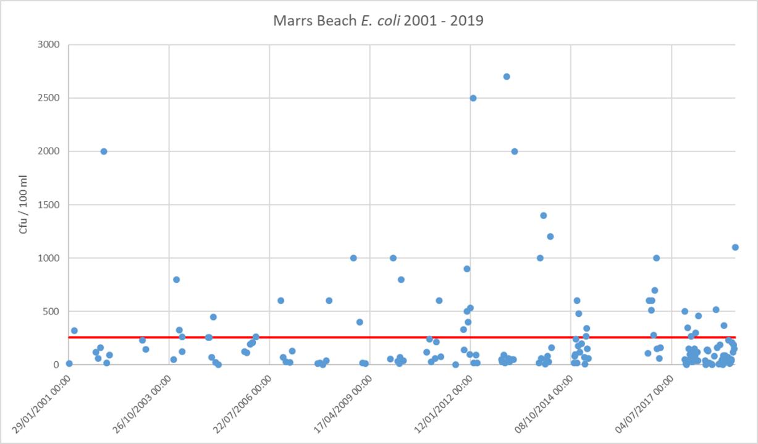
Figure 1: Marrs Beach E. coli results over time. The red line represents the 260 E. coli cfu/100 ml guideline.
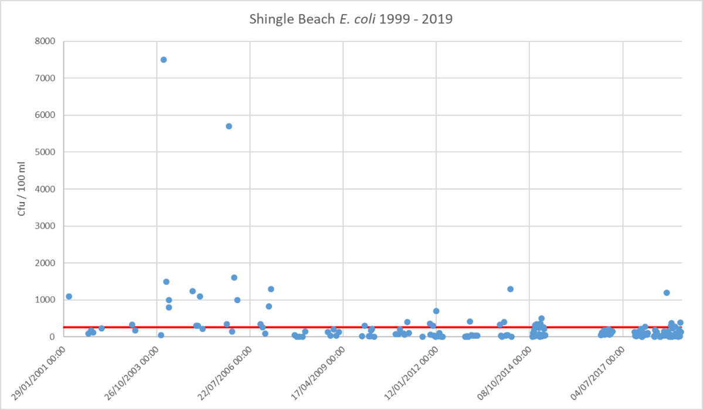
Figure 2: Shingle Beach E. coli results over time. The red line represents the 260 E. coli cfu/100 ml guideline.
The Marrs and Shingle Beach Working Group (the Group) was tasked with investigating the issue of faecal contamination at these beaches, evaluating community values, and providing recommendations to Council on how water quality might be improved at these sites.
Understanding the problem – causal loop modelling workshop
The first action of the Group was to learn about the complex nature of the faecal contamination issue and its components. This was facilitated by a workshop that evaluated the scenario using causal loop models, which were developed by the Group (Appendix 1).
Values
Values were considered and the Group unanimously identified swimming as the highest priority value for both Marrs and Shingle Beaches. They wanted to see water quality improved so that it would be safer for swimming. Other values were identified and these can be viewed in Appendix 2.
Monitoring plan
The Group implemented a monitoring plan to get data, which would aid understanding of the drivers of faecal contamination. This built on an existing platform of data that had already been collected. Existing Council monitoring sites were used as well some new sites added (Appendix 3). Another key addition included testing the genetic source of E. coli contained in samples.
Historically Marrs Beach has exceeded the E. coli guidelines for swimming more frequently than Shingle Beach, hence the group focused more attention on Marrs Beach. It has also been assumed that the drivers of exceedances at both beaches are different. Shingle Beach, on the north bank of the Buller River, is downstream of legal sewerage overflows that activate when urban stormwater overloads Westport’s combined sewerage/stormwater system. This will be rectified by the Buller District Council as resources allow. When the Group began, a broad range of potential contaminant sources were considered for Marrs Beach, including human, ruminant, and avian.
The science
Two key questions were: was there an animal (human, bird, ruminant), contributing most of the faecal contamination, and where was contamination coming from. Historic and contemporary sampling results have shown that there are often high levels of E. coli in Bradshaws Creek, which flows into the Buller River just upstream of Marrs Beach (refer map in Appendix 3). When applying criteria from the NPS-FM’s National Objectives Framework, Bradshaws Creek is in the ‘D’ category for E. coli. A ‘D’ is below the national bottom line and requires improvement under the NPSFM. Bradshaws Creek has higher E. coli concentrations than the Buller River and was considered to be a likely source of contamination, but this needed to be proven.
Key findings
- Genetic markers were used to identify what type of animal the E. coli came from. Choices were human, avian, and ruminant. Three tests were undertaken on samples from Bradshaws Creek, and two from Marrs Beach, all of which indicated that ruminant was most likely to be the dominant source. Cows, deer, and sheep are all types of ruminant animals.
- Two days were spent evaluating flow patterns around Bradshaws Lagoon using dye tracing and visual inspection. Flow patterns in this area are complicated, with very large tidal fluxes, but connectivity was observed between water from the Bradshaws catchment and Marrs Beach.
- Testing was undertaken in different parts of the Bradshaws catchment, including the northwest arm of the lagoon towards Carters Beach, and Lagoon Creek. A combination of higher flows and higher E. coli concentrations indicated that Bradshaws Creek (above Martins Rd Bridge), was the main tributary supplying faecal contamination.
- Concern was raised that mud at Marrs Beach provided a reservoir for pathogens. Analysis of water samples following sediment stirring has shown that sediment is unlikely to be a major source of pathogen risk at Marrs Beach. While naturalised E. coli can occur, is it unlikely to be a significant source.
In summary, based on the sampling undertaken by the Group to date, we are confident that ruminant faecal contamination from Bradshaws Creek is the most significant driver of elevated E. coli and pathogen risk at Marrs Beach.
Marrs Beach and Shingle Beach E.coli results have improved in recent years, however they remain above the target established by the Group. Further work with catchment land users is required to meet the water quality target.
Shingle Beach requires further investigation before appropriate management options can be established for that area.

Water quality targets
A water quality target, to apply to Marrs Beach and Shingle Beach, was chosen by the Group. This new target requires 90 % of samples (at least 18 out of 20), over the summer sampling period to be below 260 E. coli cfu/100 ml. The other 10 % of samples must remain under 550 E. coli cfu/100 ml. e.g. no more than 2 out of 20 over 260, and none over 550.
Environment Canterbury and Community Public Health have had input on these targets.
Sampling will be avoided when:
- There has been more than 50 mm rain in the last 12 hours recorded at the Bald Hill rain gauge.
- The Buller River @ Te Kuha water level is over 7.3 meters.
Future work
- AgResearch will provide recommendations on how faecal contamination can be reduced. This will include a site visit and a workshop for farmers. The cost will be $10,000, the funding for which will come from Envirolink. $5,000 has already been secured.
- Take additional samples at Shingle Beach for faecal source tracking (FST) next summer using a threshold of 500 E. coli cfu/100 ml to trigger FST analysis.
- A second updated report from the Group will be presented to the Council in the 2019-2020 financial year.
- Collect additional samples in Bradshaws Creek to improve our ability to evaluate E. coli state and trends.
- Council engages with farmers in the Bradshaws Creek catchment, discusses the faecal contamination issue and ways to improve it.
Content of this report pertains to the Group’s work to date. Another report will be provided towards the end of 2019 following further engagement and advice.

Recommendations
- Work with farmers in the Bradshaws Creek catchment to reduce sources of faecal contamination to waterbodies.
- Aim to improve E. coli concentrations in Bradshaws Creek to above the NPSFM ‘D’ category by 2023. If this is not achieved then regulatory measures may be considered in close consultation with farmers and the community.
- Pursue avenues for working with farmers to implement voluntary measures that will lead to less faecal contamination of Bradshaws Creek.
- If Bradshaws Creek has improved significantly, but water quality targets at Marrs Beach have not been achieved by 2023, then further investigation should be undertaken to determine the source of contamination at Marrs Beach.
- WCRC staff to work with Buller District Council to make the content of public health signage at Marrs Beach more relevant for the public.
- The Group remains formed in its existing structure and continues in future to meet as required.

Appendix 1: Causal loop diagrams developed by the Marrs Beach and Shingle Beach Working Group.
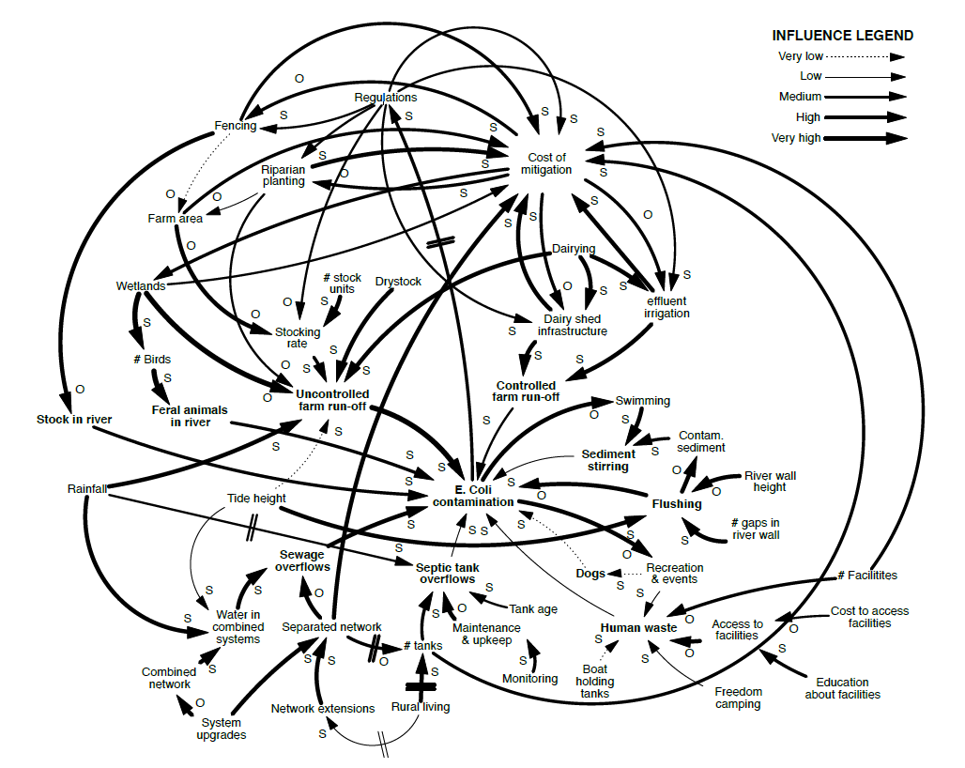

Appendix 2: Values of importance as defined by the Marrs Beach and Shingle Beach Working Group
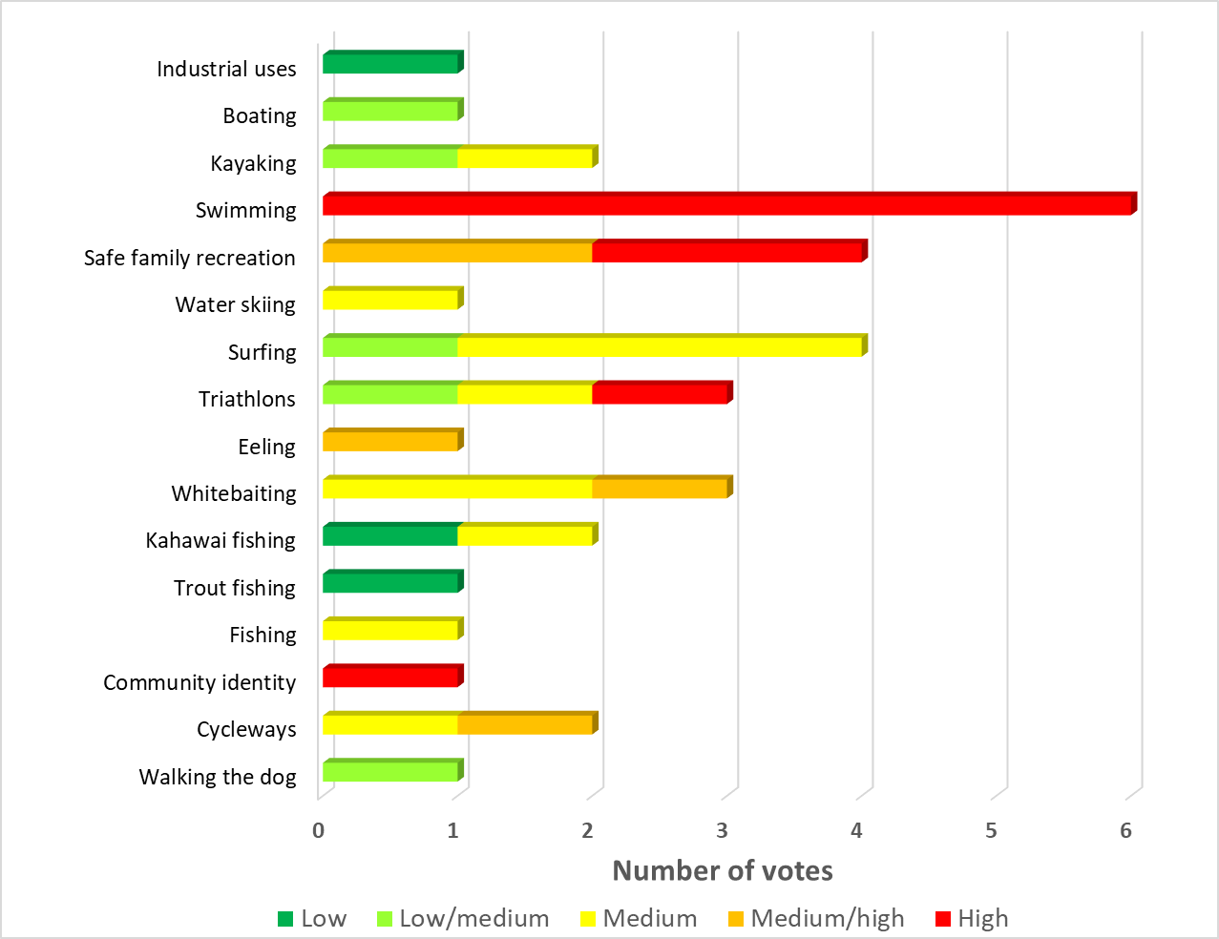
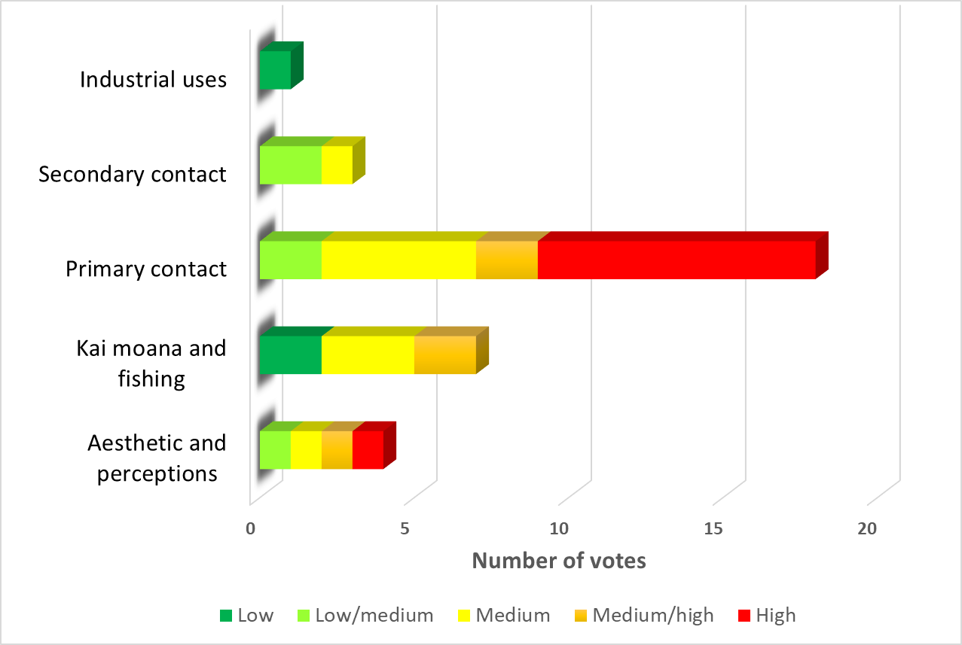

Appendix 3: Monitoring sites.
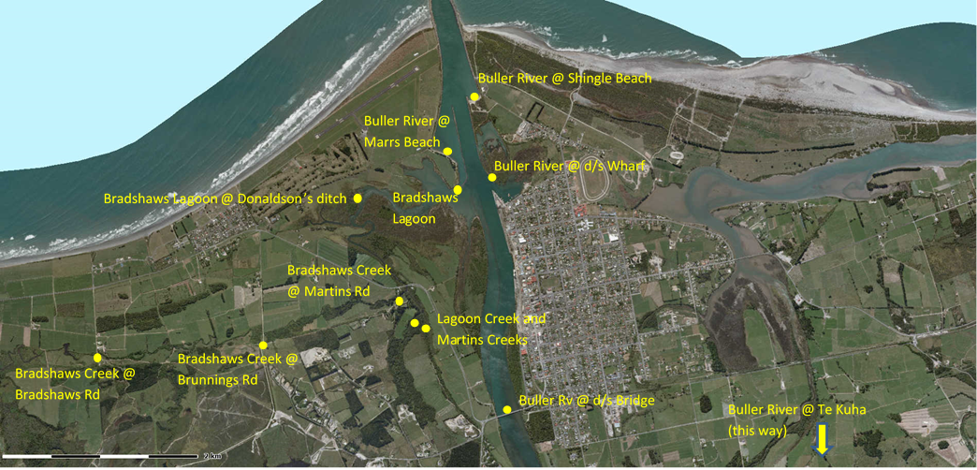
Appendix 4: Bradshaws Creek catchment demarcated by the red dashed line.

