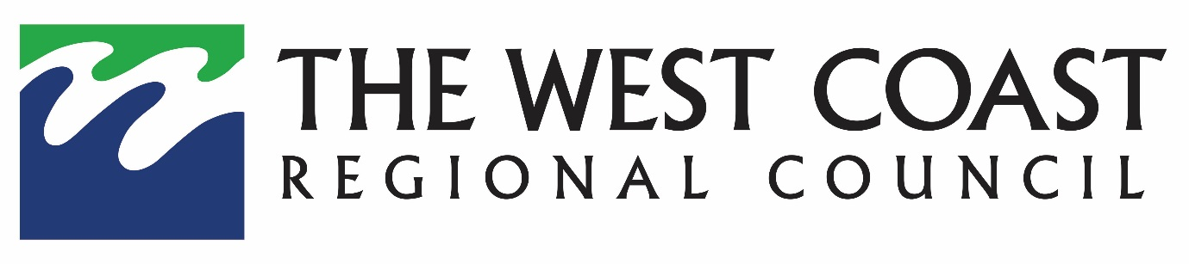
MEDIA RELEASE – 26 January 2024

Waiho River Flow Changes

West Coast Regional Council staff inspecting the Waiho River following last week’s flood event have advised that 95 per cent of the Waiho River flow is now flowing into the Tatare Stream.

Council’s river engineering and hydrology teams have visited the site and are reviewing potential options with Waiho Technical Advisory Group (TAG) members.

West Coast Regional Council CEO Darryl Lew says the Waiho Technical Advisory Group has been aware of the possibility of this occurrence and have been preparing for the situation as part of their Future Management of the Waiho River Strategy report.

Mr Lew along with WCRC councillors, Westland District Council, Department of Conservation, NZTA and community leaders will be attending a briefing at 1.30pm this afternoon to discuss the ongoing situation.

“We would like to assure the community that Council is monitoring the river flow and will be providing an update on the next steps on Friday afternoon after the meeting.”

With an orange warning forecast for the Westland region over the weekend, West Coast Emergency Management are closely monitoring weather activity and are making preparations accordingly.

ENDS ___________________________________________________________________________
Media contact

Darryl Lew | Chief Executive | West Coast Regional Council | 027 217 9306

